Unit 8 Natural disasters

1 Listening: Remembering the flood of 1955


a) Listen and tick T (= true) or F (= false).
18
 | T |  | F
- Pete was on his way home when there was a big explosion.
- The water in the house came from the river.
- To keep out of the water Pete and his family stayed in their beds.
- When they were rescued by boat the water was above their knees.
- Pa and Nanna’s house was not flooded.

- When Pete and his family got to the Clark’s house they were safe.

b) * Listen and put the sentences in the correct order. There is one extra sentence you do not need.
18
They went to Pa and Nanna’s house.

The water level in the house was 90 cm high.
They hoped the rescuers would come soon.
It took three hours to get all of them on top of the hayshed.*
Mrs Clark and Miss Spencer were very nice.

They had to make three trips in the boat.
Pete was on his way home when there was a big explosion. |  | 1
The boat went through the kitchen door.

*hayshed: Heustadel, Scheune

2 Reading: Remembering the flood of 1955

In the morning, my husband Pete pushed open the window in the hayshed* and looked over to Bolwarra. He couldn’t believe his eyes, so many of our neighbours’ houses were gone.
Later, the men decided they should go out and try and get some of the mud out of the Clark’s house. They managed to get a lot out, but just then there was a second rise of water and it all came back in again.
Mrs Clark, Miss Spencer, Tina and I had to get off the hayshed and get into the boat because the heat of the sun nearly drove us mad. When we finally got back into the Clark’s place, nobody had water, electricity or a telephone service. We only had Pete’s little portable radio and its batteries were very low, so we only switched it on every hour to listen out for important messages. One of the messages was that if anybody needed help they should put a cross on the roof of a shed with sheets or something similar and a helicopter would drop off food and supplies. So the men managed to get into the boat again and put a cross up on Pa and Nanna’s garage roof and the helicopter did drop us some supplies.
Somehow the pilot got to know that we had a 9-month-old baby. In amongst the things we got were ten tins of powdered milk. They were a great help later on because our poor little cats were very hungry when we got home and we gave them some of the milk, as well as the baby, of course.

a) * Read the text and match the sentence halves below.

1. | Pete |  | was small.
2. | The mud |  | got some of the powdered milk.
3. | The ladies |  | found out that there was a baby with them.
4. | The radio |  | came back into the Clark’s house.
5. | The pilot |  | got into the boat because it was so hot.
6. | The cats | 1 | saw that many of the houses were not there anymore.

b) Read the text and answer the questions below. Use no more than two words.

1. Who saw that many houses were not there anymore? ___Pete___

2. What came back into the Clark’s house after the second rise of water? _______________

3. What made the ladies get back into the boat? _______________

4. Was the radio big? _______________

5. Who found out that there was a baby with them? _______________

6. The baby got some powdered milk. Who else got some? _______________

*hayshed: Heustadel, Scheune

3 Writing: Natural disaster report

a) Write a report (about 100 words) about a natural disaster. Use the phrases in the box.

Yesterday/A month ago • the village/town/region • was hit by • continued to •
were hurt • felt very • tried to • was/were rescued by • said that

b) * Write a report (about 100 words) about a natural disaster. Make sure you answer all the questions.

- When and where did the disaster happen?
- What happened exactly?
- Who was hurt?
- How did they feel?
- How were they rescued?
- What did they say?

4 Language in use: Natural disasters

a) What natural disasters are the descriptions about?

1. “I woke up because I thought someone was shaking my leg. When I looked around no one was there. Then I felt my whole bed shake.”

an earthquake

2. “Just look at everything, all dried up and dead. And look at all the cracks in the ground. We haven’t had any rain now for more than two months.”

_____________________________

3. “There was a massive bang and then there was a huge cloud of smoke and ash coming out of the top of the mountain. There were also hot streams of lava running down the mountainside.”

_____________________________

4. “Everything was so peaceful and then we heard it, a loud rumble. We looked up and saw this massive amount of snow start to roll down and cover anything that was in its way.”

____________________________

6. “Three days of heavy rain was too much I guess. I was looking out of the kitchen window when all of a sudden I saw the trees and bushes and earth on the other side of the hill start to move and slide down into the valley. After ten minutes there was nothing but a big hole in the ground.”

_____________________________

b) What are the nature reserve rules? Write three rules using “must not” and three rules using “don’t”.

 | 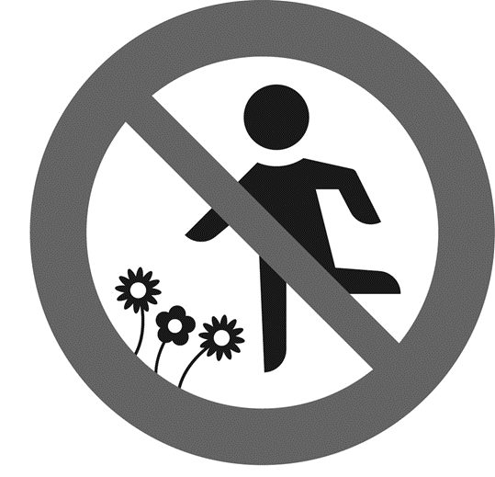 | 
1. You mustn’t feed the animals. | 2.____________________  _____________________ | 3.____________________  _____________________
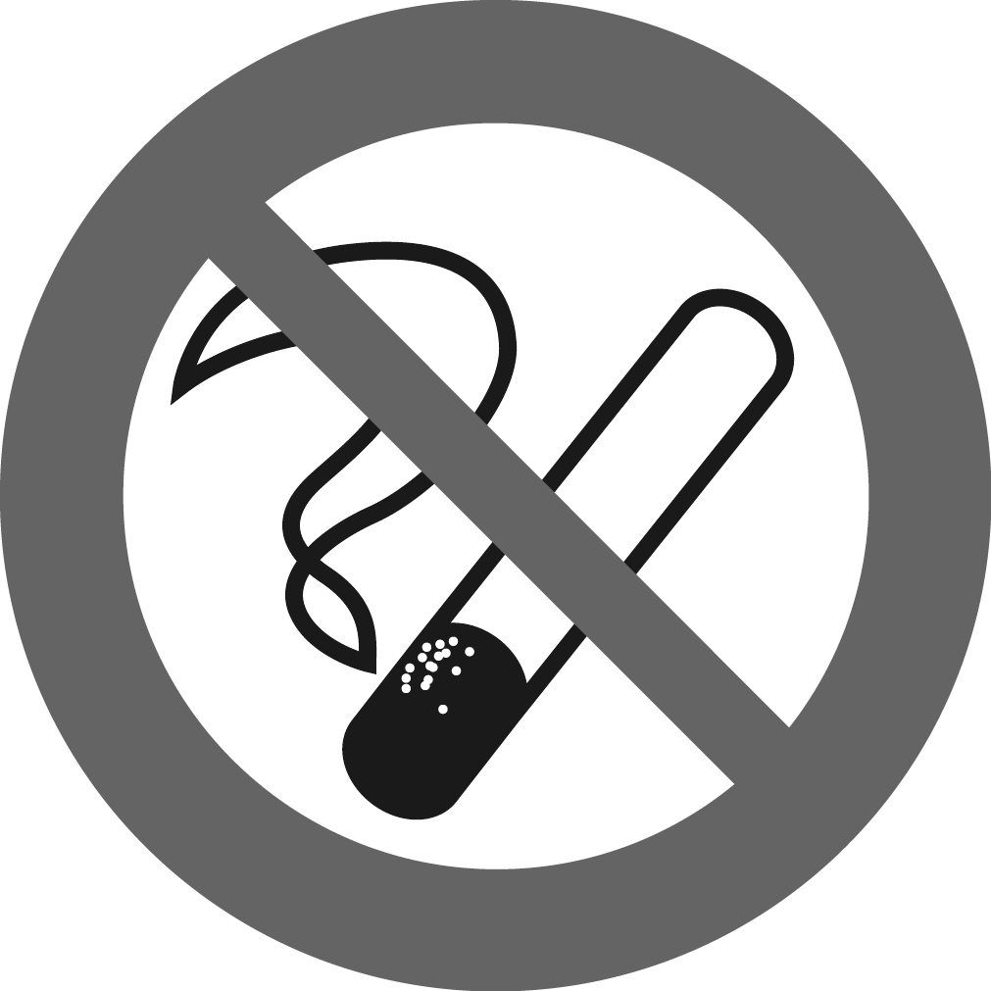 | 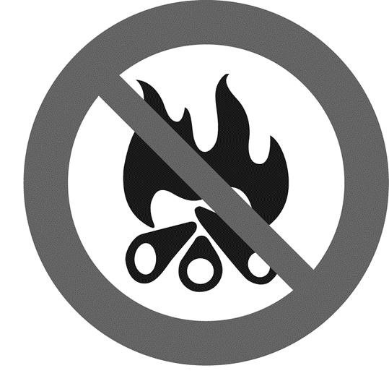 | 
4. __________________  _____________________ | 5. ___________________  ______________________ | 6. ___________________  ______________________

c) What happened? Use the correct form of the verbs in the brackets to write passive sentences.

1. | The whole sky __was lit up (light up) by the forest fires.
2. | The fires (put out) by the brave firefighters.
3. | A man (find) under a pile of bricks.
4. | The injured man (take) to hospital.
5. | Only one house in the village (not damage) by the fire.
6. | Luckily, the people who lived in the village (not kill) by the disaster.

d) Write questions for the answers below. Use different question words to start each question.

1. How bad was the damage caused by the storm?

The damage caused by the storm was extremely bad.

2. ___________________________________________________________________

The storm hit the village at around 4:00 a.m.

3. __________________________________________________________________

Mary and her family were fast asleep in bed when the storm hit.

4. __________________________________________________________________

Both Mary and her sister were injured during the storm.

5. __________________________________________________________________

The whole house was destroyed by the violent storm.

6. __________________________________________________________________

Mrs King cried because she was so upset about her damaged house.

