Unit 10 Moody Rudy

1 Listening: Feelings


a) * Listen to the dialogues. How do the people feel? Circle the correct answer.
20-24

1. | Donal feels … | a) moody. | b) worried. | c) proud.
2. | Jen feels … | a) tired. | b) sick. | c) happy.
3. | Damir feels … | a) lonely. | b) disappointed. | c) bored.
4. | Shania feels … | a) happy. | b) shy. | c) angry.
5. | Ariana feels … | a) confused. | b) nervous. | c) unhappy.

b) Listen to the dialogues. How do the people feel? Match the sentence halves below. There are four extra halves you don’t need.
20-24

1. |  | Donal feels | 1 | proud.
2. |  | Jen feels |  | happy.
 |  | r
3. |  | Damir feels |  | confused.
4. |  | Shania feels |  | angry.
5. |  | Ariana feels |  | sick.
 |  |  |  | bored.

nervous.
tired.
disappointed.

2 Reading: Asking for help

Dear Agony Aunt,
I’ve got a younger brother, Paul, and a sister, Mary. Paul and I have great fun together. It’s Mary I don’t get on well with. Whenever Paul and I play with our toys we always put them away afterwards. Not Mary. She leaves them lying all over the floor and our parents never say anything to her about it. It’s not right! She should have to put her things away too. What’s the best way to solve this problem?
Jake

Hi Jay,
Last week my brother Roger asked my parents if he could stay out with some friends until
9 o’clock. And they said no. When I was his age, they always told me to be home by 8 o’clock.
So I think this is fair. The thing is, they are always saying no to us. Roger and I would like to visit our friends for longer than we do now, but we always have to come home early and help Mum or Dad around the house, and that’s unfair. What can I do to change this?
Markus

Hello Agony Aunt,
Being an older brother or sister is not always easy. My parents always tell me to look after Matthew, because I’m older than he is. I think this is quite fair, because they let me do lots of things that Matthew isn’t allowed to do in the house, so they aren’t strict, but I wish I could go and play with my friends more often than I do instead of looking after Matthew so much. Please give me some advice.
Simon

a) * Read the letters and decide if the statements below are true for Jake, Markus or Simon. Then tick the correct person for each statement. More than one person can be ticked for each statement.

 | Jake | Markus | Simon
1. |   |  |   | … writes to an agony aunt.
2. |   |   |  | … has a problem with his younger brother.
3. |   |  |   | … doesn’t think his situation is fair.
4. |  |  |   | … wants to have more time with his friends.
5. |   |   |  | … asks for advice about what to do with his sister.

b) Read the letters and tick T (= true) or F (= false).
 | T |  | F
- Jake and Simon write to an agony aunt.
- Simon has a problem with his younger brother.
- Jake, Markus and Simon don’t think their situations are fair.
- Markus and Simon want to have more time with their friends.
- Jake and Simon ask for advice about what to do with their sister.

3 Writing: Asking for advice

Dear Sam,
A friend of mine is having a birthday party next weekend and I’ve been invited. All the other kids from my class have been invited too. The party starts at 6 p.m. and ends at midnight. My parents have said I can go to the party, but that I have to be home by 10 p.m. I’m extremely unhappy about this because all of the other kids who are going can stay until the end of the party. It’s not fair! I don’t want to be the only one who has to leave so early and miss out on all the fun. Of course, I could say that I can’t go because I’m doing something else, but I really want to go.
What should I do?
Best wishes,
Jo

a) Read Jo’s e-mail to Sam. Almost the same thing happened to you two months ago and you solved the problem. Write a reply (about 100 words) and tell Jo about how you solved the problem and what Jo should do. Use phrases from the box below to help you.

I can understand • Two months ago I had a similar problem •
I talked/asked/ suggested • You should/shouldn’t • I would/wouldn’t •
You could • Try to/not to • Why don’t you • I hope

b) * Read Jo’s e-mail to Sam. Almost the same thing happened to you two months ago and you solved the problem. Write a reply (at least 100 words) and tell Jo about how you solved the problem and what Jo should do.

- Describe your problem.
- Explain how you felt.
- Say how you solved the problem.
- Give Jo advice on how to solve his/her problem.
- Say what you hope will happen.

4 Language in use: Moody Rudy

a) How do the children feel?

 |  | 
1. The boy feels cold. | 2.___________________  _____________________. | 3.___________________  _____________________.
 |  | 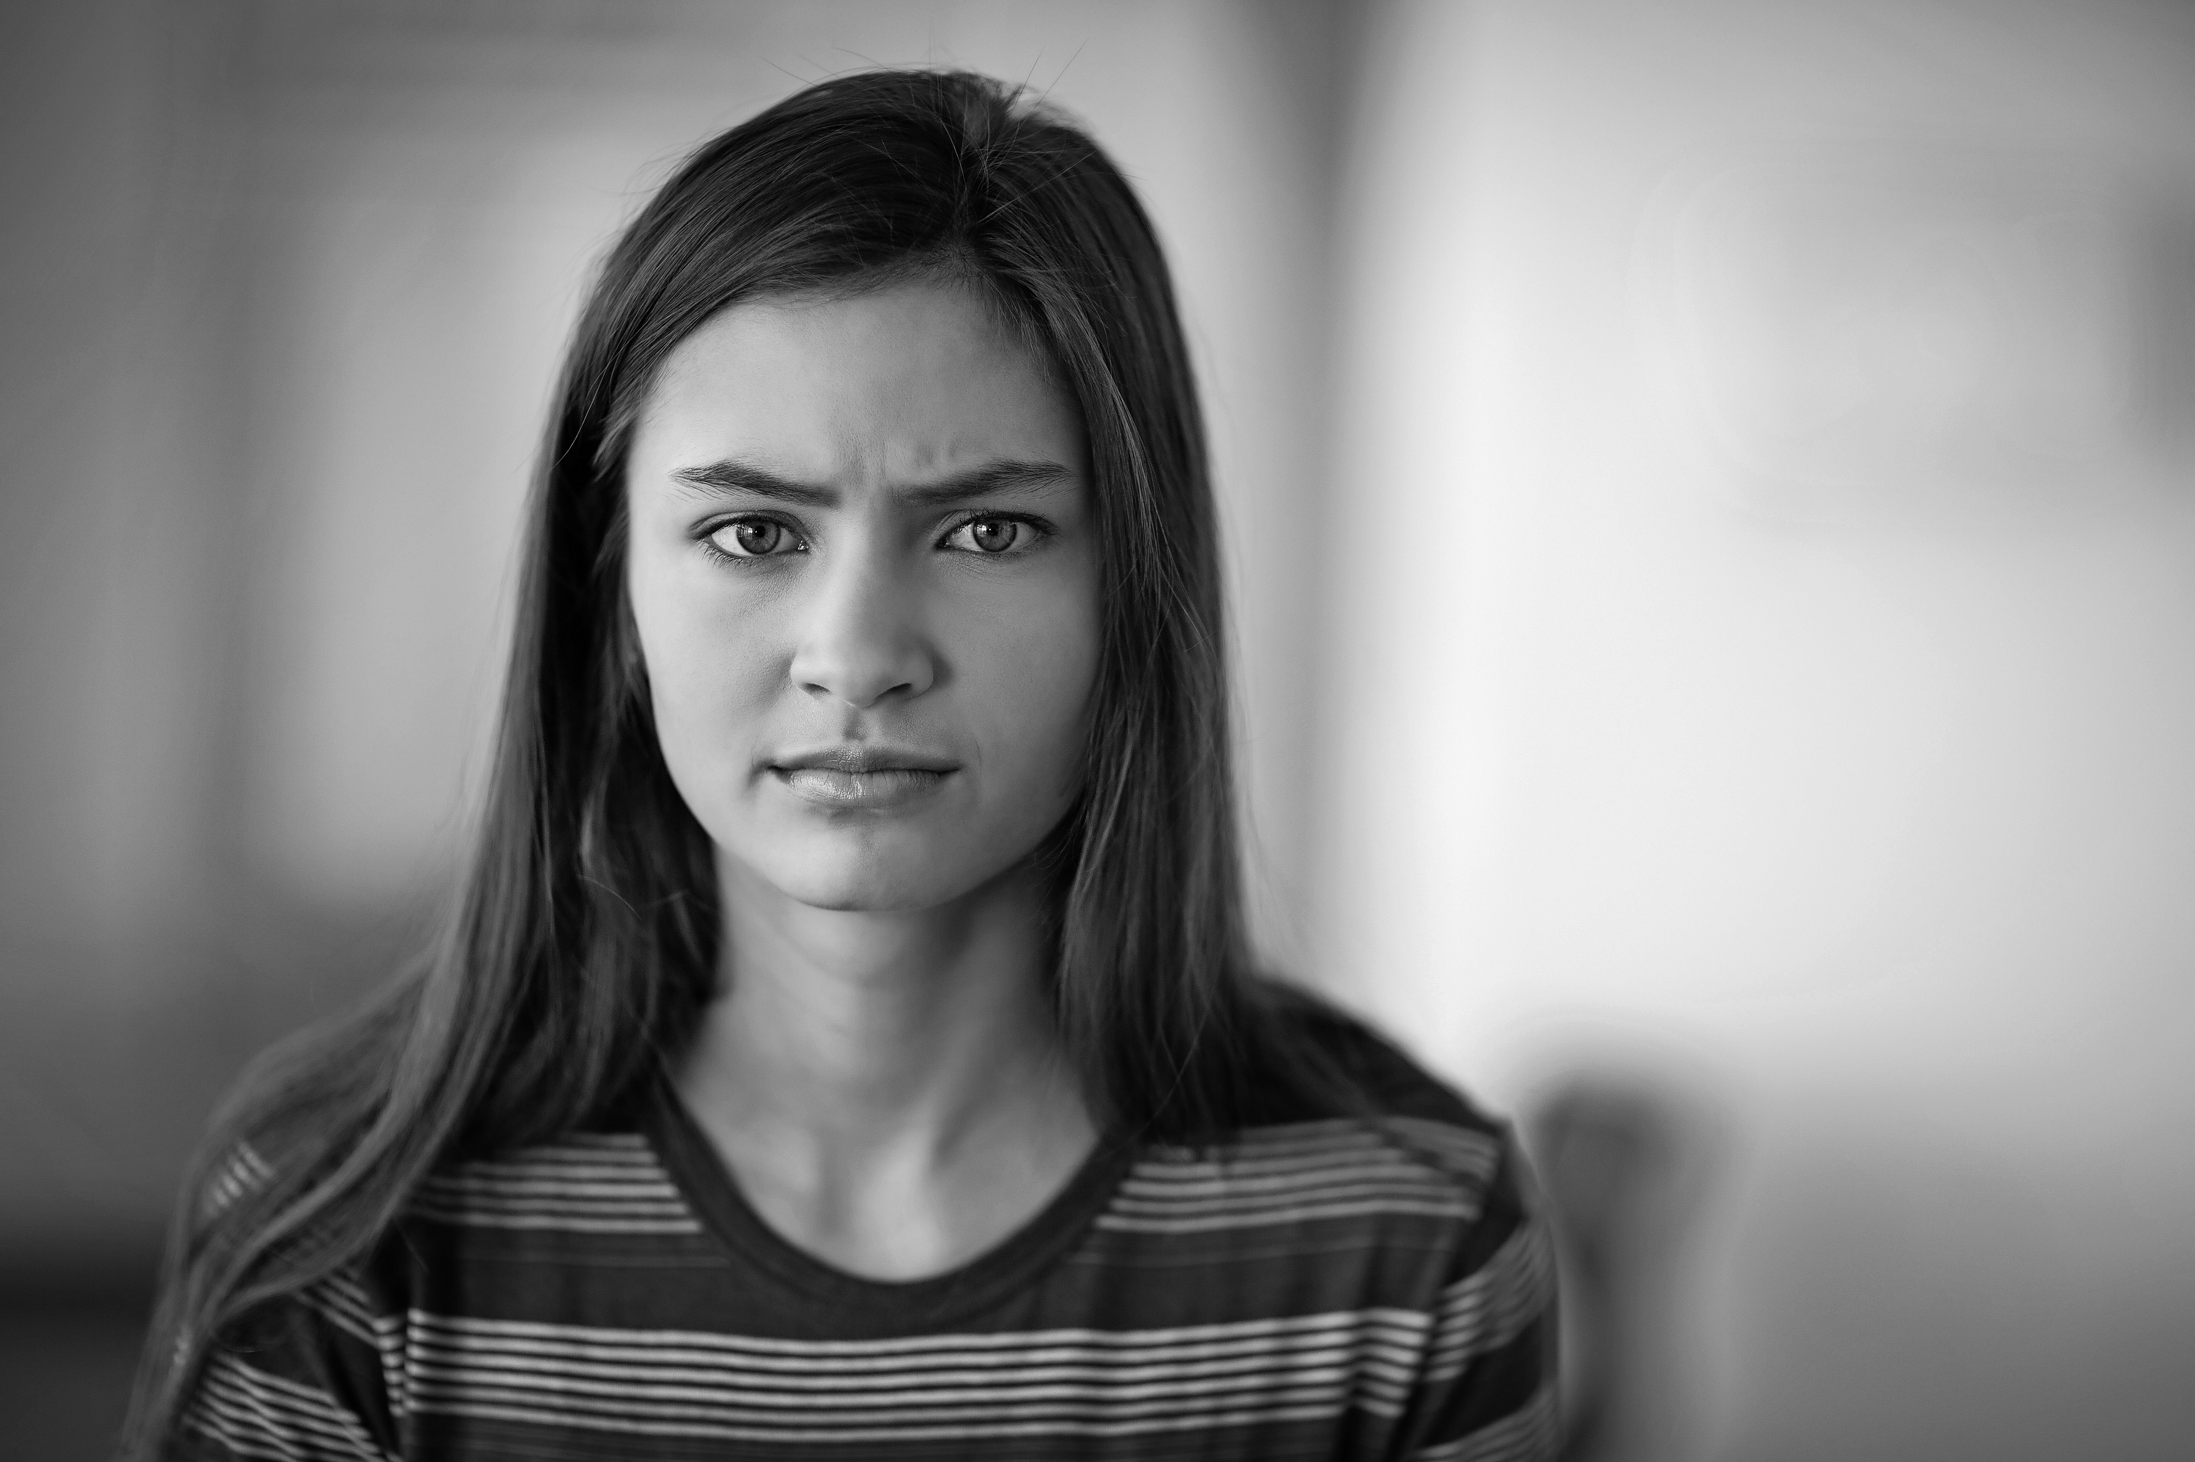
4.___________________  ___________________. | 5.___________________  ___________________. | 6.___________________  ___________________.

b) Match the sentences to the expressions. There is one extra sentence.

1. | to be in a bad mood |  | He understands that she wants to be alone.
2. | to be against something |  | He won’t tell anyone about what you have said.
3. | to accept something |  | He is riding the bike for the first time.
4. | to keep a secret |  | He does not want us to have the party.
5. | to try out something |  | He is playing the board game now.
6. | to treat somebody unfairly |  | He is not as nice to her as he is to the other girls.

 |  | 1 | He is not feeling happy at the moment.

c) Fill in the gaps with the phrases from the box below. There is one extra phrase.

has painted • hasn’t seen • has thrown away • hasn’t eaten •
has jumped • hasn’t been invited • has eaten

- What’s the matter with Jane? Someone has eaten the bar of chocolate she was keeping for her sister.
- Why is Hanna so moody? Someone ______________________________________ the picture she drew yesterday.
- What’s up with Lawrence? Jasmin is going to have a party next week and he _________________________________ to it.
- Why is Calum so angry? His mum ____________________ his room orange and he hates the colour!
- Why is Karin’s stomach making funny noises? She __________________________ anything since breakfast.
- Why is Ginny in a bad mood? She’s the only one who ________________________ the new film that’s on at the cinema.

d) Use the correct form of the verbs in the brackets to complete the sentences.

- I don’t know what’s wrong with me. I have not felt (not feel) like this before.
- The doctor thinks he is very lucky because he _______________________ (not break) any bones.
- She is very tired because she ______________________(not sleep).
- We ____________________ (buy) a big tent. Now we can go camping at the weekend.
- Someone _________________________(steal) the money for our trip. That means we can’t go now.
- They want to surprise him and ___________________ (hide) a present in the garage.

