Unit 13 Sports

1 Listening: My favourite sport


a) * Listen to the children talking about their favourite sports. Circle the correct answers.
27-32

1. | Melanie’s favourite sport is… | a) | roller skating. | b) | ice skating.
2. | Peter really likes … | a) | sailing. | b) | windsurfing.
3. | Anna prefers … | a) | riding a bike. | b) | riding a horse.
4. | Dan’s favourite sport is … | a) | basketball. | b) | volleyball.
5. | Lucy really likes … | a) | boxing. | b) | weightlifting.
6. | Ralph prefers … | a) | scuba diving. | b) | synchronized swimming.

b) Listen and tick T (= true) or F (= false).
27-32
 | T |  | F
- Melanie’s favourite sport is roller skating.
- Peter really likes sailing.
- Anna prefers riding a horse.
- Dan’s favourite sport is basketball.
- Lucy really likes boxing.

- Ralph prefers scuba diving.

2 Reading: Crazy sports

- * Read the text and tick the correct boxes. More than one sport can be correct.

Chess Boxing  Where: Berlin, Germany;  Amsterdam, Netherlands  What: It is a combination of chess and boxing. It doesn’t matter what the weather is like because it is played inside in a boxing ring.  Rules: Two players play a round of chess and then they box each other. There are 11 rounds. Each player has 9 minutes playing time. So the players have 18 minutes to win the game of chess or knockout the other player in one of the boxing rounds.  Origins: Dutch performance artist Iepe Rubingh got the idea from a 1992 comic book written by F Enki Bilal. | Cheese Rolling  Where: Gloucester,  United Kingdom  What: It is a race down Cooper’s Hill. The race always takes place. It doesn’t matter what the weather is like. Competitors can get very wet when it rains.  Rules: From the top of the hill, a round ball of cheese is sent rolling down the hill,  and 100 people, or more, then start racing down the hill after it.  The first person over the finish line at the bottom of the hill wins the cheese.  Origins: No one quite knows when the game started, but it is at least 200 years old. | Toe Wrestling  Where: Ashbourne,  United Kingdom  What: It is like arm wrestling, but instead two players wrestle with their toes.  If the weather is good, players wrestle outside, but if it’s not good, they go inside.  Rules: There are 3 rounds. The first round is played with the right foot, the next with the left, and then the right one again if necessary. The first player to win 2 out of 3 rounds is the overall winner.  Origins: The game was invented by four drinkers in Ye Olde Royal Oak Inn in Wetton, Staffordshire in 1974.

 | Chess Boxing | Cheese Rolling | Toe Wrestling
1. More than two people take part in this sport. |  | ✓
2. … takes place in more than one country.
3. … takes place outside.
4. … has more than two rounds.
5. ... ends at a given time.
6. … is the oldest of the three sports.

b) Read the text and complete the sentences below.

Chess Boxing  Where: Berlin, Germany;  Amsterdam, Netherlands  What: It is a combination of chess and boxing. It doesn’t matter what the weather is like because it is played inside in a boxing ring.  Rules: Two players play a round of chess and then they box each other. There are 11 rounds. Each player has 9 minutes playing time. So the players have 18 minutes to win the game of chess or knockout the other player in one of the boxing rounds.  Origins: Dutch performance artist Iepe Rubingh got the idea from a 1992 comic book written by F Enki Bilal. | Cheese Rolling  Where: Gloucester,  United Kingdom  What: It is a race down Cooper’s Hill. The race always takes place. It doesn’t matter what the weather is like. Competitors can get very wet when it rains.  Rules: From the top of the hill, a round ball of cheese is sent rolling down the hill,  and 100 people, or more, then start racing down the hill after it.  The first person over the finish line at the bottom of the hill wins the cheese.  Origins: No one quite knows when the game started, but it is at least 200 years old. | Toe Wrestling  Where: Ashbourne,  United Kingdom  What: It is like arm wrestling, but instead two players wrestle with their toes.  If the weather is good, players wrestle outside, but if it’s not good, they go inside.  Rules: There are 3 rounds. The first round is played with the right foot, the next with the left, and then the right one again if necessary. The first player to win 2 out of 3 rounds is the overall winner.  Origins: The game was invented by four drinkers in Ye Olde Royal Oak Inn in Wetton, Staffordshire in 1974.

1. | More than two people take part in Cheese Rolling.
2. | ____________________________ takes place in more than one country.
3. | ___________________________________________ take place outside.
4. | Chess Boxing has _____________________________________rounds.
5. | _________________________________________ ends at a given time.
6. | __________________________ is the second oldest of the three sports.

3 Writing: Sports

a) My favourite sport. Write about 100 words. In your text …

- say how long you have been doing this sport.
- explain how/why you started to do this sport.
- describe your favourite sport.
- say what equipment you need.
- say how often and where you do this sport.
- explain why it is your favourite sport.

b) * Use the mind map to give your opinion on dangerous sports. Write about 100 words.

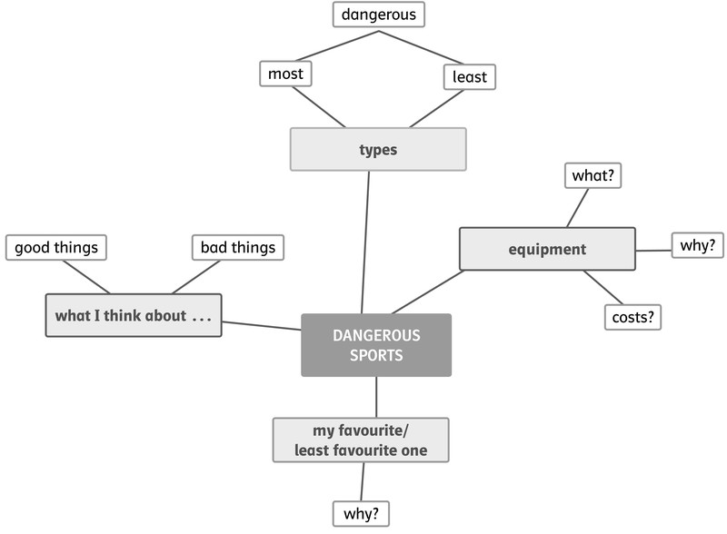

4 Language in use: Sports

a) Think of an adjective from Unit 13 that best describes each sport and fill in the gaps below.

- Everybody knows that swimming is a very healthy sport.
- Many people think chess is _________________________ because most of the time the players don’t move.
- Boxing is a __________________________ sport because the players have to punch each other’s face, head and body until one of them is knocked out.
- In comparison to Austria, not many people ski in England. It is not a very __________________________ sport there.
- To play badminton you only need to buy a net, two rackets and a shuttlecock. That’s why it is quite a __________________________sport.
- Normally, hockey is played on a field, but a few people have started to play underwater hockey. That’s a really __________________________sport.

b) Write the words in the correct boxes.

paragliding • polo • mountain biking • bungee jumping • a bungee jump • rugby • kayaking • a backflip

do | go | play
 | mountain biking

c) Write questions using the words below and give short answers.

1. you • ever • try • polo? ()

Have you ever tried polo? Yes, I have. _

2. John • ever • be • to China? (X)

_______________________________________________________________________

3. Jane and Claire • ever • go • rollerskating at night? ()

_______________________________________________________________________

4. you and your dad • ever • watch • a sporting event together? ()

_______________________________________________________________________

5. I • ever • teach • someone the rules for cricket? (X)

_______________________________________________________________________

6. Sylvia • ever • take part in • a synchronized swimming competition? ()

_______________________________________________________________________

d) Use the words below to write sentences and questions.

1. one • able • to • swim • under • minute. • Anne and Zara • water • for • are

Anne and Zara are able to swim under water for one minute.

2. you • many • score • able • Are • to • goals?

______________________________________________________________________

3. without • you • skate • backwards • Can • falling • down?

______________________________________________________________________

4. wants • be • Peter • Next year • to • races. • win • to • able • more

______________________________________________________________________

5. Moira • be • in • volleyball • to • able • the • team. • Next year • play • will

______________________________________________________________________

6. be • Will • go • your • you • able • skiing • family • to • with • next year?

______________________________________________________________________

