Unit 15 Festivals, traditions and customs

1 Listening: Festivals


a) * Listen to the audio and match the sentence halves below. There is one extra half.
34-39

1. | Teenager 1 |  | wants it to start now.
2. | Teenager 2 |  | wants to make a good wish for the future.
3. | Teenager 3 |  | wants to buy something.
4. | Teenager 4 |  | wants to watch the dancing most.
5. | Teenager 5 | 1 | wants to protect her ears from the noise.
6. | Teenager 6 |  | wants to take part in a parade.

wants to eat and drink a lot.

b) Listen to the audio and complete the sentences. Use the words in the box below. There are two festivals you don’t need.
34-39

Chinese New Year • Yi Peng Lantern Festival • Carnival in Rio • Ramadan •
St Patrick’s Day • Thanksgiving • New Year’s Eve • La Tomatina

1. Teenager 1 is talking about Chinese New Year .

2. Teenager 2 is talking about _________________________________________________.

3. Teenager 3 is talking about _________________________________________________.

4. Teenager 4 is talking about _________________________________________________.

5. Teenager 5 is talking about _________________________________________________.

6. Teenager 6 is talking about _________________________________________________.

2 Reading: Checking out a website

a) * Lisa and her class are planning a party at their school. Lisa is looking at The Party Store website. Read the website and the statements below and tick T (= true) or F (= false).
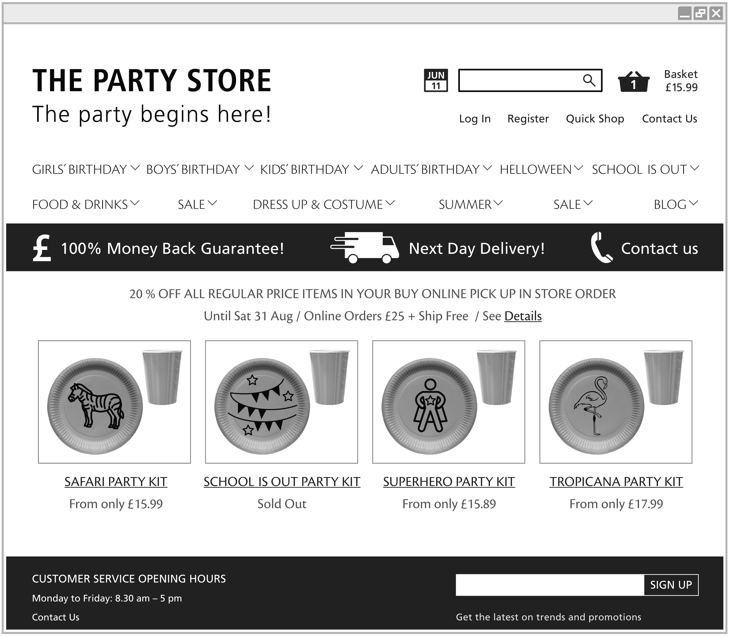
 | T |  | F
- This website sells different types of party kits.
- All the products on this website are for children’s parties.
- Lisa has already chosen a product to buy.
- The party kits cost the same.
- Lisa will have to look at another website to find clothes for the party.

- Lisa will have to look at another website to find a party kit for the end of year school party.
b) Lisa and her class are planning a party at their school. Lisa is looking at The Party Store website. Read the website and circle the correct words below.

1. Lisa is looking at the website because she wants to write about ● buy something for a party.
2. This website sells products not only for ● just for birthday parties.
3. Lisa has not chosen ● chosen a product that she wants to buy.
4. The prices for the party kits are the same ● different.
5. Lisa will have to ● will not have to look at another website to find clothes for the party.
6. Lisa will have to ● will not have to look at another website to find a party kit for the end of year school party.

3 Writing: Celebration time!

a) You want to have a party to celebrate a special day. Write a to-do list. What do you have to do before the party begins? Use the verbs in the box below.

make • organise • decide • prepare • print • talk to • ask • find

b) * You want to have a party to celebrate a special day. Write a text of at least 100 words about the party. Make sure you answer all the questions.

- What do you want to celebrate?
- Where are you going to have the party?
- Who are you going to invite? Why?
- What do you want to have at the party?
- How are you going to organise the party?
- What will be the best thing about the party?

4 Language in use: Festivals, traditions and customs

a) Use the phrases from the box to fill in the gaps. There is one extra phrase.

I can do this • What do we have to do first? • We mustn’t forget •
What is the most important thing • I’d like to • We must find • Why don’t we

Theresa: Right everyone. Let’s start planning the surprise party for Andy.
Frank: What do we have to do first? [1]
Theresa: Well, I think we should decide who does what, don’t you?
Simone: Good idea.
Theresa: __________________________________________ [2] that we have to do?
Simone: I would say it’s organising the food and drink.
Frank: Yes, I agree. __________________________________________ [3] organise the food and drinks. Is that okay with you?
Theresa: Sure. That’s great. What about the decorations? Who should we get to make them?
Simone: Let’s ask Sue, she’s really good at that.
Theresa: ______________________________________________ [4] someone to talk to Andy’s parents about having the party in their garage.
Frank: I’ll ask Patrick. He knows Andy’s parents very well. ______________________________________________ [5] to ask Harry to organise the games. He’s got the best ideas.
Theresa: Okay. _____________________________________________ [6]. I’ll write it down on my to-do list right now.

b) Present perfect tense and short answers. Use the correct form of the verbs in the brackets to complete the text.

Mrs Dunn: Oh dear, it’s almost seven o’clock and the guests are going to start arriving!
John, have you put (put) [1] the drinks in the fridge?
John: Yes, Mum. I ________________________ (have) [2].
Mrs Dunn: Good. Fran, ________________________ (decorate) [3] the room?
Fran: No, I _______________________ (not have) [4]. Not yet.
Mrs Dunn: Why not?
Fran: Because Sarah _______________________ (not finish) [5] making them all yet.
Mrs Dunn: Well she’ll have to hurry up! John, ________________________ (prepare) [6] all the games you want to play?
John: Yes, Mum. They’re all ready.
Mrs Dunn: Good boy! What about the table?
John: Don’t worry Mum. I ____________________________ (lay) [7] it and put everything on it.
Mrs Dunn: Oh, that’s wonderful. So, we’re almost ready then.

c) Mixed tenses. Use the key words and phrases in the text to fill in the gaps.

Milly: Hey Jane, have you and your sister ever been (you and your sister ever be) [1] to a fancy dress party?
Jane: Yes, _________________________ [2]. We ________________________ (go) [3] to one last year and it ___________________ (be) [4] really cool.
Milly: What ____________________________ (you wear) [5]?
Jane: We each ____________________________ (wear) [6] a ghost costume.
Have ____________________________ (ever see) [7] the film called Caspar?
Milly: I’m not sure. What ______________________ (be) [8] it about?
Jane: It’s about Caspar who is such a cute little ghost. Rose and I ____________________________ (want) [9] to look like Caspar at the party and everyone ____________________________ (say) [10] how good we looked.

