For the Cauliflower:  1 medium cauliflower, cut into florets  2 tbsp olive oil  1 tbsp honey  1 tsp curry powder  ½ tsp smoked paprika  ½ tsp turmeric  Salt and pepper to taste | For the Crunchy Chickpeas:  1 can (400g) chickpeas, drained and rinsed  1 tbsp olive oil  ½ tsp paprika  ½ tsp cumin  Pinch of salt | For the Grilled Halloumi:  200g halloumi cheese, sliced into 1 cm thick pieces  1 tsp olive oil
Toppings:  2 tbsp sliced almonds, toasted  Fresh parsley, chopped  Lemon wedges (optional) | 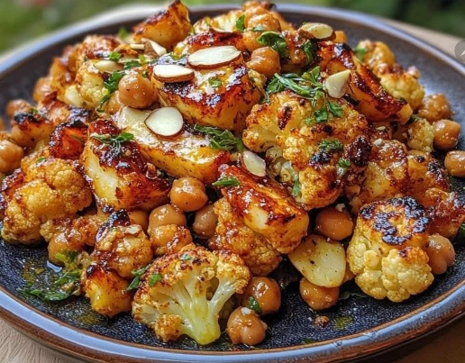
Prepare Cauliflower:  In a large bowl, mix olive oil, honey, curry powder, smoked paprika, turmeric, salt, and pepper.  Add cauliflower florets and toss until evenly coated.  Spread the cauliflower on one of the trays in a single layer. | Pat chickpeas dry with a paper towel.  Toss them with olive oil, paprika, cumin, and salt.  Spread the chickpeas on the second tray.  Roast:  Place both trays in the oven.  Roast the chickpeas for 25–30 minutes, shaking the tray halfway through.  Roast the cauliflower for 30–35 minutes, until golden and tender. | Grill Halloumi  Toast Almonds  Arrange roasted cauliflower on a serving platter. Top with grilled halloumi slices, crunchy chickpeas, toasted almonds, and fresh parsley.  Serve with a squeeze of lemon if desired.

