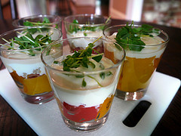
Roasted peppers with tahini infused yoghurt!!!!

