IKEA Kitchenplanner

I am sending you a first draft of the kitchen so you can see where to put the outlets and waterpipes…

My plan is only a first draft and I might change some details but it will give you an idea of where I would like to have the different parts. The strange object on the right wall (next to the door) is a kitchen cupboard from one of the furniture series. It cannot be imported into the kitchen planner. That is why I have drawn this object with the same measurements.

IKEA.at and IKEA.gr are using the same program, but the databanks are in different locations, so we cannot see my plan from the Greek site. You can have a look at the Greek version to see how it works (or simply turn on google translate on the .at version.)

If you want to see more details of my plan, you will need my username and password:
My username is: lis@polzleitner.net (my e-mail address)
My password is: moritz1

http://kitchenplanner.ikea.com/at/UI/Pages/VPUI.htm

the Greek version can be found at

http://kitchenplanner.ikea.com/gr/UI/Pages/VPUI.htm

For a quick overview I’ve copied the plan here:

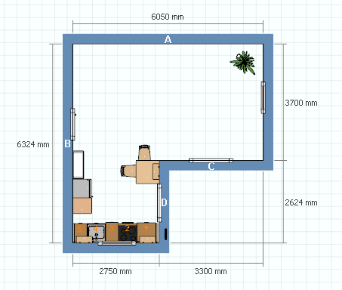
Instead of nr 1 (which is now a 60x60 cupboard for a washing machine or a dishwasher I would like to have open shelves made of the same wood as the kitchen counter. We can later (maybe) put in a dishwasher – if we decide we want one – but not now. I’d still buy the black body and keep the door in reserve for later but make a shelf or two out of the same wood as the counter.

Interestingly the IKEA kitchen furniture and electrical appliances are about 40% more expensive in Greece than in Austria. We might bring them at Easter (or at least some of it). The other stuff (beds, cupboards, shelves…) is the same price or even cheaper in Greece, so we will buy it in Ioannina in the summer.
Here are a few of the 3D pictures, if you do not want to go through the IKEA software.

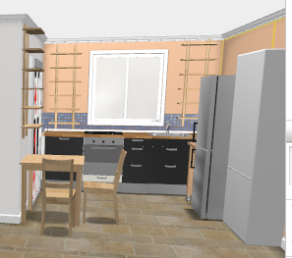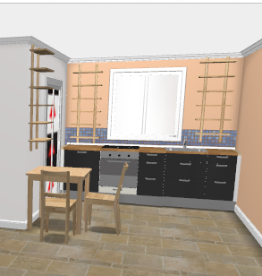

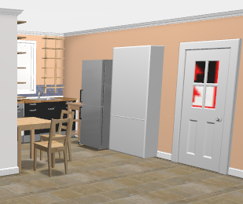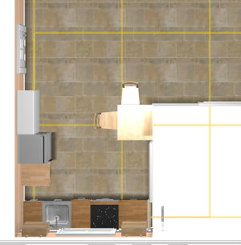

Bathroom: I’d like to have a mini washing machine in the upstairs bathroom under the wash-basin. (3kg or 3,5 kg machine) Could you please make sure the washbasin is hung high enough or is moved to the side a bit. We’d need a faucet for the washing machine and the drainage.
Height: approximately 67 – 69 cm
see examples below for measurements of these machines.

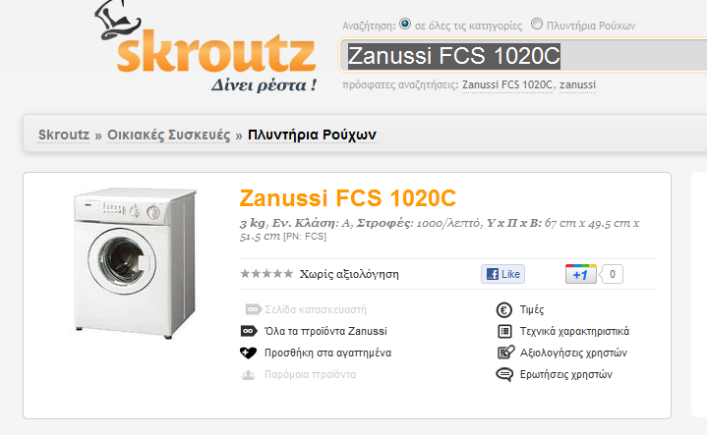
or

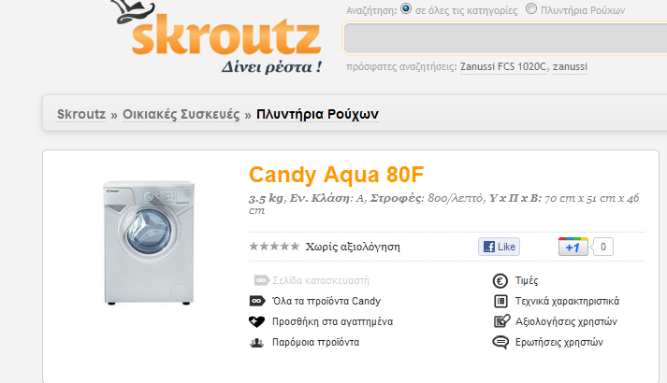

…or something similar. There are a few other mini-models that seem to be available in Greece.
We might have to choose a different washbasin – I do not remember exactly what we have chosen and how big it is. But I am sure the girl at Porcelana can help us with this.

