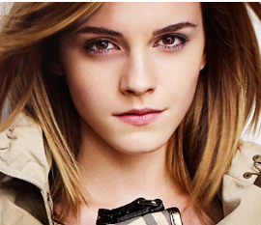
STARS

E _ _ _ W _ _ _ _ _
She is a famous actress.
She plays in all the Harry Potter films.
Now she is a fashion model.
She lives in England.
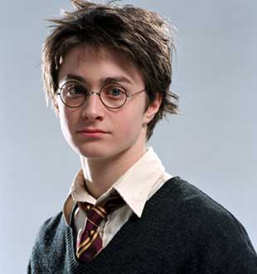

This is D_ _ _ _ _ _ R_ _ _ _ _ _ _
He is a famous actor.
He lives in England.
He plays in all the Harry Potter films.
He goes to school but he doesn’t like homework.

  A_ _ _ _ _ Sch _ _ _ _ _ _ _ _ _ _ _  He was a body-builder and a film-star.  Now he is a politician.  He is Austrian, but now he lives in America.  His wife is Maria Shriver.  He has three children. | 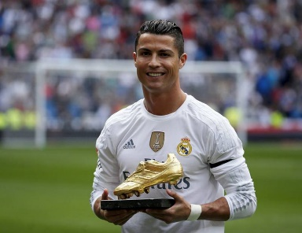  Cr_ _ _ _ _ _ _ Ro_ _ _ _ _  He is a famous soccer player.  He plays for Real Madrid.  He runs very fast.  He is very rich.  He is 1.85m tall.
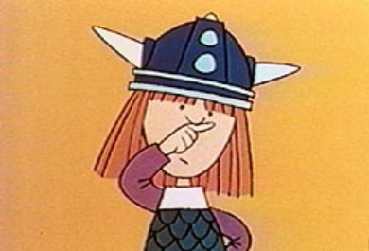
V_ _ _ _
This is V…..
He is a Viking boy but he is quite fearful.
He is not very strong but he is very smart.
He likes thinking about a problem before finding the correct solution.
He lives with his parents Halvar and Ylva in the small village Flake.

G _ _ _ _ _ _ _

He is American.
He likes eating Lasagne and he likes teasing Odi.
He hates Monday mornings.

Homework: Now write about your favorite star. If possible, include a photo or draw him/her.

