Tips for signing up to 1c Cyberspace
1. Go to: www4.edumoodle.at/epep
You will see a list of courses. In the list click: 1c Cyberspace

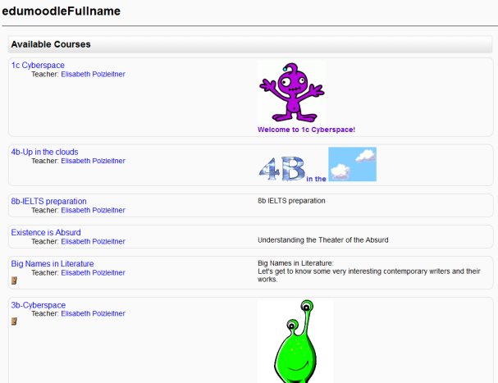

2. Then you will see this screen: Click “Create a new account”

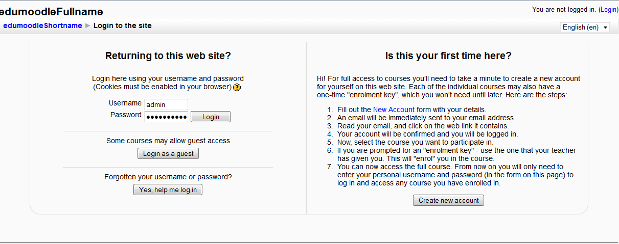

3. Answer all the questions.
Suche dir einen username und ein password aus.
PLEASE write your new password on your password card in your English folder and give it to your parents. You MUST NOT forget this password.
Then click “create my new account”
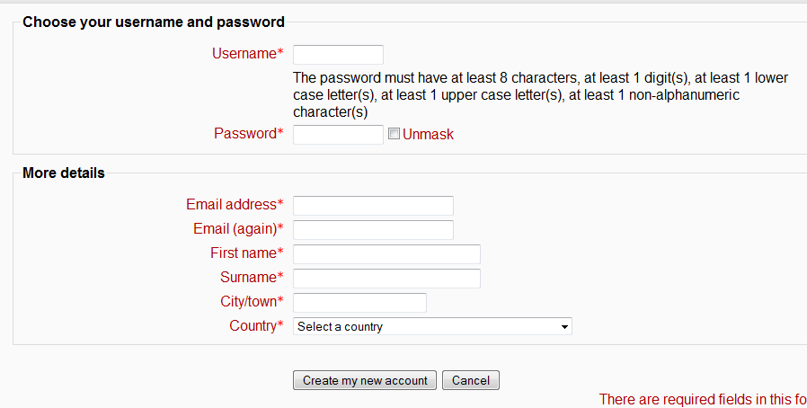
4. Then you will see this:

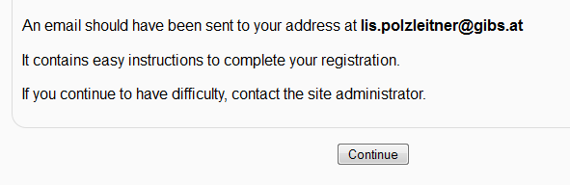

5. Now you have to wait for an e-mail from moodle. This may take a few minutes, sometimes even longer.
It will look like this:

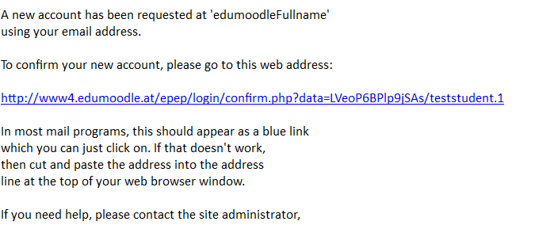

6. Click on the blue link.

Then you will see this: Click YES.
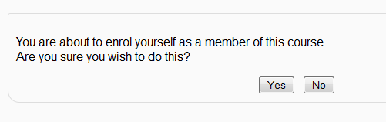
That’s it! Congratulations, you have now enrolled in our course.
Super! Jetzt bist du dabei!!!

Look around! You will soon learn how to use more of Moodle.

