What we have in common...
Mrs. Pölzleitner and the students of 1a have these things in common:

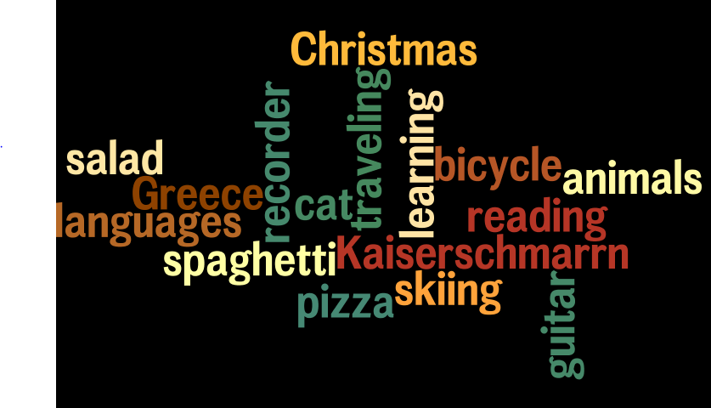

Ailish likes piglets (baby pigs). I also like piglets, they are really cute.
Christian likes sports. I also like sports a lot. I like skiing, jogging and riding my bike.
Clara likes pizza a lot. I also like pizza, but only if it’s without meat.
Edi speaks 3 languages. He speaks German, Serbo-Croatian and a little bit of English. I also speak many languages. I speak German, English, French, Italian and Greek.
Elisabeth has a cat. I also have a cat. My cat is called Moritz.
Jakob’s favorite color is dark blue. I also like dark blue a lot.
Jannik’s favorite continent is Europe. I also like Europe best. I like to live here.

… and so on

More words you can use:

X plays the guitar. I also play the guitar.
X plays an instrument. I also play an instrument. I play the piano.
X has 2 brothers and 1 sister. I have ….
X likes travelling. I also like travelling.
X likes playing soccer. I also play soccer.

