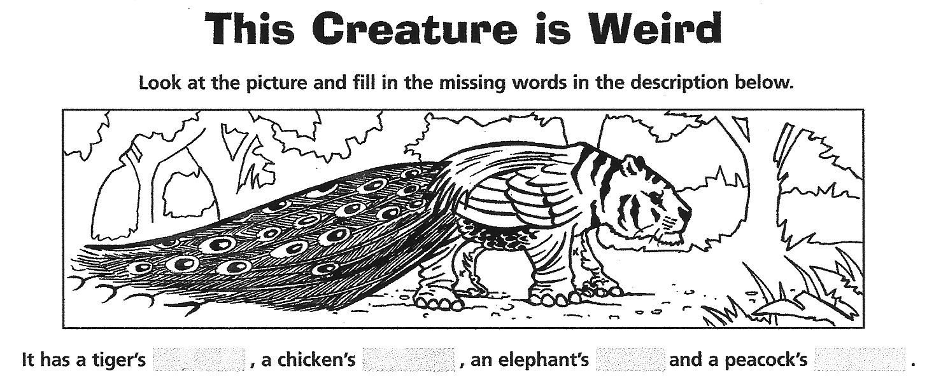

2. Now work with a partner. Use the picture cards for “This Creature is Weird”. You will find them on your teacher’s desk.
Beschreibt abwechselnd die “funny creatures”. Dein Partner/deine Partnerin legt die passenden Kärtchen auf den Tisch. Schreibt beide die Antworten in die offenen Zeilen.

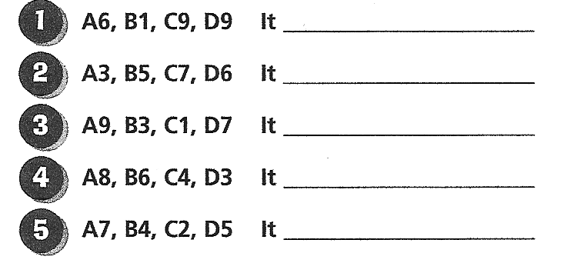
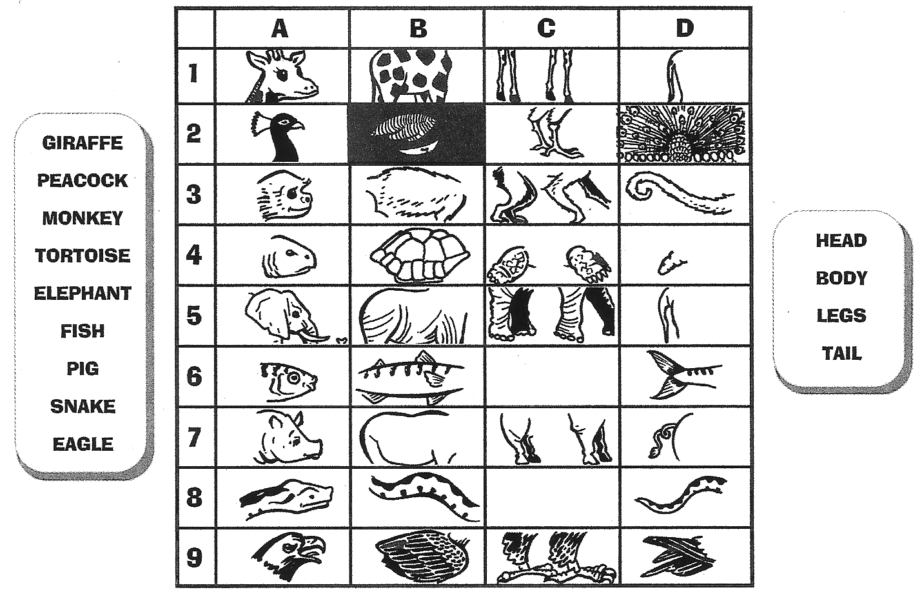
adapted from: Timesaver Grammar Activities, Mary Glasgow magazines, An Imprint of Scholastic Inc.p. 53
cut up for game!

