The PLURAL of nouns (Die Mehrzahl)
What differences can you see? Write them down on a worksheet.
Example: In picture 1 there are …. but in picture 2 there are …

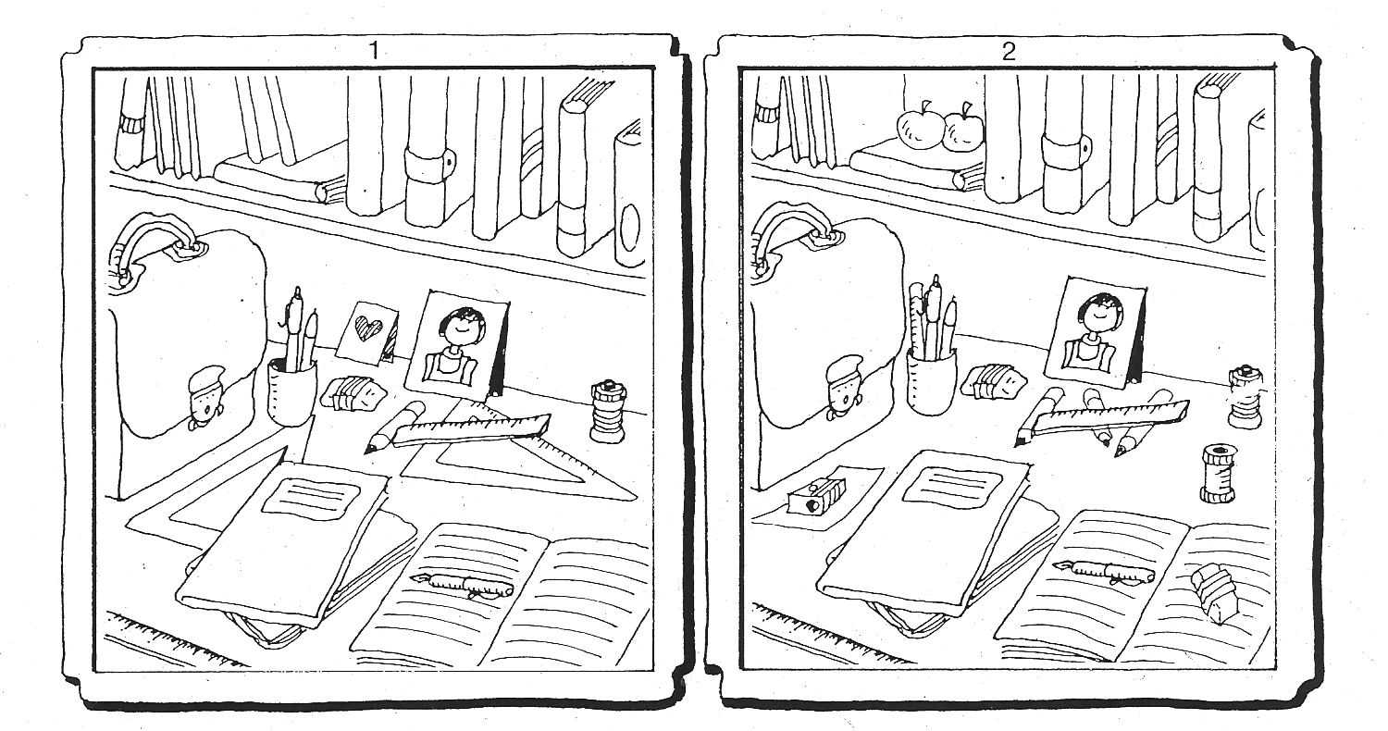

a or an?

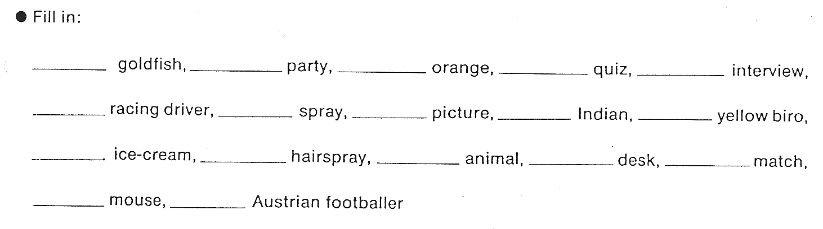

What is your rule?

