A bit of GRAMMAR

Find the rule

Look at the following sentences and find out when you need an –s at the end of the verb.
Finde heraus, wann man im Englischen an das Zeitwort ein –s anhängen muss.

Examples:
Ann likes skating. My mother hates ironing.
Jack and Jull play tennis every Tuesday.
Our hamster sleeps 10 hours a day.
My brother and I clean our room once a week.
Tim and Bob watch TV every day.
My little sister often plays with our cat.
I love reading.
I hate the rain.
Do you play an instrument?

My Rule:

Now have a look at these sentences.

How are the verbs “to have” and “to do” used here?

I have a blue schoolbag.  Do you have any brothers and sisters?  Mrs. Pölzleitner has a red schoolbag.  Matteo has a cool surfboard and a kite. He does kite-surfing.  We have a very small classroom.  Jakob has a sweet black puppy and two rabbits.  The students of 4a have a much bigger classroom. | I do not like Sauerkraut.  Do you like it?  Mrs. Pölzleitner does not eat meat.  We do our homework every day.  Some students do not clean up the workshop games.  Mrs. Pölzleitner does not like this at all.

My Rule:

Now fill in the verbs in the correct form

do/does, , have/has, , like/likes, keep/keeps, sleep/sleeps

My guinea pig ………………………………….. in a box in the kitchen.

Carina’s goldfish …………………………….. to eat flies.

My parents ……………………………. a wonderful big bedroom.

I …………………. my homework from four to six o’clock every day.

Tim’s three cats ………………….. to be outside.

Mary ………………………. her school-things in her bookshelf.

I ………………….. not have any pets.

John ………………….. two brothers.

How do we use the verb “to be”?

How are you today?
Today I am ………………………………………………………
My mom is called ……………………………………………………………………………………………………………………….
My dad is called …………………………………………………………………………………………………………………………
We are a ………………………….. family.
My best friends are called ………………………………………………………………………………………………………….
Complete the table:
I | am
You
He/she/it
We
You
(You all)
They
(My friends)

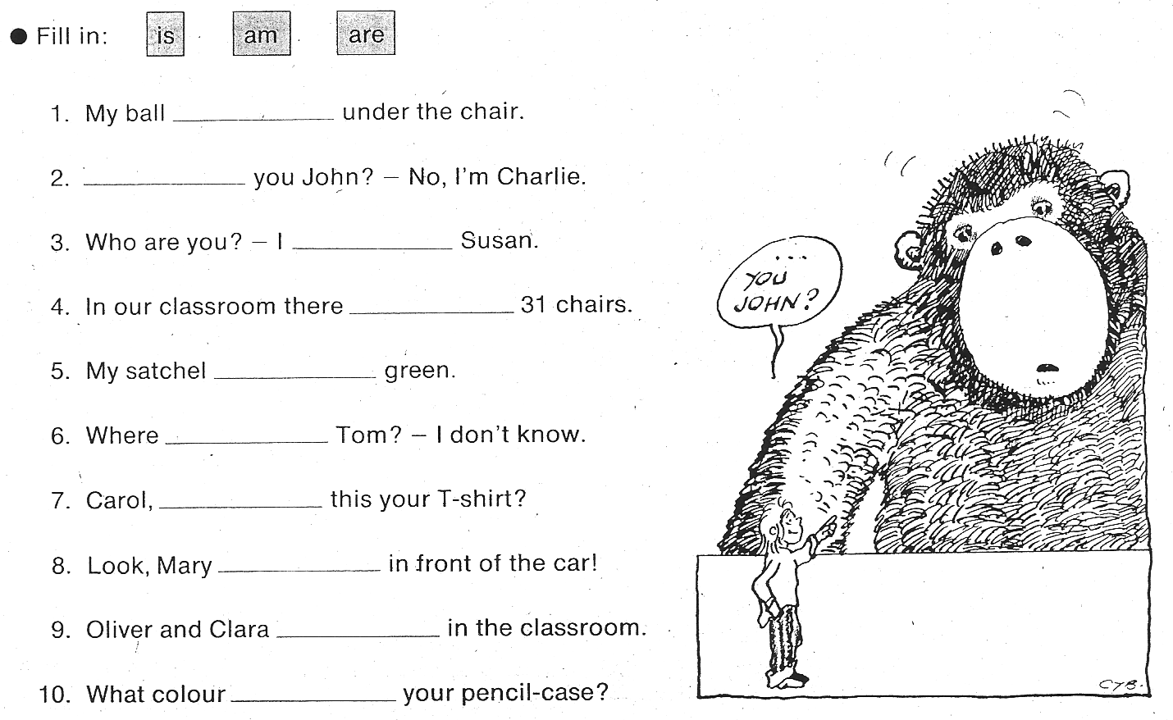
Source: Ticket to Britain 1, Newby et al.


Welcome to 1c Cyberspace,
our very own web-space.

Let’s introduce ourselves

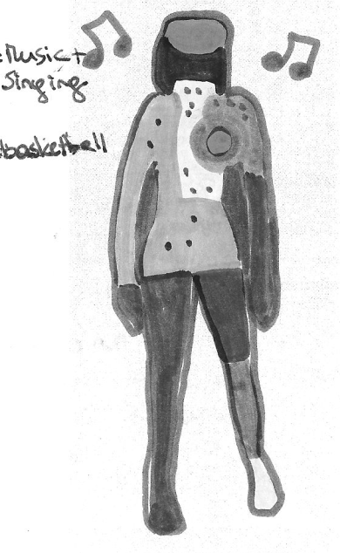
1. That’s me:
Design a beautiful page to present yourself. Draw and write as much as you can say on one A4 page. Use only your firstname – no lastname on this sheet. Do not give your exact address. This page will be scanned and will then present you online.

2. Interviews:
Let’s first collect all the questions we can ask to find out more about our new friends.

Then work with a partner. Choose some good questions that you would like to ask your new friend.
Practice your interview several times.
Then record your interviews with a teacher.

You will then be able to listen to all the interviews online.

3. Listen to your friends' interviews. What can you learn from your friends?
Höre dir die Interviews deiner MitschülerInnen an. Was gefällt dir besonders gut? Hol dir ein paar gute Ideen. Wenn du möchtest, kannst du nächste Stunde dein Interview noch einmal aufnehmen und noch besser machen.
Write your friends some nice comments on their pages.
Schreib deinen Freunden ein paar nette online-Kommentare -- Try writing in English. Don't worry about making mistakes.

4. What we have in common:
Listen to each interview and find one thing that you have in common with each of your friends. Write one or two sentences about each of your friends. Have a look at the example on Moodle.

Attention: he/she/it das s kommt mit
I like..... he/she likes

