Our Classroom
1. Read the text about our classroom and fill in the missing words.

Our Classroom
Our classroom is on the first floor. There are _______________________ students in 1a and our classroom isn’t very big, so there isn’t much space.
There are huge _____________________ with ________________blinds and ______________________curtains. We can close the blinds or the curtains when it’s too sunny. Our ________________________ are gray. We’ve got a __________________ and a cloth to clean the board. There are lots of_______________________ and chairs. The __________________are blue, red ______________ and ___________________. Our ___________________ is white. It is fixed on the ceiling. There is also a plant in a ___________________ pot in our classroom. It stands on the __________________ where we keep our school things. The shelves are ______________________. On the back __________________ there is a pin-board for information and so on. Next to the __________________ there is a sink and there are three _____________ between the sink and the boards. One bin is for biodegradable waste like food, one is for plastic and one is for ______________________________(the rest!).
All in all I / ____________________________________ our classroom.

2. How many times can you find there is and there are in this text?
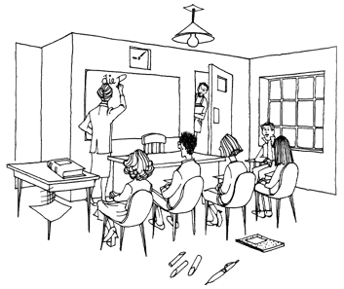
there is___________________ times there are __________________times

3. How many plural (Mehrzahl) words can you find in this text? Write a list.
students


Word Search: The numbers 0-20 are hidden in this star, can you find them?

 |  |  |  |  |  |  |  |  | V | Z
 |  |  |  |  |  |  |  |  | Y | S
 |  |  |  |  |  |  |  | E | Z | I | C
 |  |  |  |  |  |  |  | S | E | X | S
 |  |  |  |  |  |  | T | E | R | T | J | H
 |  |  |  |  |  |  | R | V | O | E | B | A
V | N | E | E | T | N | E | V | E | S | E | T | H | R | E | E | A | B | D | D
R | X | W | S | Y | T | W | O | N | Q | N | T | S | O | I | M | P | H | A | Q
 | V | L | J | E | Y | T | N | E | W | T | E | K | M | W | M | H | W | L
 |  | N | I | N | E | T | E | E | N | L | N | E | V | E | L | E | P
 |  |  | J | M | S | F | O | U | R | T | E | E | N | I | T | M
 |  |  |  | R | I | H | X | N | I | N | E | L | A | G | W
 |  |  | N | E | X | J | L | L | E | I | G | H | T | H | E | S
 |  |  | E | V | F | U | N | E | E | T | R | I | H | T | L | M
 |  | I | E | I | J | N | X | M | A | Q | T | K | F | E | V | V | P
 |  | M | T | F | F | O | U | R |  |  | L | T | X | E | E | M | Q
 | D | E | F | T | X | P | Z |  |  |  |  | S | L | N | H | J | U | W
 | B | C | I | O | R |  |  |  |  |  |  |  |  | K | O | H | H | X
S | T | X | F |  |  |  |  |  |  |  |  |  |  |  |  | E | N | O | F
J | K |  |  |  |  |  |  |  |  |  |  |  |  |  |  |  |  | J | U

