My English Portfolio
  - What I have learned in the first semester
My Name:________________________________________________________Class: ___________
I can…talk about / write about/ / understand…
I am good at… I would like to learn how to….
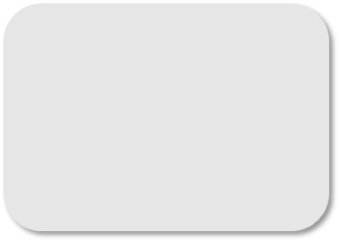  Writing |  | Speaking
 | 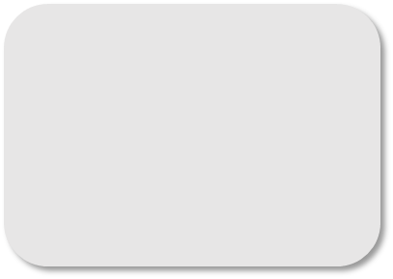  Reading | Listening

Table of Contents
My best texts of the first semester

