Revision for the second test
In this lesson we are going to revise for the test. Work really hard so you are well prepared.
Topic | 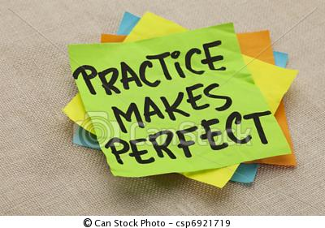  Activities |   How well can I do this?
Clothes | Look at the fashion catalogues of last year’s class. Then design your own page for this year’s 1b fashion catalogue. Describe your clothes in as much detail as possible.
Clothes | Speed-matching game (in pairs)
Talking about routines    and talking about present activities | Design competition: (in pairs)  Who can make the best grammar page to explain when we use the simple present (I get up, I work) and the present progressive (I am thinking, I am writing).  Your page must include: examples, a rule and logos (pictures).  There will be a voting for the BEST GRAMMAR PAGE on Moodle. Hand in your perfect sheet at the end of the lesson.
Little grammar and spelling issues | Work with a partner. Go through WS 9 and WS 8 and test each other. Can you use possessive adjectives (my-your-his-her-our-their) a/an , this/these correctly?
Furniture | Work in groups of 3-4. Put two sets of your self-made furniture memory cards together. Go through the cards to correct little errors together. Then play “furniture pairs” in your group.
the boy’s dog  the boys’ dog | Pairwork: solve your partner’s task.  If you have lost it, use one from the teacher’s desk or draw a new one quickly.
Talking about your plans | What are you going to do on the coming weekend?  Write down 5 sentences. Then ask 2 classmates and write down what they are going to do.
Vocab work | Write and Check:  Work with a partner. Use your vocab boxes and test each other. Write your phrases into your vocab practice book or on a sheet in your folder.
Homework | - Revise all your recent texts for your portfolio.  - Practice “write and check” with your vocab box  - Do all missing homework and workshop tasks (don’t forget the eyejot videos)

