Snakes and Ladders
- Go up the ladders and down the snakes.
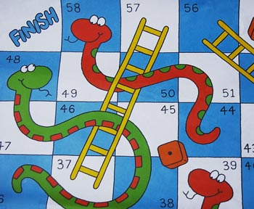
- Count in English.
- Answer in full sentences (ganze Sätze).

2. Say what you are called, how old you are and where you are from.
4. What are your favorite subjects at school?
5. Name two colors your teacher is wearing today.
7. Say something about your pet or your friend’s pet.
9. What is thirty-eight plus twelve?
10. Add together all the ages of the people playing this game. What’s the answer?
12. What do you like doing at the weekend?
13. Name three things that are in your school bag.
14. What is your favorite animal? Do you like snakes?
15. Name three things that are in this classroom.
16. How do you feel when you don’t sleep?
17. Where can you wash your hands in the classroom?
19. What do you say to your teacher when you are late for class?
21. What do you ask the teacher if you are hot?
23. Say where the bins are in your classroom.
25. How do you feel when you see a monster?
27. Name two colors you are wearing today.
29. Name some of your hobbies.
30. Name three things you don’t like.
32. Who sits next to you, behind you and in front of you in class?
33. When is your birthday?
35. When you win a game how do you feel?

