Tasksheet 11: Finding your way

Whole Class: “Follow me through Graz”

Skills Organisation | Workshop Tasks | Material |  | checked
vocab. | In the town: Do the tasks on WS 1 and write the new words on cards.  City Center and Plan of a School: Label (beschriften) all the buildings and the rooms of the school.  Don’t get lost: Put T (true), F (false), or NEE (kann man nicht genau sagen, not enough evidence) next to the sentences of the exercise.  Listening: How do you get to your friend’s house. Follow the way on the map  The Supermarket: Write the names of the foods in the correct places.  Furnish the Kitchen: Draw in the furniture.  Pairwork: Work with a partner. One of you has sheet 5A, the other one has 5 B. Find your way around town.  Mark Hill’s street: Put the sentences in the correct order.  Where do they live? WS 6  Partner Crossword: Work with a partner. Use 7 A or B  Complete the crossword. Do not show it to your partner.  Practice Sheet: In Town: Do the tasks on WS 8  Bath Carnival Procession: Work with a partner and plan a carnival route through bath. Then get together with another pair and tell them what route you have planned. Ask your partners to draw in your proposed (vorgeschlagene) route. Then listen to your partners’ route and mark it in your plan.  In The Zoo: Work with a partner and find all the animals in the zoo. Use WS 10 a or b  Your neighborhood: draw a map of your neighborhood on an A4 sheet and label the places. Use this map for the chatroom and for the EyeJot activities below:  Chatroom: Describe your house and your neighborhood to Ms Bauer and ask her to describe her family’s house and neighborhood in Scottland to you. Take notes and write a short text about it (1 A5 page at least). Show your text to a teacher or co-teacher and ask them to correct it. | WS 1  WS 2  WS 3  WS 3  WS 4  WS 4  5a or 5b  WS 6  7 a or b  WS 8  WS 9  10 a or b  A4 sheet and color pencils  your map
This week's homework:
EyeJot (my neighborhood): EyeJot works like mailVu, but even better.
Use the map of your neighborhood and record a 2-3 minute video. Describe your neighborhood in as much detail as possible and save your link on moodle. Do this task very carefully – we might show it to the Greek students in Patras.

EyeJot (my room): Do the same for your room. Make a nice drawing, label all the furniture and then record a 2-3 minute video for the Greek students.

Vocabulary: Write all the new words and phrases in this workshop on vocab. cards and study them well.
Write sentences: Use this week’s vocabulary list (WS 7 and the words on WS 10 and write good sentences on a page.

Finish your workshop tasks and clean up your folder.

Reading is fun
- Choose a nice English book from our box or from the library. Take a picture book or a more difficult book – anything that looks interesting to you.
- Read your book. Enjoy it in a quiet place.
- Write a short comment about your book into your new READING DIARY. Use the “tips for my first reading diary” for ideas.

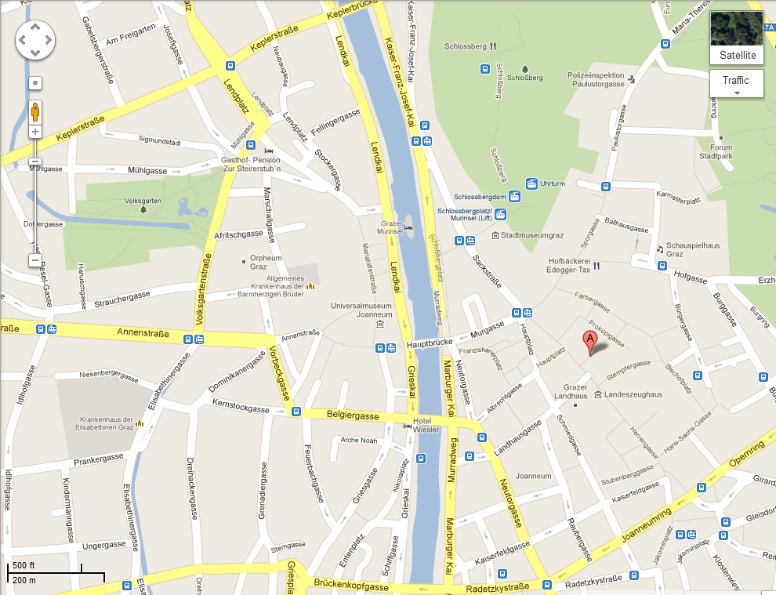
How do you get to your friend’s house? Listen and draw follow the way on the map.

