

Our SECOND Workshop
Class Work
Tasks / Activities |  | Organisation | Materials
 | Forms of to be: am, is or are? Fill in the correct answers. |  | I E 10 abcd  I E 10 efgh
 | 3rd person s: |  | I E Gr 2a
 | Revision tasks: Do the tasks in the book | Whole class / individual | Students’ Book,  p. 36/37
 | MY FRIENDS AND I: Videos  - What we have in common. Write sentences about your friends and yourself. | whole class / individual work | I E Gr 2a  I E 12 & interview notes
 | - Writing about people: Write texts about the three students, using the information given. | individual work | I E 13
 | - Partner dictation: Choose one dictation card and dictate it to your partner. Then he/she dictates one card to you. Exchange the cards and check your spelling. | pairs | dictation cards, paper
 | Song, the monster | 1-2 | I E 14
 | 3rd person –s: Fill in the correct forms. | 1-2 | I E 15
 | Days of the week: Do Students’ Book p 32/ex 12.  Write the days of the week on vocab cards. Study! | 1-2 | Students’ Book 32/12; voc box
 | Spot the difference! Sind die Bilder gleich oder unterschiedlich? Lies die Anleitung genau! | groups of 4 | card game: Location
 | Mixed exercises and revision:
 | Chatroom with Ms. Bauer or Mr Wardell |  | Interviews/MeBook
 | Feelings: How are the smileys feeling? | 1-2 | I E 10d
 | The Box of Colours: Fill in the missing words. | 1-2 | I E 16 and box
 | A or an? Fill in the correct answers. | individuals/pairs | I E 16
 | Counting practice: choose 10 numbers from the counting chart and dictate them to your partner. | pairs | I E 17
 | Sea Battle (Schiffe versenken) Speak English only!! | pairs | I E 17a
 | Plurals of nouns |  | I E 18
 | Choose 2 games and play them in groups: | group work | games, ask your teacher
 | - Snakes and Ladders: Answer the questions! | groups of 3-4 | board, dice, counters
 | - Numbers dictation: dictate and draw | pairs | sheet A&B
 | - Feelings memory | pairs | cards

 | Self Assessment: Answer the questions in writing. | individual work | Task sheet

Homework
Tasks / Activities |  | Deadline | Materials
 | Do the exercises on WS I E 9 (on the worksheet/ in your HW book). | Thu, 08/11 | I E 9, on a sheet
 | Study your vocabulary cards and write new cards for the days of the week and the parts of your body. | Mo, 12/11 | Vocab cards
 | My friend: Write a nice text about your friend in your ME-book. Use your interview notes. | Thu, 08/11 | your interviews, MEbook

Tasks for English Native Speakers
1. | Mood Swings. Do the reading and writing tasks. | individual/pair work | Worksheets, ask your teacher
1. | Charles. Do the reading and writing tasks. | individual/pair work | Worksheets, ask your teacher

Optional Tasks
1. | Go back and do workbook exercises of the last units we haven’t done yet. | individual/pair work | Workbook
2. | Play some of the language games. | pair/group work | Ask your teacher

Self-Assessment
Wenn du mit allen Übungen und Spielen fertig bist, überlege wie gut dir die Arbeit gelungen ist.
 | Hast du rasch und gerne gearbeitet?
 | Hast du dich leicht ablenken lassen?
 | Wurdest du gestört? Wodurch? | 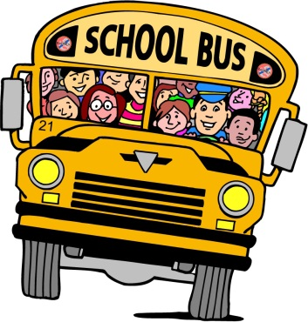
 | Möchtest du sonst noch etwas zu diesem Workshop sagen? | 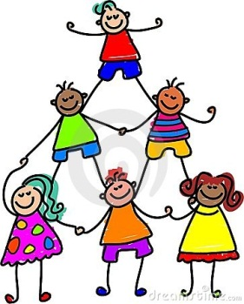
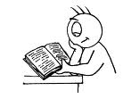

Writing about People

Write about the children on this page. Look at the example carefully first.


Robert is from Graz.
He likes sport and playing computer games.
He doesn’t like afternoon school.
He’s got a sister but he hasn’t got a brother.
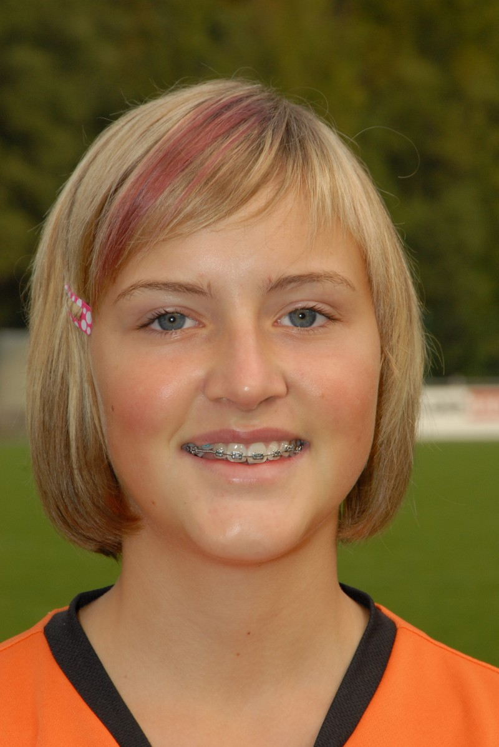




Robert
Graz
- sport
playing computer
games
afternoon school
1s. / - br.

Uli
Innsbruck
- skiing
reading
watching TV
cleaning her room
2 br.
3 cats

Diana
Paris
- dancing
music
football
skiing
2 s./ 1br.

Jim
Glasgow
- school
cinema (Kino)
washing father’s car
doing his homework
3 s.
1 dog

Fill in the right preposition.

- The boy is under the desk.

- The children are _______________ the cupboard.

- The school bag is _______________ the desk.

- Your book is _______________ the chairs.

- They are _______________ the window.

- Tom is _______________ the girls.

How are the smileys feeling? Write down sentences.

 Smiley 1 is happy.
 Smiley 2 __________
 ________________________
________________________
 _____________________
 ________________
 _____________________
 ________________________
 ______________________
________________________

The Box of Colours Look at the things in the box, fill in the missing words.
- There is a _____________________ pig in the box.
- There are ___________ dinosaurs in the box. One is _____________________ and _____________________. The other one is _____________________ and _____________________ and has _____________________ eyes.
- There is a dog in the box. It is _________________ and has ____________________ spots (Punkte).
- There is a robot in the box. It is _____________ and _______________.
- There is a gorilla in the box. It is ______________ and has a ____________ face.
- There is a clown in the box. He is smiling and is driving a ____________ tractor.
- A monster is driving a car. The car is ________________ and the monster is ________________.
- There is also a ___________ ship with _____________ stripes in the box. Its captain is Asterix.

a or an?
an apple / a bookshelf / a desk / a white desk / a curtain /an orange curtain / an ice cream / a big room / a dog / a beautiful poster / an English book
My rule:

Now fill in a or an:
- He needs ______ new sweater.
- Britta thinks yellow is ______ beautiful colour.
- Can I have ______ exercise book and ______ pencil case please?
- “Music, music!” is ______ good radio show.
- The zebra is ______ nice animal.
- Paul has got ______ old German teacher. She is very nice.
- Do you think it is ______ African elephant?
- Monday is ______ boring day.
- I think this is______ easy text.
- Lucy has _______ dog.
- Let's sing _______ song.
- Is Alfred ______ German or ______ English name?
- Peter has _______ aunt (Tante) in Berlin.
- We listen to _______ English CD.
- She has _______ exercise book in her school bag.
- They finished _______ unit

Fill the gaps with the correct form of the verb.
Attention:
he/she/it - das -s kommt mit!
I like..... he/she likes
Fülle die Lücken mit der richtigen Verbform:

- Tony __________________ (live/lives) in London.
- He _________________ (like/likes) swimming.
- He and his sister _________ (go/goes) to Westend High School.
- Every day Tony and Anne _________________ (take/takes) the bus to school.
- Tony ________________ (see/sees) his best friend Steven after school.
- On Wednesday he and Steven ________________ (play/plays) football.
- Anne _______________ (like/likes) school but she _____________ (hate/hates) her school uniform.
- Tony _______________ (think/thinks) it is all right.
- Anne _____________________ (love/loves) hip hop.
- Anne and Tony ____________ (have/has) a lot of homework.
- On the weekend they ______________ (watch/watches) TV or ____________ (play/plays) sing star.
- They _________________ (laugh/laughs) a lot.
- Tony ___________ (clean/cleans) his room on the weekend. Anne _________ (bake/bakes) muffins.
- Sometimes they ________________ (listen/listens) to their favorite music.
- They have a cute little puppy, Rango. It _____________ (sleep/sleeps) in a basket (Korb).
- Tony’s mother ________________ (feed/feeds) Rango.


Complete the sentences using verbs from the box. For the last sentence put the verb into the negative ( Verneinung: don’t, doesn’t).

A tiger is orange and black.
eat, run, sleep, to be
It __________ very fast.


It __________ a lot.
It doesn’t like pizza.
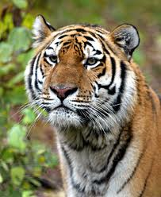
Marc is two years old.
play, like, read, to be
He __________ warm milk.
He __________ a lot with his sister.
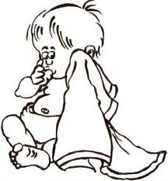
He _______ ______ books.
Birds like to fly.
like, eat, have, like
They __________ insects.
They _______ wings (Flügel).
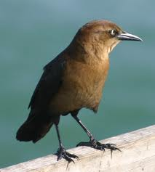
They _______ ______ cats.

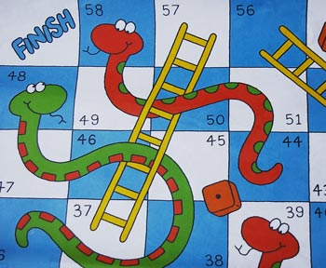
Snakes and Ladders
- Go up the ladders and down the snakes.
- Count in English.
- Answer in full sentences (ganze Sätze).

2. Say what you are called, how old you are and where you are from.
4. What are your favorite subjects at school?
5. Name two colors your teacher is wearing today.
7. Say something about your pet or your friend’s pet.
9. What is thirty-eight plus twelve?
10. Add together all the ages of the people playing this game. What’s the answer?
12. What do you like doing at the weekend?
13. Name three things that are in your school bag.
14. What is your favorite animal? Do you like snakes?
15. Name three things that are in this classroom.
16. How do you feel when you don’t sleep?
17. Where can you wash your hands in the classroom?
19. What do you say to your teacher when you are late for class?
21. What do you ask the teacher if you are hot?
23. Say where the bins are in your classroom.
25. How do you feel when you see a monster?
27. Name two colors you are wearing today.
29. Name some of your hobbies.
30. Name three things you don’t like.
32. Who sits next to you, behind you and in front of you in class?
33. When is your birthday?
35. When you win a game how do you feel?

SPOT THE DIFFERENCE
Instructions /Spielanleitung:

Jeder hat eine Karte. Achtung, sie ist streng geheim! Jedes Kind sagt einen Satz über das Bild,

z.B.: There is a man between the window and the door.

Dann ist der nächste dran und sagt einen Satz. Findet heraus, ob alle Bilder ganz gleich sind, oder ob es Unterschiede gibt! Schreibt dann eine kurze Antwort so auf:

The differences we found:
- There is a man in front of… in picture A.

SPOT THE DIFFERENCE
Instructions /Spielanleitung:

Jeder hat eine Karte. Achtung, sie ist streng geheim! Jedes Kind sagt einen Satz über das Bild,

z.B.: There is a man between the window and the door.

Dann ist der nächste dran und sagt einen Satz. Findet heraus, ob alle Bilder ganz gleich sind, oder ob es Unterschiede gibt! Schreibt dann eine kurze Antwort so auf:

The differences we found:
- There is a man in front of … in picture A.

SPOT THE DIFFERENCE
Instructions /Spielanleitung:

Jeder hat eine Karte. Achtung, sie ist streng geheim! Jedes Kind sagt einen Satz über das Bild,

z.B.: There is a man between the window and the door.

Dann ist der nächste dran und sagt einen Satz. Findet heraus, ob alle Bilder ganz gleich sind, oder ob es Unterschiede gibt! Schreibt dann eine kurze Antwort so auf:

The differences we found:
- There is a man in front of … in picture A.

SPOT THE DIFFERENCE
Instructions /Spielanleitung:

Jeder hat eine Karte. . Achtung, sie ist streng geheim! Jedes Kind sagt einen Satz über das Bild,

z.B.: There is a man between the window and the door.

Dann ist der nächste dran und sagt einen Satz. Findet heraus, ob alle Bilder ganz gleich sind, oder ob es Unterschiede gibt! Schreibt dann eine kurze Antwort so auf:

The differences we found:
- There is a man in front of… in picture A.

