Tasksheet 4
 | Tasks | Materials | Done
Whole class | What’s the time? | More student’s book  p 76-77
Whole class | Words and Phrases for Everyday School Life | p. 3
Whole class | Everyday School Life: Game | Cards and stop watch
 | 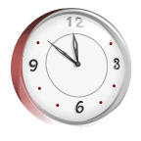  How are they feeling? | p. 5
Workshop
1-2 | Time Bingo | p. 2
2 | Take two blue cards (A and B) from the teacher’s desk and complete the times. Do not show your card to your partner. | blue cards A and B
1-2 | Possessives: Do the exercises on p.7  Then take a colored card from the teacher’s desk and make your own riddle for your friends. | p. 7 | 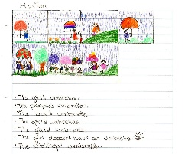
Interviews | Interviews: Do you like? | p. 4
1-2 | “Am” or “Is” or “Are”? | p. 5
1-2 | Clocks: It’s logical! | p. 6
1-2 | Describe the classroom in the picture | p. 6

Games
3-4 | Pairs: What’s the time? | cardgame
2 | Dominoes: The time | cardgame
3-4 | Boardgame: Months of the Year | board,dice and counters
2 | Chatroom: Have a little chat with your teacher or co-teacher or read a book with her.  Take your vocab-box along for this activity. | Books, picture cards (STARE)
Homework: | Finish the workshop tasks if you didn’t finish them in class.
 | Write the time phrases on vocab-cards (use p. 2) Write the new everyday-classroom phrases (p. 3) on vocab-cards. | Textbook,  voc.box
 | Do all the exercises on pages 102- 106 in your More workbook | More workbook
 | Practice the new vocabulary (walk and talk, write and check) | vocab-box and vocab-practice book

Self-assessment | Wenn du mit allen Übungen fertig bist, überleg wie gut dir die Arbeit gelungen ist. | 1 | 2 | 3 | 4 | 5 | 6 | 7 | 8 | 9 | 10
 | Have you worked a lot with your vocabulary box?
 | Have you done all your homework?
 | Have you concentrated in class and worked hard?
 | Have you been very quiet (did you whisper/flüstern and sneak/schleichen) during workshop time?
 | Möchtest du sonst noch etwas zu diesem workshop sagen?

Count: How many clocks and how many watches can you find on this page?
……. clocks and ………..watches.

Telling the time: | 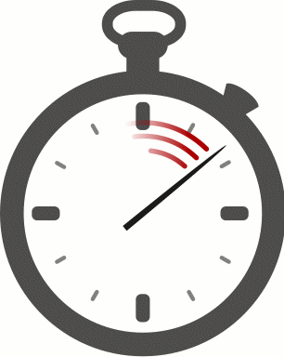  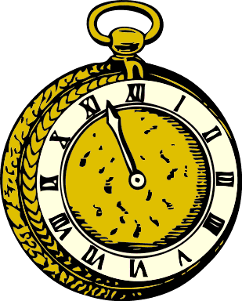
It’s one o’clock.
It’s twelve o’clock.
It’s midnight.
It’s five (minutes) past three.
It’s ten past four.
It’s quarter past five.
It’s half past six.
It’s quarter to seven.
It’s ten to seven.
It’s five to twelve.

Time Bingo
Draw in nine different times. Only draw five minute steps.
Then listen to your teacher and tick off the times that your teacher has announced.
Bingo: If you have ticked off three clocks in a row, shout out “BINGO”. You are the winner!

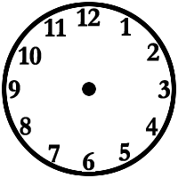

Write all these phrases on vocab cards and practice them.
- Walk and Talk
- Write and Check

Words and Phrases for Everyday School Life.

Can I  May I | close  open  switch on  switch off  have  go and get  collect  hand out  ask  speak to  say it  go to  borrow  clean  pack up  put down/up |   worksheets      office      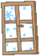    Mrs. Pölzleitner  in German      homework |  |  | please?
I | need  would like | dice  game 16    holes in this worksheet |  |   counters    some glue    a pair of scissors
I am sorry | I didn’t hear you.    I don’t understand.  I’m late.  I’ve forgotten my book.  I’ve left it at home. |  |  | Pardon?  Could you repeat that, please?  Could you explain that, please?
Match the English sentences with the German translations. Draw lines.
It’s my turn.  Whose turn is it?  I’m ready.  I’ve finished.  Who are the monitors?  The bell has rung.  Where is Mrs. Pölzleitner’s desk?  Is it the long break?  What’s today’s date?  I don’t know what to do.  How do you spell it?  What does this word mean?  How do you say “Kreide” in English? |  |  | Ich bin bereit (etwas Neues zu tun).  Ich bin an der Reihe.  Es hat geläutet.  Wo ist der Platz von Mrs. Pölzleitner?  Wer sind die Klassenordner?  Ich bin fertig (habe etwas fertiggemacht.)  Wer ist an der Reihe?  Was heißt „Kreide“ auf Englisch?  Der wievielte ist heute?  Ist jetzt die lange Pause?  Wie schreibt man das?  Was bedeutet dieses Wort?  Ich weiß nicht was ich machen muss.

Interview: Do you like?

I like…. He likes… We like… She likes… You like…
I don’t like… You don’t like… He doesn’t like... She doesn’t like.

Interview your classmates to find out what they like and don’t like.
What about you? Which of these things do you like?

Do you like… | my friend | Mrs. Pö | Mrs. Brown | my mom | ?your idea? | me
running
rock music
big dogs
Graz
peanut butter
Schwarzenegger
skiing

rats
your own idea:

Now write 10 sentences about the interview on a worksheet.
For example:
My friend Max likes …
I don’t like…
My mom doesn’t like..

How are the smileys feeling? Write down sentences.

 Smiley 1 is happy. | 
 | 
 | 
 | 
 | 

Am // Is // Are
I am he – she – it is you – we – they are

Write 10 true sentences using am – is – and are. Write about your friends, family and pets. Use the new feelings words in your sentences.

Clocks  It’s logical! Work out what time it is on the 4th clock.  The first one has been done for you: A: It’s twelve o’clock. | 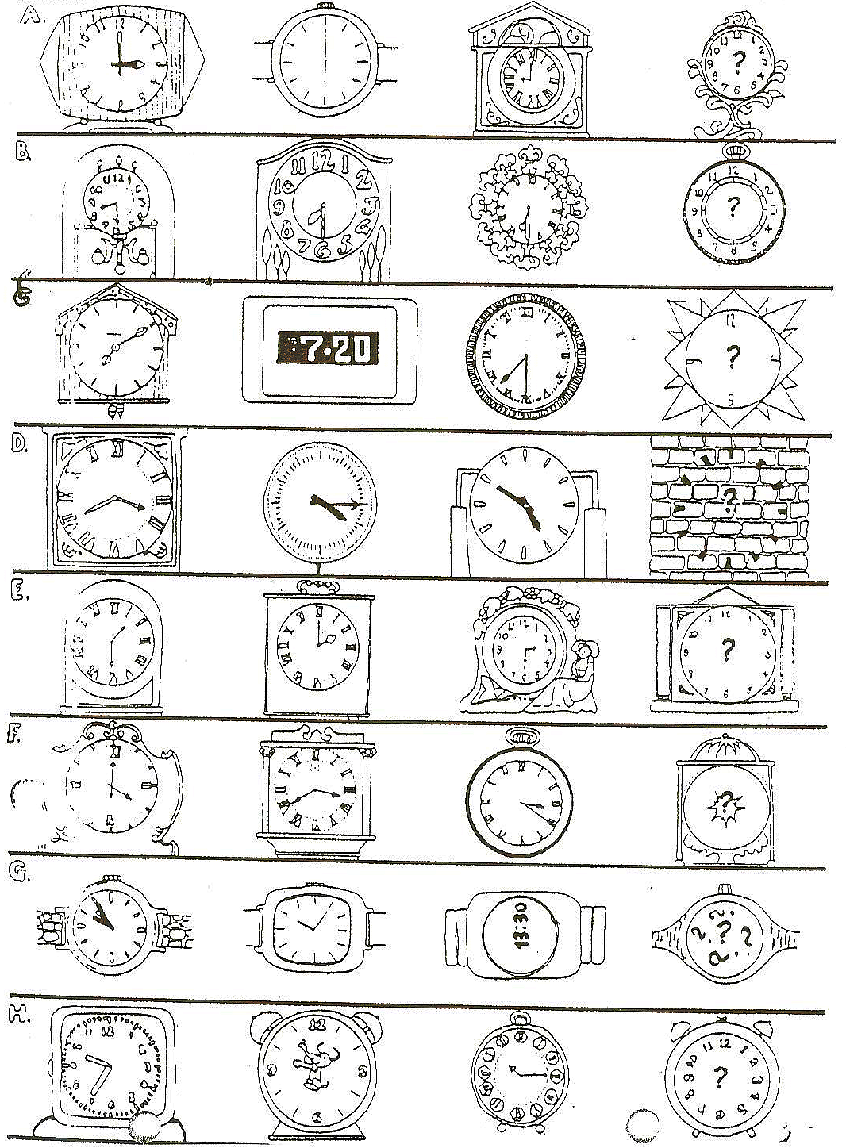

Comparing classrooms:  Look at this picture of a classroom and describe it in as much detail as possible.  Then compare this classroom to your own classroom and what you like about it and what you don’t like about it.  Do you like it more or less than your own classroom? Write your text on a worksheet. | 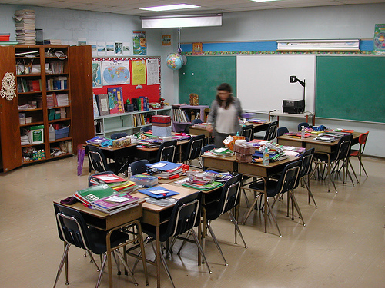 | These phrases will help you:  - it is smaller//bigger than  - we have more// less space/ room/ desks/ shelves/ children than…  - it is older// newer // more modern… than  - I like my classroom better/less than the classroom in the picture  - I prefer…  - I would like to have a …

Teacher’s materials:

Partner Dictation A and B: copy on blue paper, 2 pages on one.

Classroom Phrases: chain game (cards)
Pairs: What’s the time?
Dominoes: time
Boardgame: Months of the year

Do the smileys with the whole class (projector)

Smiley 1 is happy.

Partner Dictation: Time
Student B: Dictate these times to your partner. He/she has to draw them into the clock-faces.
1 | 2 | 1. It’s five to eleven.  2. It’s a quarter past one.  3. It’s twenty past four.  4. It’s quarter to nine.  5. It’s half past eight.  Now add your own:  6.  7.  8.
3 | 4
5 | 6
7 | 8

Partner Dictation: Time
Student A: Dictate these times to your partner. He/she has to draw them into the clock-faces.
1 | 2 | 1. It’s half past six.  2. It’s a quarter to eight.  3. It’s ten past five.  4. It’s twenty to ten.  5. It’s five to seven.  Now add your own:  6.  7.  8.
3 | 4
5 | 6
7 | 8

