1. Read the text and color the picture of the classroom
Sally’s classroom is very colorful. The walls are pink and the floor is green.
The door in Sally’s classroom is blue. They have a dark green blackboard. The desks are gray but they have red legs. The chairs are also red.
The shelves are blue and the curtains are yellow.
There are so many colors. Some children like the classroom. Others say it’s so colorful that they cannot concentrate.

What do you think? Do you like Sally’s colorful classroom?

Yes, I think it is cool. 

Yes, it is ok. 

No, I do not like it. 

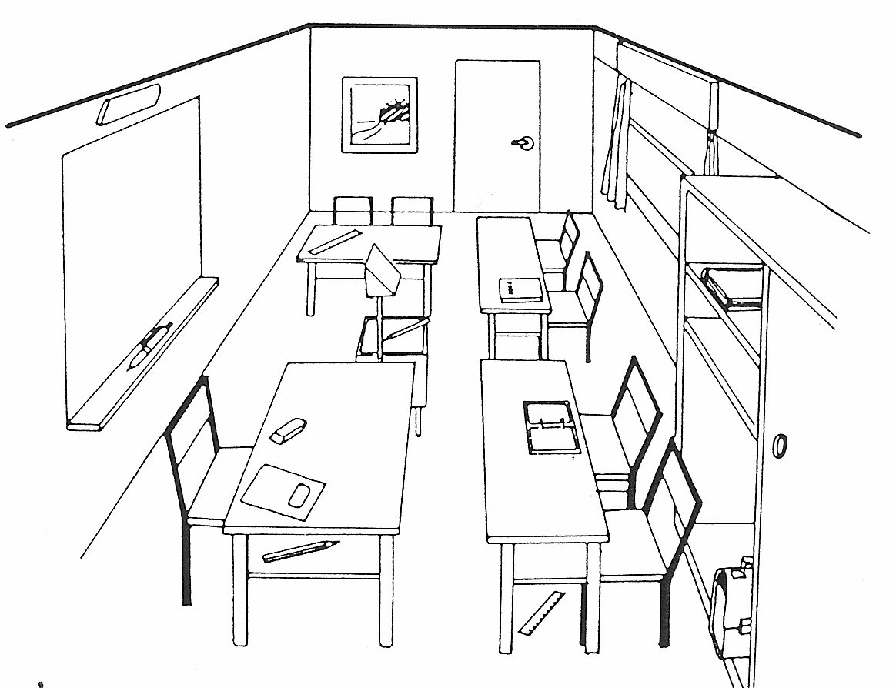

- Fill in the missing words from the box
chairs desks curtains like cannot
legs shelves
walls floor door blackboard

Sally’s classroom is very colorful. The ____________ are pink and the _________ is green. The ____________ in Sally’s classroom is blue. They have a dark green ______________. The ________________ are gray but they have red _________. The _____________ are also red.
The _______________are blue and the _______________ are yellow.
There are so many colors. Some children ______________ the classroom. Others say it’s so colorful that they ______________ concentrate.

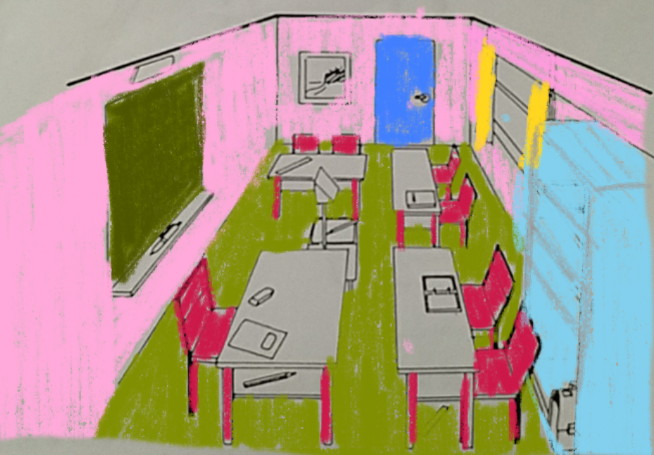
A colorful classroom

- Work with a partner.

- Color the picture of the classroom. Do NOT show your picture to your partner.

- Then find out the differences.

Ask your partner about his/her classroom:

Your partner’s classroom
What color is your blackboard?
What color are your walls?
What color are your chairs?
What color is your floor?
What color are the shelves?
What color are the chairs?
What color is the door?
What color are the desks?
What color are the curtains?

Our classroom: Running dictation
Our classroom is nice and big. We have very large windows with colorful curtains. The curtains are red, yellow, blue and green.
Our walls are white and we have a big green blackboard.
Our desks are gray and our chairs are brown.
On the teacher’s desk there is a computer and we have a projector so we can see the pictures on the front wall.
We have a yellow floor.
On the back wall we have two big gray cupboards and we have brown shelves for our books and folders.
I really like our classroom.

Our Classroom
What’s wrong? Correct the text and write the corrected text on a practice sheet.
Was stimmt nicht? Stelle den Text richtig und schreib den richtigen Text auf dein Arbeitsblatt. (Practice Sheet)

My classroom is big and colorful. It has very small windows. Our curtains are white. The desks are brown and the chairs are gray. There are two boards, they are black. We have pink walls and a blue floor. Our washbasin is in the back, it is white. We have lots of bookshelves for our folders and shoes. On the teacher’s desk we have a CD player so we can listen to music.
In the back of our classroom we have three large, blue cupboards. We also have a nice, big plant and some posters on the pinboard.
My dream classroom for bilingual students

We all spend a lot of time in our classrooms. The atmosphere of the classroom plays an important role in your learning.
What would your ideal classroom look like?
Describe it in as much detail as possible.

