Possession
Work with a parter. Look at the examples: Wie wird im Englischen Besitz ausgedrückt? Was fällt dir bei der Schreibweise auf?
Teile die Sätze in zwei Gruppen. Lege zuerst die Satz und Bildkarten auf, dann übertrage deine Lösung in das Arbeitsblatt und finde deine eigene Regel.
Peter’s camera is brand new.
Thomas‘ pencil is very long.
My parents‘ bedroom is very big.
John’s pumpkin is huge.
Sue’s desk is clean.
The rabbit’s ears are long.
My friend’s house is very small.
My cousins’ dog is a great friend.
My cousin’s dog is a great friend.
My parents’ car is very big.
My hamsters’ cage (Käfig) is very big.
My hamster’s cage is always clean.(sauber)
My grandmother’s cakes are the best.
Group 1:

Group 2:

My Rule:
Fill in:
my, your, his, her, Peter's, our, mine, yours, ours

........... name is Mary. What's ................ name?

........... name is Tom. He's from America.

........... name is Ann. She's from England.

Do you like ................. new school, Peter and Mary?

Yes, we like ................ new school very much.

Is this your homework book, Tom? No, it isn't .........., it's...............

Thomas, is this your pencil case? No, .............. is here, under........desk.

Complete the text

Look, this is ....... new schoolbag. It's just like .............
Sue's bag is also new, but ......... is not as nice as ............
Is that ruler on the floor .............? Yes, thank you, it's ...... ruler.
Where is ............... ruler?
Look, this is ............. new house. We like it very much.
Do you have a picture of .......... ? Here you are, that's ............. house.
Do you like it?

Where are the school-things? Write sentences.
Example: The pencil is on the desk.

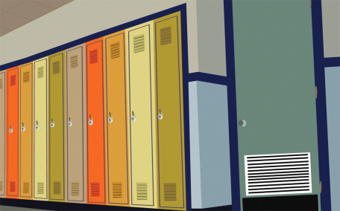


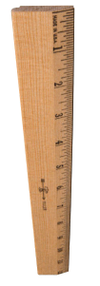

Now find out what color the school-things are.
Write the sentences on a worksheet. Example: Peter’s pen is black.
Peter | 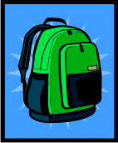      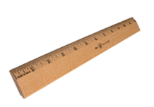     | yellow
Mary |  | orange
Susan |  | red
Nick |  | purple
Andrew |  | pink
Fred |  | blue
Lilly |  | green
Lisa |  | white

Where are the things?

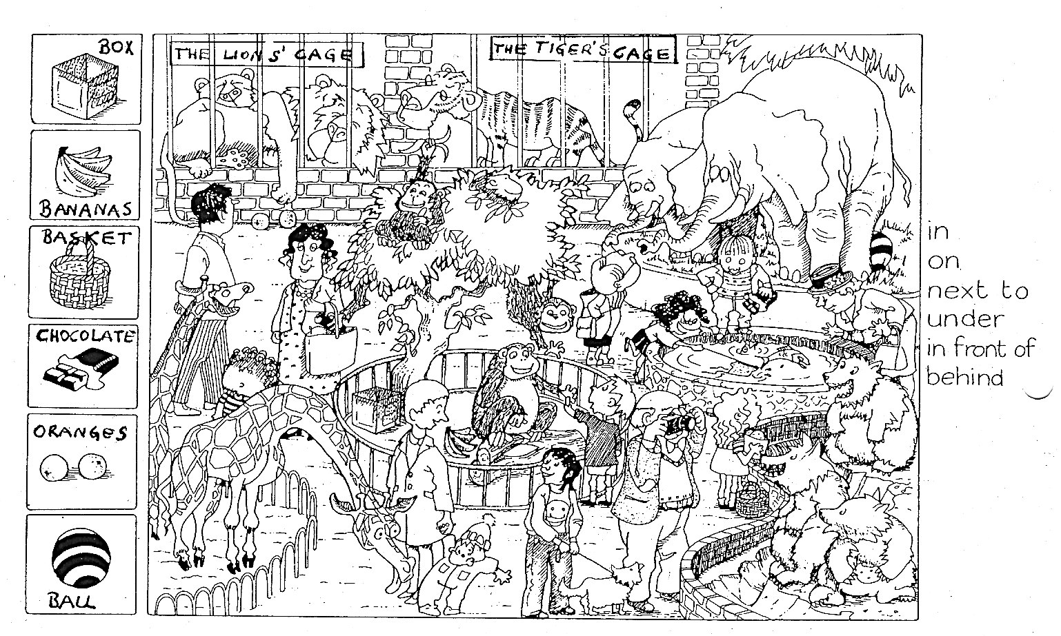
Write your answers on a worksheet.

Funny Figures:
Look at the pictures and answer the questions. Write them on a worksheet.
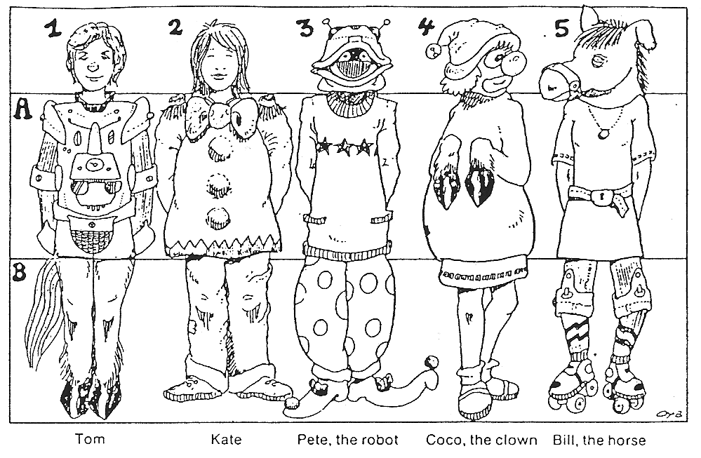
1. Whose head is it? It’s Tom’s head.
Whose body is it? It’s Pete’s body.
Whose legs are they? They are Bill’s legs and tail.
2. It’s…………………………head. It’s ………………………… body and …………………….legs.

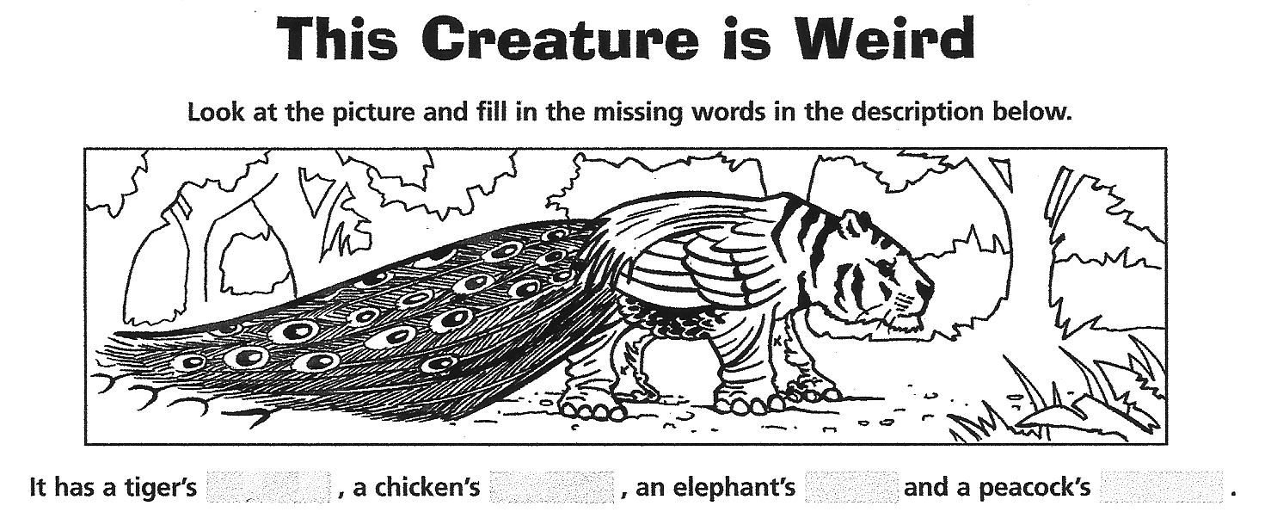

2. Now work with a partner. Use the picture cards for “This Creature is Weird”. You will find them on your teacher’s desk.
Beschreibt abwechselnd die “funny creatures”. Dein Partner/deine Partnerin legt die passenden Kärtchen auf den Tisch. Schreibt beide die Antworten in die offenen Zeilen.


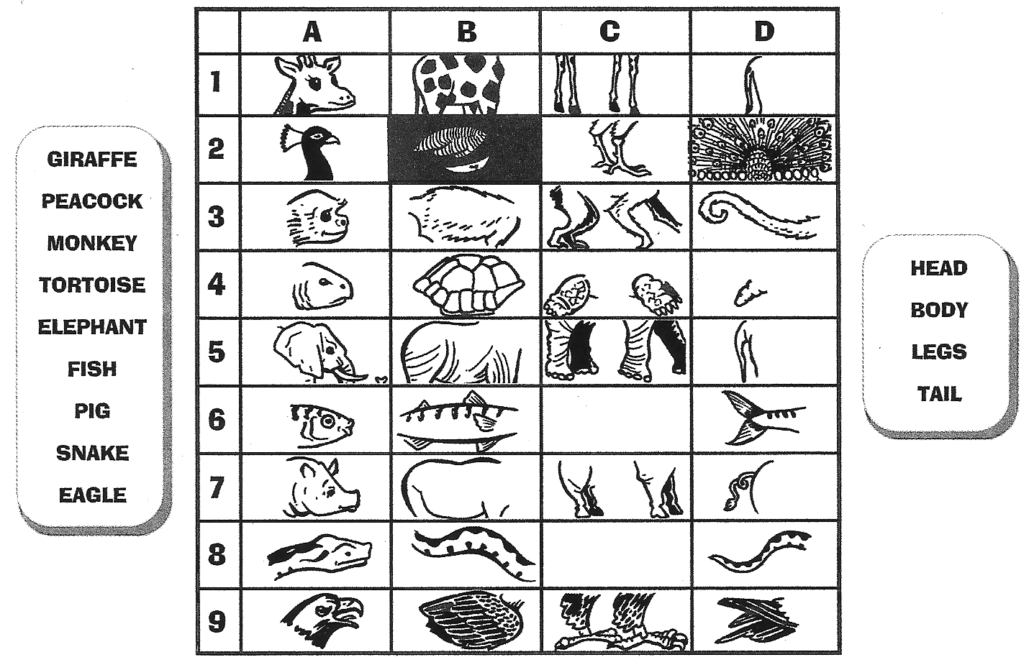
adapted from: Timesaver Grammar Activities, Mary Glasgow magazines, An Imprint of Scholastic Inc.p. 53

Homework: More weird creatures

1. Take a white sheet and draw a funny mixed up creature. Be creative and draw carefully.
Give your creature a name. For example: a Mouselefgirabird. Can you imagine what this creature might look like?
2. On a separate sheet describe your creature in detail. Write exactly what it looks like. Does it have wings, feathers, claws, a beak… Use all the words you have learned.
3. Write your name on the back of each sheet, not in the front! We will use the sheets for a game in class.

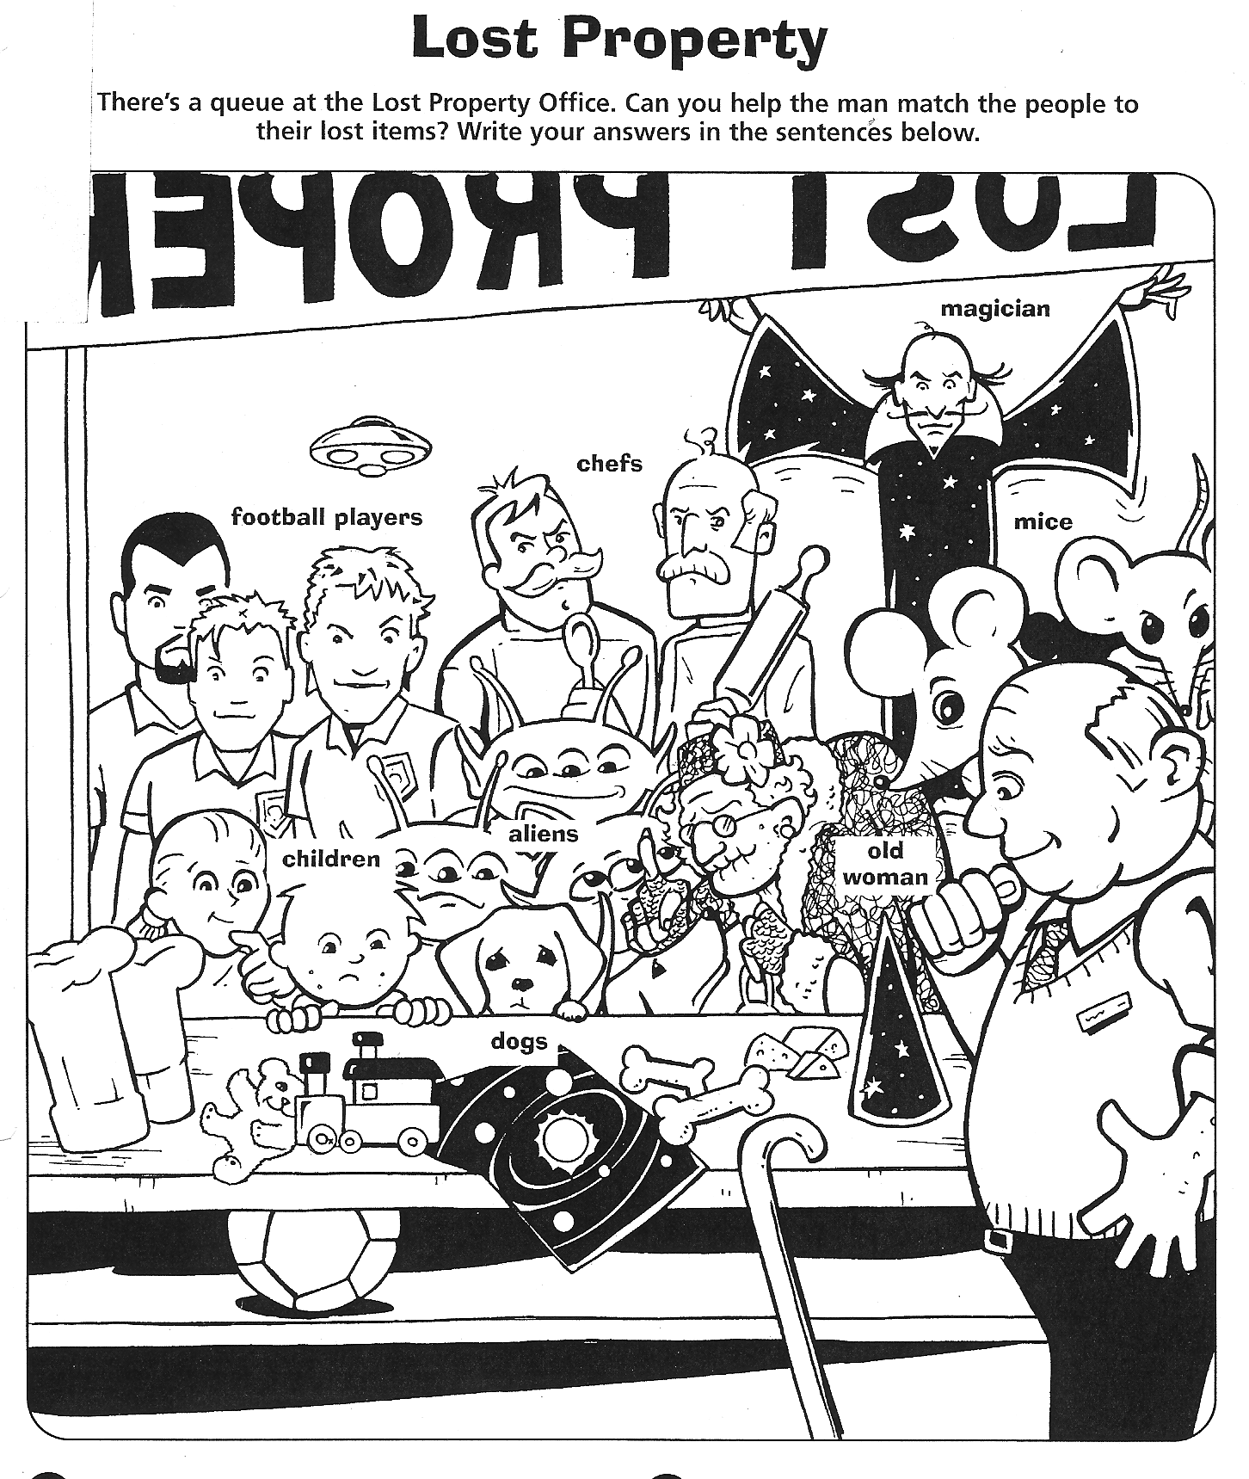

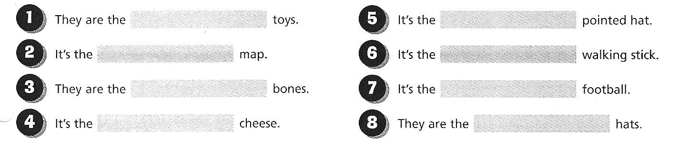
Source: Timesaver Grammar Activities, Mary Glasgow magazines, An Imprint of Scholastic Inc.p. 54
Solutions and TEACHER’s Materials:

Fill in:
my, your, his, her, Peter's, our, mine, yours, ours

My name is Mary. What's your name?

His name is Tom. He's from America.

Her name is Ann. She's from England.

Do you like our new school, Peter and Mary?

Yes, we like our new school very much.

Is this your homework book, Tom? No, it isn't mine, it's Peter’s

Thomas, is this your pencil case? No, mine is here, under my desk.

Complete the text

Look, this is my new schoolbag. It's just like mine.
Sue's bag is also new, but hers is not as nice as mine.
Is that ruler on the floor yours ? Yes, thank you, it's my ruler.
Where is your ruler?
Look, this is our new house. We like it very much.
Do you have a picture of yours ? Here you are, that's our house.
Do you like it?
Peter’s camera is brand new.
Thomas‘ pencil is very long.
My parents‘ bedroom is very big.
John’s pumpkin is huge.
Sue’s desk is clean.
The rabbit’s ears are long.
My friend’s house is very small.
My cousins’ dog is a great friend.
My cousin’s dog is a great friend.
My parents’ car is very big.
My hamsters’ cage (Käfig) is very big.
My hamster’s cage is always clean.(sauber)
My grandmother’s cakes are the best.
Peter’s camera is brand new.
John’s pumpkin is huge.
Sue’s desk is clean.
The rabbit’s ears are long.
My friend’s house is very small.
My cousin’s dog is a great friend.
My hamster’s cage (Käfig) is always clean.
My grandmother’s cakes are the best.
Thomas‘ pencil is very long.
My cousins’ dog is a great friend.
My parents‘ bedroom is very big.
My parents’ car is very big.
My hamsters’ cage is very big.

Peter’s camera is brand new.
John’s pumpkin is huge.
Sue’s desk is clean.
The rabbit’s ears are long.
My friend’s house is very small.
My cousin’s dog is a great friend.
My hamster’s cage (Käfig) is always clean.
My grandmother’s cakes are the best.
Thomas‘ pencil is very long.
My cousins’ dog is a great friend.
My parents‘ bedroom is very big.
My parents’ car is very big.
My hamsters’ cage is very big.

Peter’s camera is brand new.
John’s pumpkin is huge.
Sue’s desk is clean.
The rabbit’s ears are long.
My friend’s house is very small.
My cousin’s dog is a great friend.
My hamster’s cage (Käfig) is always clean.
My grandmother’s cakes are the best.
Thomas‘ pencil is very long.
My cousins’ dog is a great friend.
My parents‘ bedroom is very big.
My parents’ car is very big.
My hamsters’ cage is very big.

 Peter’s camera is brand new.
My hamster’s cage (Käfig) is always clean. 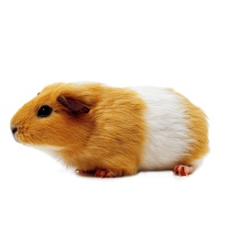

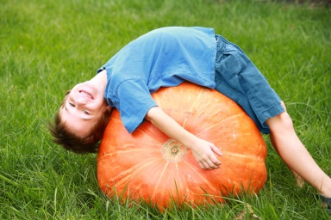John’s pumpkin is huge.

Sue’s desk is clean. 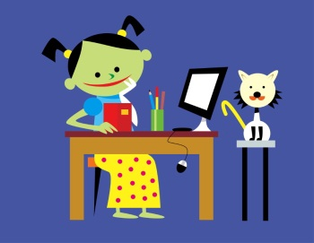
The rabbit’s ears are long.
My friend’s house is very small. 


Thomas‘ pencil is very long.
My grandmother’s cakes are the best.


My cousins’ dog is a great friend.

My cousin’s dog is a great friend.
My parents’ car is very big.
My parents‘ bedroom is very big. 
My hamsters’ cage is very big.dfasd

cut up for game!

