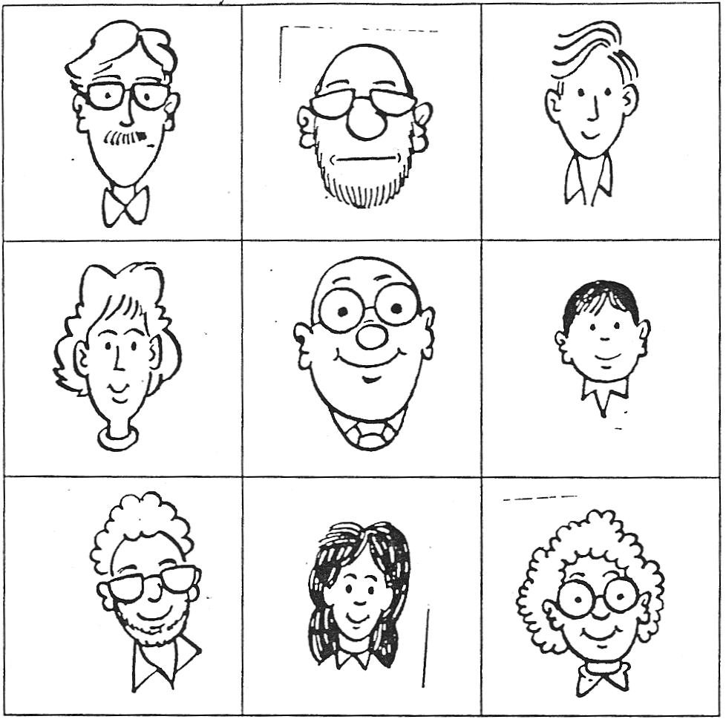
Twins: A
On your sheet there are nine faces. Your partner has almost the same sheet, only one of the faces is different.
Take turns to describe your faces and find the new face.

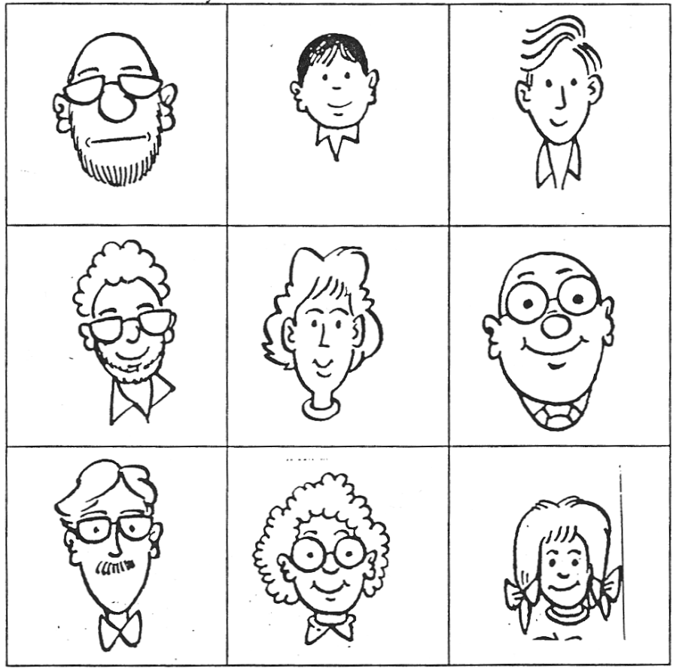
Twins: B
On your sheet there are nine faces. Your partner has almost the same sheet, only one of the faces is different. Take turns to describe your faces and find the new face.

