Who is who? Find the families.

1. Find three students to work with. You must be four players to play this game.
If you are only 3 – one person has two families.

2. Look at your card. Do not show your card to the other players.
The four people are all in your family. Give your family members names:
(Firstnames and a lastname)

3. One player starts: Describe one of your family members and say his/her name.
For example: My family is called Smith. Anna Smith is the mother. She has black, shoulder length hair and she wears glasses.

The other players find that person on the sheet and write the name next to the face and on the matching family card.
4. Then the next player describes one of his/her family members…

Anna Smith
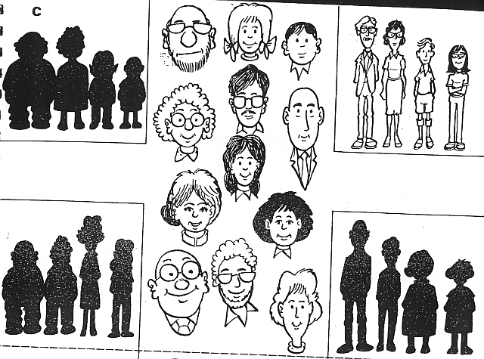
Paul Summer

This game is adapted from: Charles and Jill Hadfield, Elementary Communication Games, Nelson
Buy the book! It has lots of fantastic activities!

