angry | excited
bored | happy
sad | nervous
cold | hungry
hot | tired
sick | thirsty
 | 
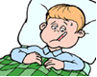 | 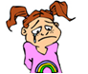
 | 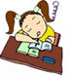
 | 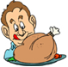
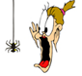 | 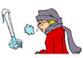
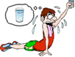 | 
scared | 