A or an?
- He needs ______ new sweater.
Attention:
he/she/it - das -s kommt mit!
I like..... he/she likes
- Britta thinks yellow is ______ beautiful colour.
- Can I have ______ exercise book and ______ pencil case please?
- “Music, music!” is ______ good radio show.
- The zebra is ______ nice animal.
- Paul has got ______ old German teacher. She is very nice.
- Do you think it is ______ African elephant?
- Monday is ______ boring day.
- I think this is______ easy text.
- Lucy has _______ dog.
- Let's sing _______ song.
- Is Alfred ______ German or ______ English name?
- Peter has _______ aunt (Tante) in Berlin.
- We listen to _______ English CD.
- She has _______ exercise book in her school bag.
- They finished _______ unit

Complete the sentences
Fülle die Lücken mit den passenden Verben

meet, play, go, take, hate, think, do, listen, sleep, feed have, watch, play, laugh, live, like clean, bake,
You can use some of these verbs more than once.

- Tony __lives__ in London.
- He _________________ swimming.
- Toni and his sister _________ to Westend High School.
- Every day Tony and Anne _________________ the bus to school.
- Tony ________________ his best friend Steven after school.
- On Wednesday he and Steven ________________ football.
- Anne _______________ school but she _____________ her school uniform.
- Tony _______________ the uniform is all right.
- Anne _____________________ hip hop.
- Anne and Tony ____________ a lot of homework.
- On the weekend they ______________ TV or ____________ sing star.
- They _________________ a lot of fun and ____________ a lot. 
- Tony ___________ his room on the weekend. Anne _________ muffins.
- Sometimes they ________________ to their favorite music.
- They have a cute little puppy, Rango. It _____________ in a basket (Korb).
- Tony’s mother ________________ Rango.

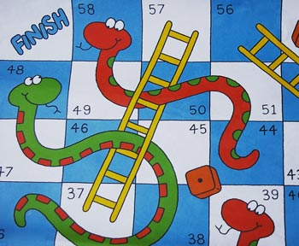
Snakes and Ladders
- Go up the ladders and down the snakes.
- Count in English.
- Answer in full sentences (ganze Sätze).

2. Say what you are called, how old you are and where you are from.
4. What are your favorite subjects at school?
5. Name two colors your teacher is wearing today.
7. Say something about your pet or your friend’s pet.
9. What is thirty-eight plus twelve?
10. Add together all the ages of the people playing this game. What’s the answer?
12. What do you like doing at the weekend?
13. Name three things that are in your school bag.
14. What is your favorite animal? Do you like snakes?
15. Name three things that are in this classroom.
16. How do you feel when you don’t sleep?
17. Where can you wash your hands in the classroom?
19. What do you say to your teacher when you are late for class?
21. What do you ask the teacher if you are hot?
23. Say where the bins are in your classroom.
25. How do you feel when you see a monster?
27. Name two colors you are wearing today.
29. Name some of your hobbies.
30. Name three things you don’t like.
32. Who sits next to you, behind you and in front of you in class?
33. When is your birthday?
35. When you win a game how do you feel?

