Halloween Poems
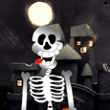
Skeleton Parade

The skeletons are out tonight,
They march about the street
With bony bodies, bony heads
And bony hands and feet.

Bony Bones
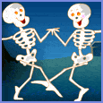
Bony, bony, bony, bones
With nothing in between
Up and down and all around
They march on Halloween

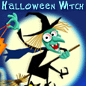
The Witches

It’s Halloween and witches fly
On their broomsticks through the sky
Each is wearing a pointed hat
And each has got a big black cat

