Halloween
What are these things called?
Write their names.
It’s that _______________ time of year again…  It’s Halloween…  The night is _____________ and all is ___________…  Halloween…  Ghosts and _____________, ghouls and _________________  All the _____________ things you like to see…  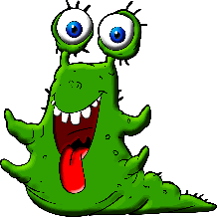  on Halloween…  Skeletons and _____________  Terrifying _____________  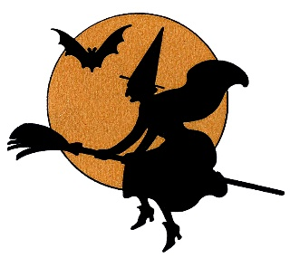  Black cats and big ____________  Zombies and ________________  Trick or Treat  Halloween  Trick or Treat  Halloween  Don’t be scared ‘cause Jack O’ Lantern-  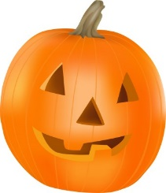  He’s going to chase them all away,  So you can play your _______________  Don’t be scared ‘cause Jack O’Lantern-  He’s going to chase them all away,  If they come _________ again.  Trick or Treat  Time to put your ______________ on  It’s Halloween  See if you can scare someone,  Halloween… | 