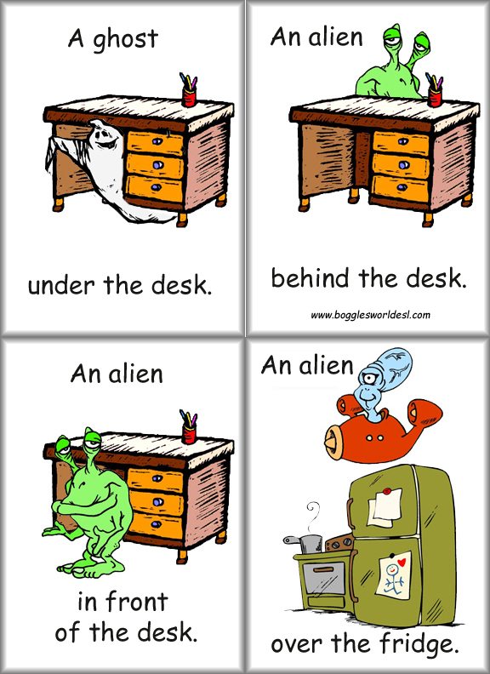
Halloween Workshop:

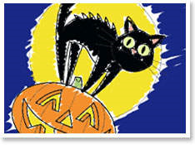

Song: In the Grave Yard...

Games: Play all the games in a small group (3-4)
“The Haunted House” (Halloween pairs)

STARE! Play this game with Ms Burks.

READ a Halloween storybook with one of your teachers and write three new
phrases on your vocab-cards.

Do all the WORKSHOP TASKS in this package carefully

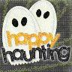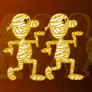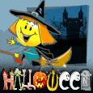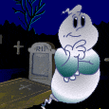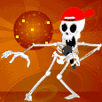

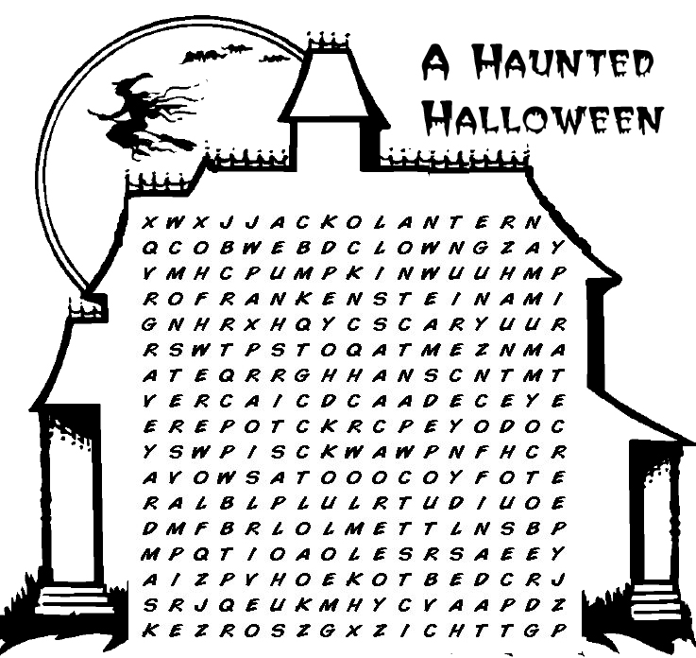
 | bat  black cat  broom  candy clown  cobweb | coffin  costume  creepy  Dracula  Frankenstein  ghost  graveyard | Halloween  happy  haunted house  jack-o'-lantern  mask  monster  mummy | October  party  pillowcase  pirate  pumpkin  scary | skeleton  spooky  trick-or-treat  vampire  werewolf  witch
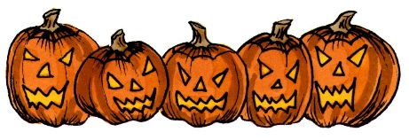

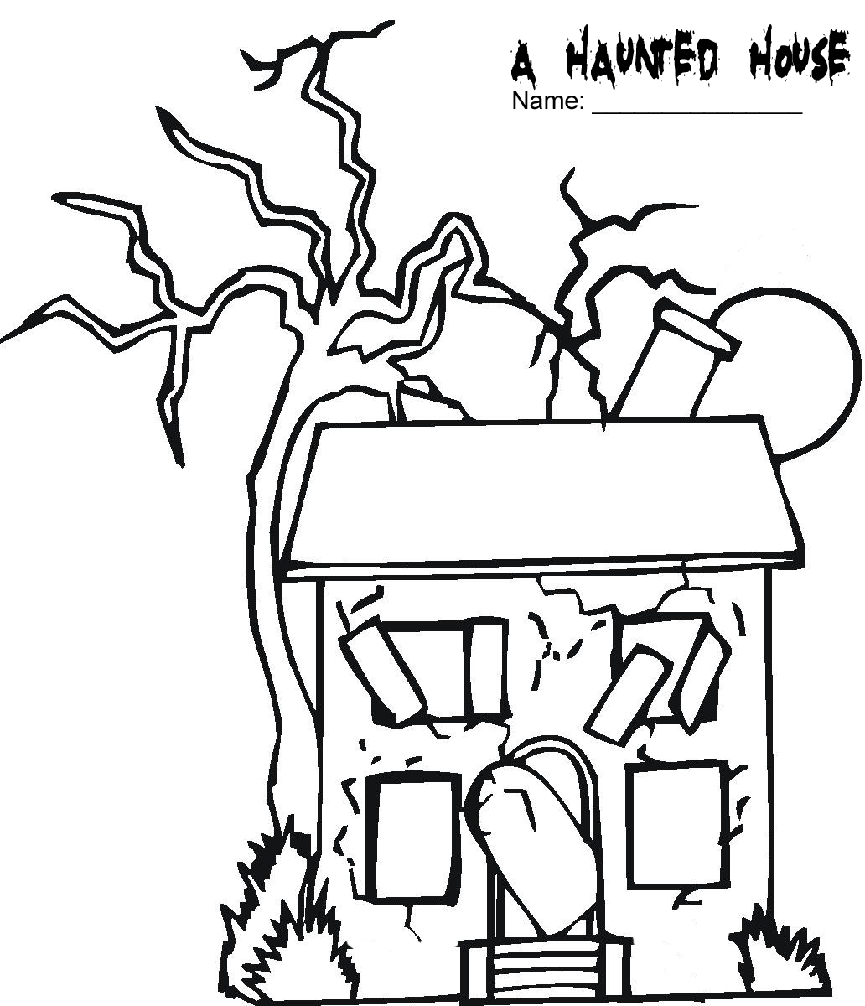

Draw the things below in the haunted house. Then add 3 more things but do not show them to your partner. Tell your partner to draw your things too.

an owl in the tree  a jack-o’-lantern in front of the house  a cat on the roof  a ghost in a window | a witch flying on a broomstick  graves beside the house  a skeleton in a window  a bat in the sky


 |  |  | 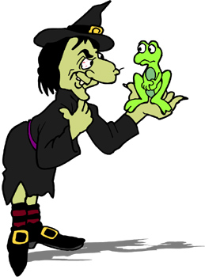
Across  1. What a witch wears on her head.  4. A witch flies on this.  5. Witch’s brew ingredient: bat __________.  8. What a witch turns a person into.  9. ____________ a spell.  11. What witches make in their cauldrons.  12. A witch's pet.  14. A big black pot that witches use to make their brew.  15. You do this to break the spell and turn the frog into a prince.  16. Witch’s brew ingredient: _________ of newt. | Down  2. __________ someone into a frog.  3. A group of witches.  5. What a witch has on her nose.  6. Some witches have this color skin.  7. Type of hat worn by witches.  10. Cast a ____________.  11. The color of a witch's clothes.  12. An evil spell.  13. Put someone ___________ a spell.
www.bogglesworldesl.com


 |  |  | 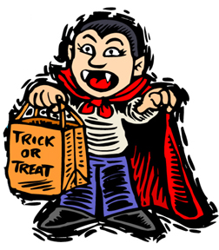
Across  3. Vampires hate the smell of this food.  4. Vampires __________ blood.  5. A vampire's bed.  6. A vampire's teeth.  8. A vampire can turn into one of these and fly away.  9. Some vampire victims ____________ vampires.  11. A blood-sucking monster. | Down  1. This can kill a vampire by shining on it.  2. The most famous vampire.  5. A religious item that vampire's hate.  6. How long can a vampire live?  7. The vampire's favorite place to bite.  8. What a vampire drinks.  9. The color of a vampire's cape  10. What a vampire wears.

www.bogglesworldesl.com

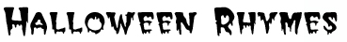
A witch’s pet that rhymes with rat:  A scary thing that rhymes with toast:  A bony monster that rhymes with sun:  A monster that rhymes with wire:  A monster that rhymes with tummy:  A funny person that rhymes with down: |  | 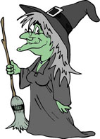
What a witch rides that rhymes with room:

What kids say that rhymes with meat:

A scary pumpkin that rhymes with burn:
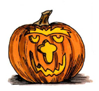 | Where kids keep candy that rhymes with face:  A monster with stitches that rhymes with mine.  A person who steals treasure that rhymes with sit:  A skeleton’s home that rhymes with slave:  Who makes a web and rhymes with wider:

www.bogglesworldesl.com

- Choose one of the trick-or-treat poems that is posted on the blackboard.
- Do a little-bird-dictation and copy it on this page.
- Learn the poem by heart and tell it to your teacher or co-teacher.

For the GIRLS: ask five of your friends

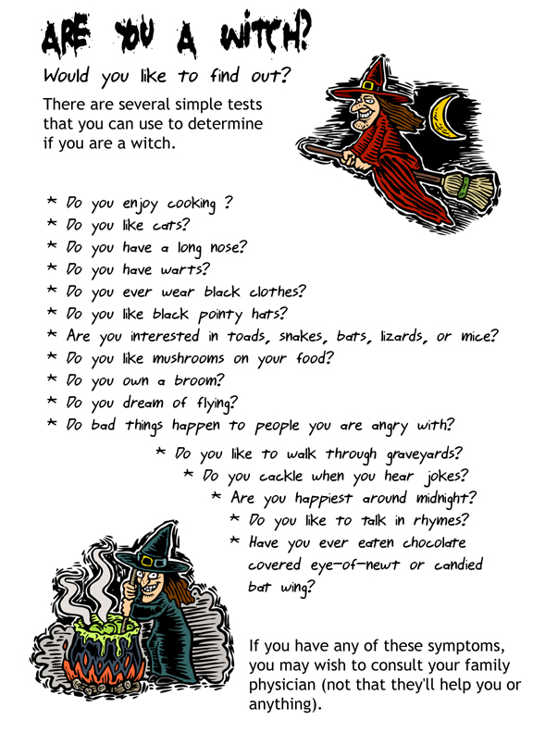

For the BOYS: ask five of your friends
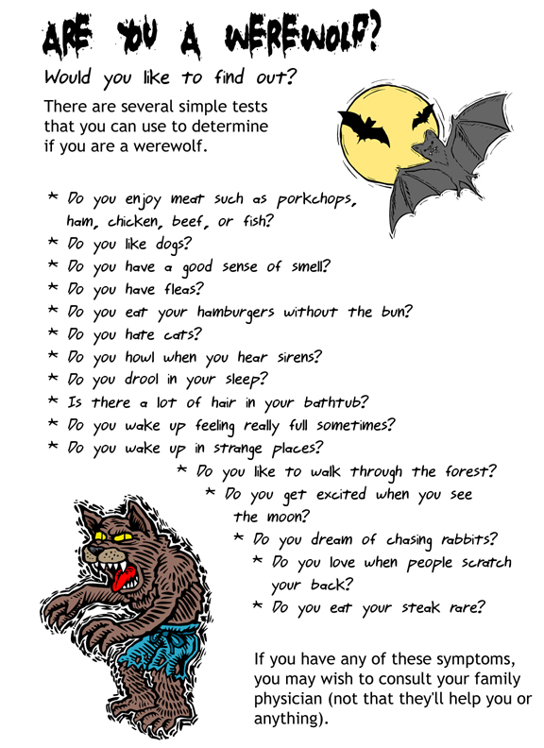

Now write your own test questions:
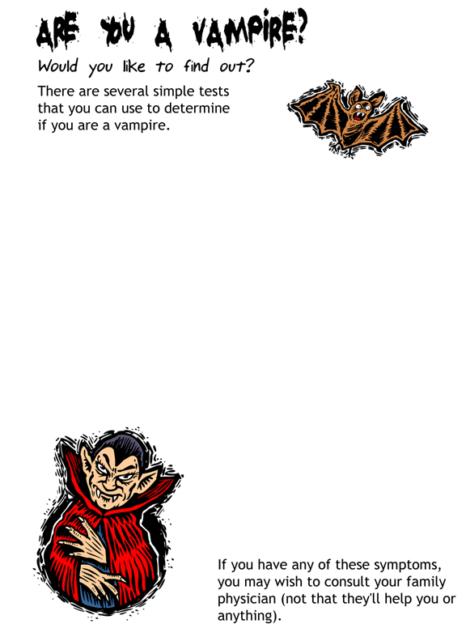

Ask your partner where the ghosts are in his/her picture and draw them in. Then compare your pictures.

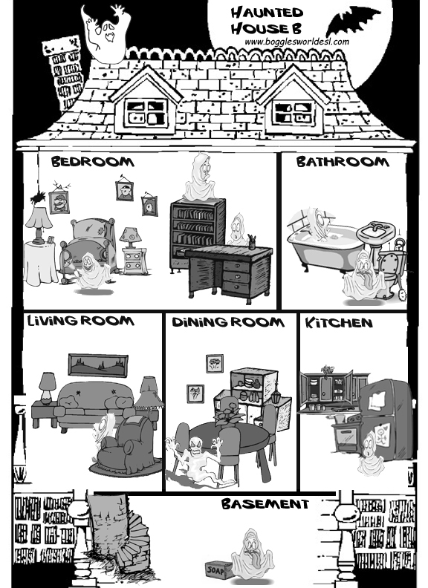

Solve the logic puzzles
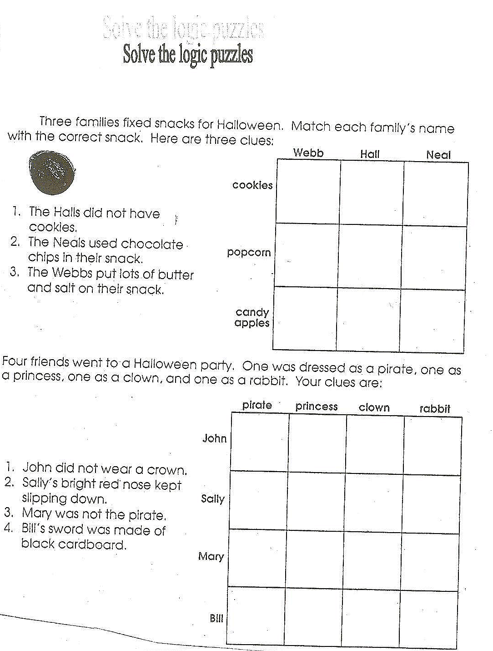
Ask your partner where the ghosts are in his/her picture and draw them in. Then compare your pictures.

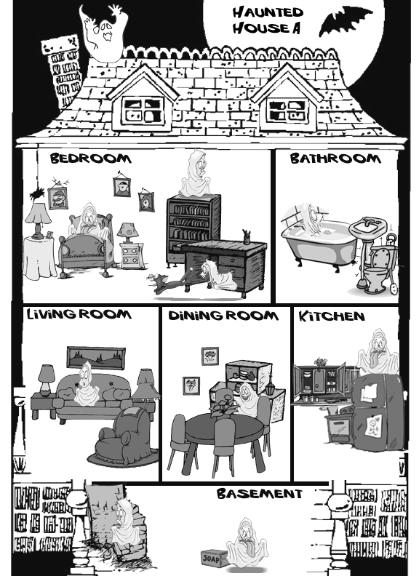

Solve the logic puzzles

For bilingual students:

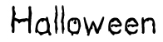 | 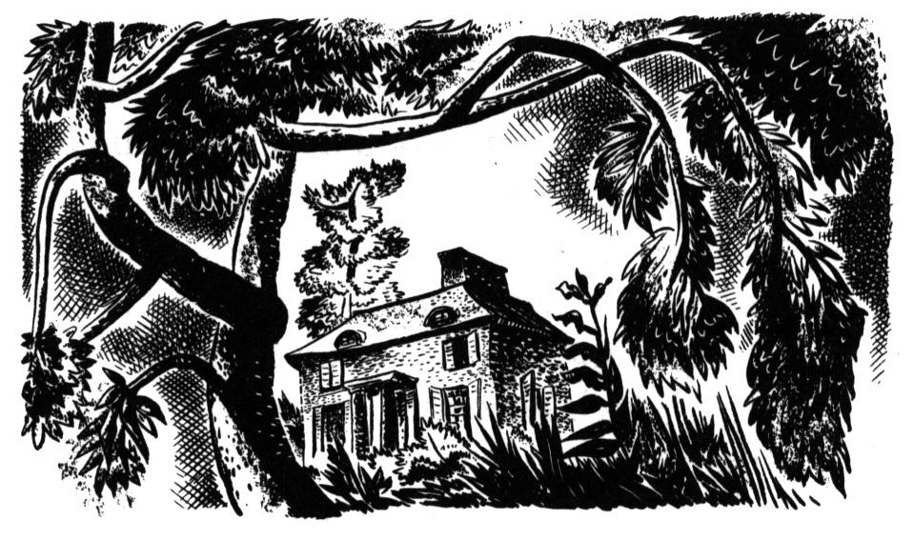  The house on the hill in the old forest.
I went trick-or-treating with my best friends _______, _______, and _______. Our pillowcases were full of candy, and it was getting late, so my friends wanted to go home.

I wanted a few more chocolate bars so I turned to my friends and said, “Let’s knock on a few more doors and then head for home.”

They were worried because they thought it was already too late. “Let’s go home now,” they said to me. I told them not to worry because we could take a shortcut through the old forest.

So after a few more houses, I took my friends to the path that went through the forest. We walked about 20 minutes, and then, suddenly, I felt very strange. I couldn’t remember the way! It was dark and foggy. We were lost. And to make matters worse, it started to rain. And then, it started to pour. Lightning lit up the sky and thunder rang in our ears. We wandered around in the rain for over two hours. We were very wet and very cold. And then, at about midnight, I saw an old abandoned house on a hill.

“I think we’ll have to spend the night in that old house and wait till morning,” I said.

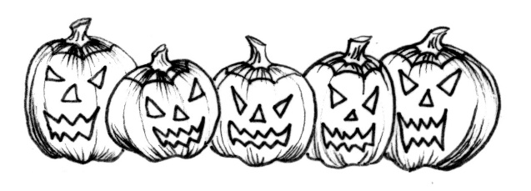 |  | My friends didn’t think it was a good idea, but they were cold and wet, so they agreed. We walked up the old wooden steps to the front door. The door creaked open and we went inside, sat down, and started to eat a chocolate bar, when . . .
http://bogglesworldesl.com

Reading Comprehension:  What is happening at the beginning of the story?  Why did the writer want to go to a few more houses?  Why didn’t the writer worry because it was getting late? |  |  |  |  | 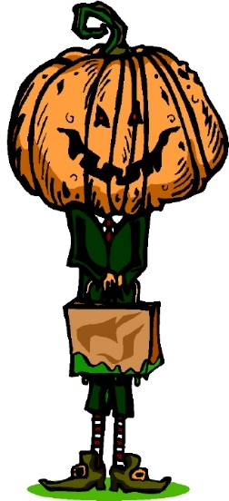
What happened in the forest?

What was the weather like in the forest?

Did the writer’s friend think it was a good idea to stay in the house?

Why did the friends agree to stay at the house?

What did they do as soon as they went into the house?

Match the following words with their definition:
abandoned |  | wander |  | shortcut |  |  | pour
______________ A quicker way to get somewhere.
______________ Go from place to place.
______________ Rain very hard.
______________ Empty with no one living there.

Finish writing the story using all the phrases in the box below.
Creative Writing Box |  |  | screamed  saw a light  ran down the hall |  |  | cobwebs  heard footsteps  hid under the bed
heard a noise
dawn
http://bogglesworldesl.com

For bilingual students

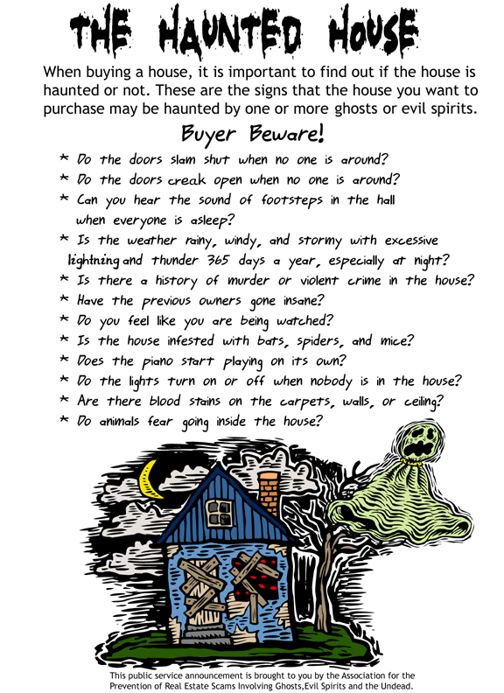

Buyer Beware Reading Comprehension

A) Read the public service announcement on buying houses that may be haunted. Then look up any words you don’t know in your dictionary. Write those words here.

B) Choose the expression that best matches the underlined phrase:

(1) The doors slam shut.
(a) | break | (b) | close quickly | (c) | knock | (d) | open slowly
(2) There was excessive noise.
(a) | scary | (b) | very little | (c) | too much | (d) | pleasant
(3) He went insane.
(a) | jolly | (b) | angry | (c) | happy | (d) | crazy
(4) The house is infested with termites.
(a) | filled with | (b) | clean of | (c) | out of | (d) | protected against

C) Answer the following questions.
(1) Have you ever seen a ghost?

(2) Do the doors of your house ever slam shut?

(3) Do you believe in ghosts?

(4) Have you ever heard strange noises in your house?

(5) Are there any haunted houses near your neighborhood?

D) Creative writing: If you were going to buy a house and you thought it might be haunted, how would you find out for sure?




