1 | Complete the story with one word in each gap. Put the verbs in the right form.

look go fall bump pull find climb leave

Mrs Moans can’t find her dog. She ¹........................ her house at nine in the morning and ²........................ to the park. At the park, she ³........................ for her dog. Mrs Moans ⁴........................ a tree in the park. Oops! She ⁵........................ her head and ⁶........................ out of the tree. But it’s OK. Her dog ⁷........................ her. He’s a big dog, so he ⁸........................ Mrs Moans home again.
2 | Look at the pictures and write sentences about what the children like/don’t like to eat.

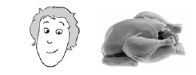
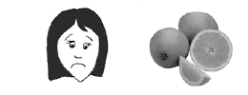
1 Anna...............................................................................................

2 Joe ................................................................................................

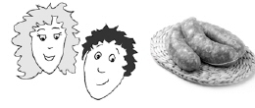
3 Sally and Jason..............................................................................

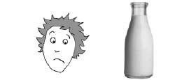

4 Peter .............................................................................................

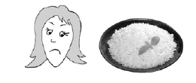
5 Yoriko ............................................................................................

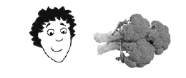

6 Steven ................................................................................................

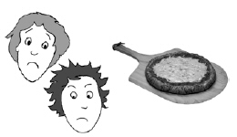

7 John and I ................................................................................................

3 | Write what the children usually wear.

1 | 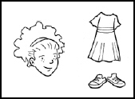  Dora usually wears ..............................  ............................................................ |  | 2 | 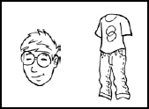  Adam usually ..............................  ............................................................
3 | 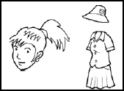  Susannah usually ..............................  ............................................................ |  | 4 | 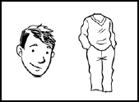  Robbie usually ..............................  ............................................................
5 | 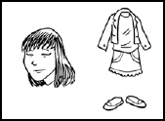  Harriet usually ..............................  ............................................................ |  | 6 | 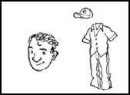  Jasper usually ..............................  ............................................................

4 | Write the words.

1 | 13 = ....................................... |  | 6 | 93 = .......................................
2 | 19 = ....................................... |  | 7 | 12 = .......................................
3 | 8 = ....................................... |  | 8 | 34 = .......................................
4 | 20 = ....................................... |  | 9 | 87 = .......................................
5 | 49 = ....................................... |  | 10 | 64 = .......................................

5 | Write the missing days of the week.

Monday
............................................................ |  | ............................................................
............................................................ |  | ............................................................
............................................................ |  | ............................................................

6 | Write the time in words.

1 | 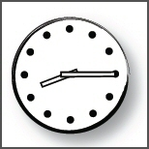  ............................................................  ............................................................ |  | 2 | 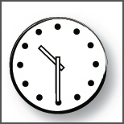  ............................................................  ............................................................
3 | 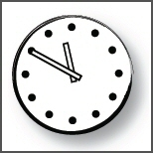  ............................................................  ............................................................ |  | 4 | 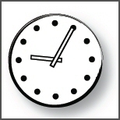  ............................................................  ............................................................
5 | 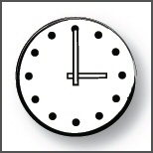  ............................................................  ............................................................ |  | 6 | 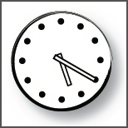  ............................................................  ............................................................

7 | Write a or an.

There’s ¹......... great restaurant, we sometimes go to at the weekend. It’s ²......... old restaurant, but the food is really good. I usually have chicken curry when we go there, and I have ³......... banana yogurt drink with it. My friend doesn’t have ⁴......... chicken curry because he doesn’t eat meat. He has ⁵......... egg curry and he says it’s delicious. He has ⁶......... orange yoghurt drink with his curry. After the meal I always have ⁷......... ice cream. My friend has ⁸......... small fruit salad.
I like to have ⁹......... ice cream after ¹⁰......... meal.

