The
rainforest
The biggest rainforest in the world is the Amazon
rainforest. It is in South America.
The climate there is steamy, humid,
wet and hot.It rains nearly every day.There are so
many animals that have not been found yet.A third of all
insects live there.There are people that cut down
the rainforest.This is very dangerous for us because
the rainforest gives us oxygen.

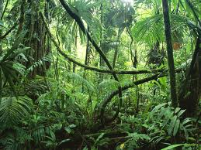
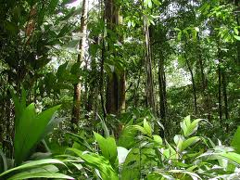
Do you want that in a few years this has been cut down?
No!!!!!!!!!! Please help!!!!!

by Sarah.Schreiber

