What do they usually wear and what are they wearing right now?
always usually often | now
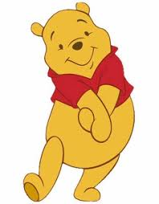  Winnie always | 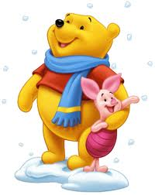  Now it is cold and Winnie
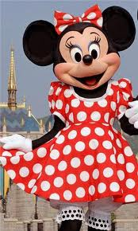  Minnie often |   Now it is Christmas and Minnie
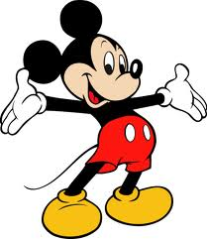  Mickey usually | 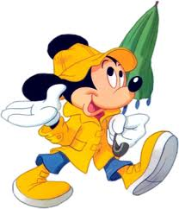  Now it is wet and Mickey
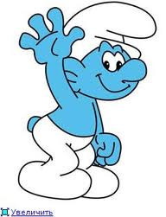  Smurfs always | 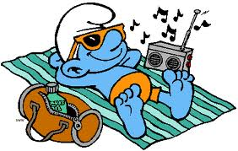  Now it is sunny and the smurf
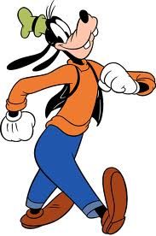  Goofy often | 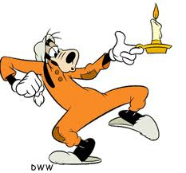  Now it is midnight and Goofy

Here are some words to help you . Add other words that you know already.

pyjamas a raincoat sunglasses a vest slippers gloves a bow shorts
bathing trunks a Christmas hat an umbrella

