Listen to the three dialogues and follow the directions on the map. Try to find out what the buildings (A, B and C) are called.

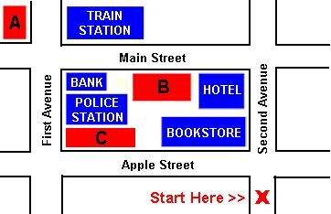

http://www.englishlanguageworld.com/Beginning_English_Lesson13/Beginning_English_Lesson13_Listening.html

Put the words in the right order!

- get How to restaurant do I the ?
_________________________________________________________________________________ ?
- straight turn and ahead Go left .
_________________________________________________________________________________ .
- cinema the bakery next to is The .
_________________________________________________________________________________ .
- zoo the behind office The post is .
_________________________________________________________________________________ .
- on Take first the the left street .
_________________________________________________________________________________ .
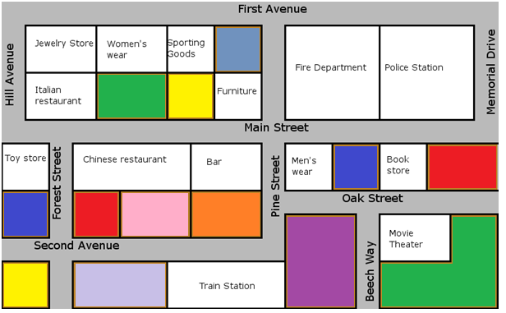 You are here

Follow the directions on the map and mark the sentences  – true or false | T or F
The bar is on Second Avenue.

The police station is next to the Fire Department.

The toy store is opposite the Chinese restaurant.

The movie theater is near by the police station.

The train station is on Main Street.

The bar is next to the Chinese restaurant.

The jewelry store is behind the Italian restaurant.

1)

2) Choose two of the colored/empty buildings and name them. For example “School”, “Supermarket”, “Playground” … whatever comes to your mind - be creative!
3) Now write down the directions for your building. How do we get to this place? Always start from Beech Way!

