Mock-test 1c Group A December 2016

1. (CD 2, track 33)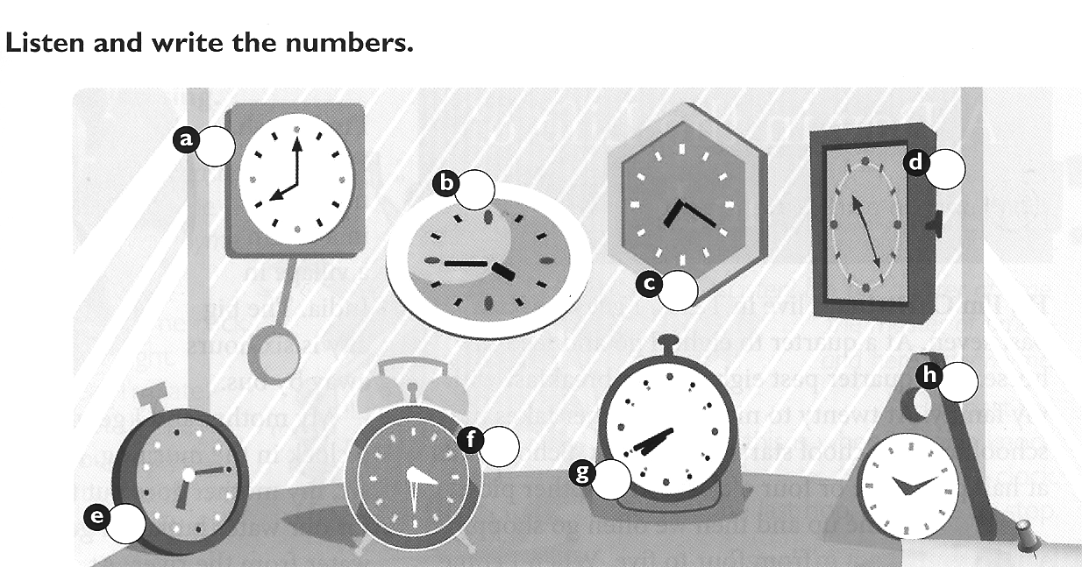

2. What time is it? (Schreibe auch die Zahlen aus.)

A | B | C | D
 | 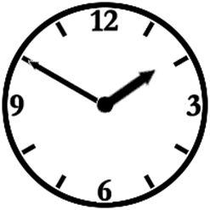 | 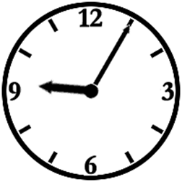 | 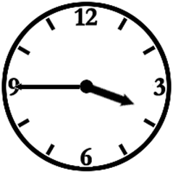

A:
B:
C:
D:

3. How do you say these numbers? Write them down.

55: …………………………………………………….………….. 83: …………………………………………………………………….

14: ………………………………………………………………… 47: …………………………………………………………………….

4. Where are the things? Write sentences.
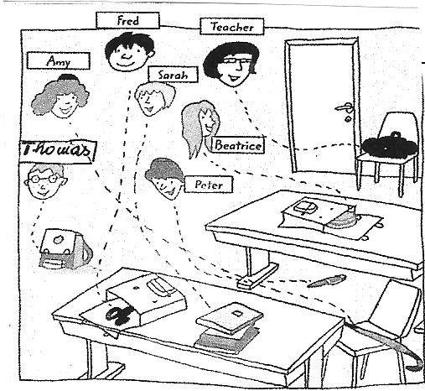 | Example: Amy’s umbrella (Schirm) is on the chair.  ……………………………………………………………………………………………………  …………………………………………………………………………………………………..  …………………………………………………………………………………………………..  ……………………………………………………………………………………………………  …..................................................................................................  …………………………………………………………………………………………………..

5. My best friend:
Write about your best friend. What does your friend like /dislike? Write about hobbies, favorites. You can also write about your friend’s pets.
Write about half a page.

Mock-test 1c Group B December 2016

1. (CD 2, track 33)

2. What time is it? (Schreibe auch die Zahlen aus.)

A | B | C | D
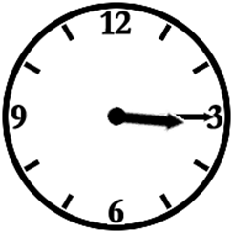 | 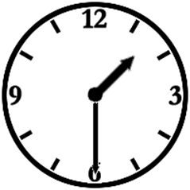 | 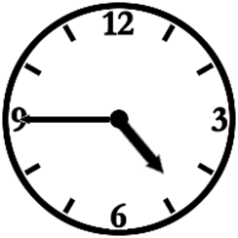 | 

A:
B:
C:
D:

3. How do you say these numbers? Write them down.

15: …………………………………………………….………….. 85: …………………………………………………………………….

13: ………………………………………………………………… 42: …………………………………………………………………….

4. Where are the things? Write sentences.
Example: Amy’s umbrella (Schirm) is on the chair.

……………………………………………………………………………………………………
…………………………………………………………………………………………………..
…………………………………………………………………………………………………..
……………………………………………………………………………………………………
…..................................................................................................
…………………………………………………………………………………………………..

5. My best friend:
Write about your best friend. What does your friend like /dislike? Write about hobbies, favorites. You can also write about your friend’s pets.
Write about half a page.

