Group A Name:..................................

Year 1 English Test 18th March 2004

- Asking Questions
Imagine there is a new girl in your class. Her name is Tina and she only speaks English because she has just come to Graz. Look at the dialogue below. Fill in the questions you ask Tina.

You: Hi, Tina! How are you?
Tina: OK, thanks.

You:
Tina: I’m from Dublin.

You:
Tina: No, I don’t. I can only speak English.

You:
Tina: In a house in Andritz.

You:
Tina: I usually just read or play with my sister.

You:
Tina: Sunday? I think we’re going to go to Vienna.

You:
Tina: Tuesday afternoon? That would be great. I love birthday parties.

- Adverbs of frequency

Example: never/ John/ to the cinema/ go…………. John never goes to the cinema.

get up / at / usually / 7 o’ clock / John and Mary

jeans / always / Mary / wear / blue /her

watch TV / never / in our bedroom / we


- Going To
Write sentences. What are they going to do in their Easter holidays ?

Susan...

Cathy and I ...

What are you going to do in the Easter holidays? Write 2 sentences (new things).

- Possessive Adjectives:
What is Mary Adams saying? Add my, your, his, her, our or their.

My first name is Mary. ___________ family name is Adams. What about you? What’s _________ first name? And what’s ________ family name? I’m married. You can see _________ husband in the picture. __________ name is Arthur. We’ve got one son and one daughter. __________ son is 20. ___________ name is Nick. _____________ daughter is 25. Emily is married. ___________husband’s name is Bruce. Emily and Bruce have got two children. _____________ names are Ken and Eva.
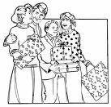

- This or These?
Complete the sentences with this or these.

Do you like __________ pullover? No, not really, but I like _____________ shorts. They are very colorful.
Can you help me with _____________ exercise? It is very difficult.
Peter always wears _____________ dirty sneakers to play in the garden.

- Meet Mrs. Petty, Jimmy or Omar
Choose one of the pictures below. Who is he/she? What is he/she like?
Write a long text about your person. Look at the checklist. You MUST write about these things in your text. The title of your text is: Meet Mrs. Petty/Jimmy or Omar.
Write about one and a half pages.
Checklist:
- description: what does he/she look like?
- clothes: what does he/she usually wear?
- house/apartment: where does he/she live?
- lifestyle: what does he/she usually/ sometimes/ never do?
job, hobbies, daily routine…
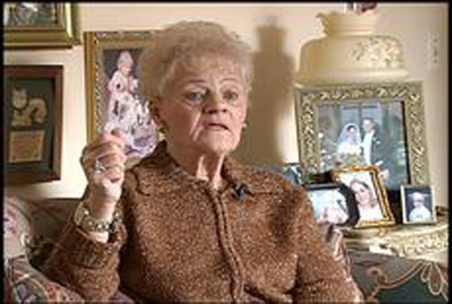
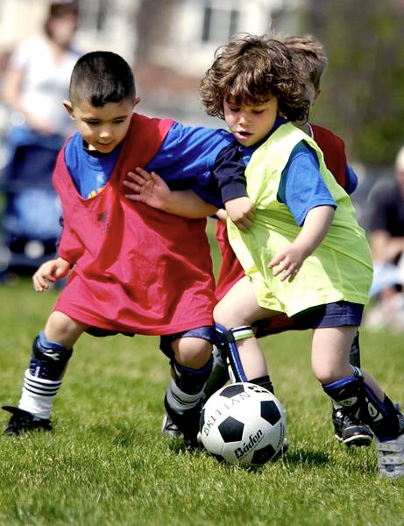

B Name:___________________

Year 1 English Test 18th March 2004

- Possessive Adjectives:

What is Mary Adams saying? Add my, your, his, her, our or their.

My first name is Mary. ___________ family name is Adams. What about you? What’s _________ first name? And what’s ________ family name? I’m married. You can see _________ husband in the picture. __________ name is Arthur. We’ve got one son and one daughter. __________ son is 20. ___________ name is Nick. _____________ daughter is 25. Emily is married. ___________husband’s name is Bruce. Emily and Bruce have got two children. _____________ names are Ken and Eva.

2. Going To
Write sentences. What are they going to do in their Easter holidays ?

(glue in 2 pictures:
Group A: Susan, Cathy and I,)
Group B: Nora, Jane and Fahim

What are you going to do in the Easter holidays? Write 2 sentences (new things).

- This or These?
Complete the sentences with this or these.

Can you help me with _____________ homework ? It is very difficult.
Do you like __________ jeans ? No, not really, but I like _____________ T-shirt. It is very colorful.
David always wears _____________ dirty sneakers to play outside.

- Asking Questions
Imagine there is a new girl in your class. Her name is Tina and she only speaks English because she has just come to Graz. Look at the dialogue below. Fill in the questions you ask Tina.

You: Hi, Ann! How are you?
Tina: OK, thanks.

You:
Tina: I’m from London.

You:
Tina: No, I don’t. I can only speak English.

You:
Tina: In a house in Mariagrün.

You:
Tina: I usually just read or play with my brother.

You:
Tina: Sunday? I think we’re going to go to Salzburg.

You:
Tina: Wednesday afternoon? That would be great. I love birthday parties.

- Adverbs of frequency
Example: never/ John/ to the cinema/ go…………. John never goes to the cinema.

get up/ at / usually / 7 o’ clock/ my parents

trainers / always / Peter / wear / blue /his

wear / never / Scott / a shirt and tie

