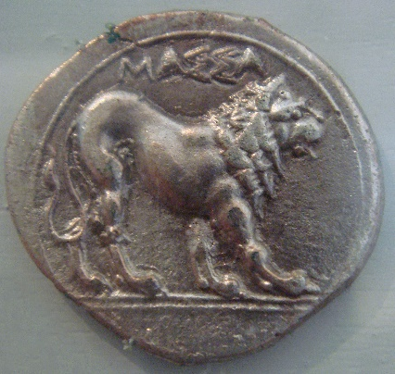
The Coin

Read the story and fill in the missing words.

Tom was not a coward. He was good at sports and he was not afraid of ghosts or spiders. But Tom _______ afraid of dogs. On his way to school there ________ a lot of houses with gardens. In one garden there _______ always a big brown dog. When Tim ________to the garden, he crossed the street and _________on the other side. But sometimes the dog _______ out in the street. Then Tom was very afraid. One day he ____________the dog on his side of the street. There was a small shop on this side of the street too. Tom was afraid and _______ into it.
“What can I do for you?” the shopkeeper ________. He ______an old man with white hair. “I don’t... I’m… The dog . . . I’m afraid of the dog” Tom __________.
The old man _____________ at Tom. Then he ____________into a room at the back of the shop. When he __________ back, he __________ a coin in his hand. It ________ old and there __________ a tiger on it. “Put it in your pocket,” the old man ___________ to Tom, “it will help you.” “Thank you very much,” Tom __________ and he __________ out into the street.
There he __________ the big dog again. The dog ___________ at Tom and Tom ____________ at the dog. Then Tom __________ his hand in his pocket. The coin _______ there. Tom ________feel it with his fingers. He __________ at the dog again and then he __________on.
For the first time in his life he was not afraid of the dog. Tom felt very good.
The next day the brown dog was out in the street again. Tom _____________ and said hello to him. Then he __________ on.

True of false? Circle the correct answer and correct the false sentences

Tom was afraid of dogs and spiders.
T F Tom was afraid of dogs but not of spiders.

One day Tom saw the dog on his side of the street.
T F

He went into a shop and bought some ice-cream.
T F

He gave the shopkeeper an old coin.
T F

He was not afraid of the dog because the coin made him feel strong.
T F

Tom was happy. He was not afraid of dogs any more.
T F

Now it’s your turn:
What do you think about the coin? Was it magic? Does it also help in other situations?
Write another story about the coin. Plan your story:
What was the person afraid of?
Who?

What happened?

How did the person get the coin?

What happened next?

