Group A Name:___________________

1a English Test April 2017


- Asking Questions
Imagine there is a new girl in your class. Her name is Tina and she only speaks English because she has just come to Graz. Look at the dialogue below. Fill in the questions you ask Tina.

You: Hi, Tina! How are you?
Tina: OK, thanks.

You:
Tina: I’m from Dublin.

You:
Tina: No, I don’t. I only speak English.

You:
Tina: In a house in Andritz.

You:
Tina: I usually just read or play with my sister.

You:
Tina: Sunday? I think we’re going to go to Vienna.

You:
Tina: Tuesday afternoon? That would be great. I love birthday parties.

- Mrs. Pölzleitner’s everyday life

Guess what your English teacher does in her everyday-life. Write 5 sentences and use each of these words:
always, never, sometimes, rarely, often

- What is happening around you?
Write 5 sentences about things that are going on right now at GIBS. Think of specific people or classes and guess what they are doing right now. If you are not sure, start your sentence with “I think…”

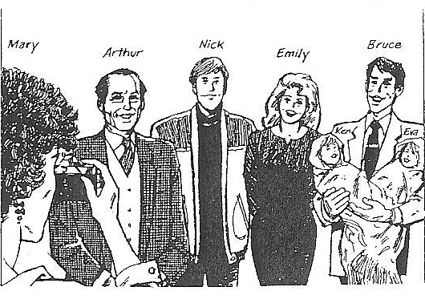
- Possessive Adjectives:
What is Mary Adams saying?
Add my, your, his, her, our or their.

My first name is Mary and my family name is Adams. I’m married. You can see _________ husband in the picture. __________ name is Arthur. We’ve got one son and one daughter. __________ son is 20. ___________ name is Nick. _____________ daughter is 25. Emily is married. ___________husband’s name is Bruce. Emily and Bruce have got two children. _____________ names are Ken and Eva.

What about you? What’s _________ name?

- This or These?
Complete the sentences with this or these.

Do you like ……………… pullover? No, not really, but I like ………….. shorts a lot. They are very colorful.
Can you help me with …………… exercise? It is very difficult.
Peter always wears ………………..dirty sneakers to play in the garden.

- Meet Mrs. Petty, Jimmy or Albert
Choose one of the pictures below. Who is he/she? What is he/she like?
Write a long text about your person. Look at the checklist. You MUST write about these things in your text. Write about one A4 page.
Checklist:
- description: what does he/she look like?
- clothes: what does he/she usually wear?
- house/apartment: where does he/she live? Describe it in detail.
- lifestyle: what does he/she usually/ sometimes/ never do?
job, hobbies, daily routine…

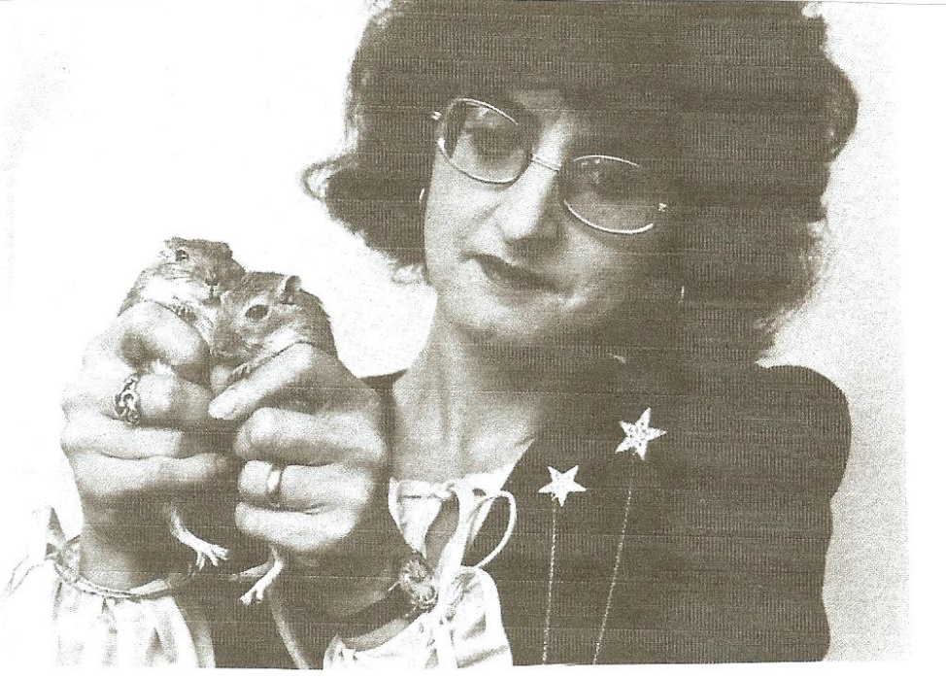



Group B Name:___________________

1a English Test April 2017

1. Possessive Adjectives:
What is Mary Adams saying?
Add my, your, his, her, our or their.

My first name is Mary and my family name is Adams. I’m married. You can see _________ husband in the picture. __________ name is Arthur. We’ve got one son and one daughter. __________ son is 20. ___________ name is Nick. _____________ daughter is 25. Emily is married. ___________husband’s name is Bruce. Emily and Bruce have got two children. _____________ names are Ken and Eva.

What about you? What’s _________ name?

2. What is happening around you?
Write 5 sentences about things that are going on right now at GIBS. Think of specific people or classes and guess what they are doing right now. If you are not sure, start your sentence with “I think…”

3. This or These?
Complete the sentences with this or these.

Thomas always wears ………………..dirty sneakers to play soccer.
Can you help me with …………… homework? It is very difficult.
Do you like ……………… coat? No, not really, but I like ………….. jeans a lot. They are very colorful.


4. Asking Questions
Imagine there is a new boy in your class. His name is Mark and he only speaks English because he has just come to Graz. Look at the dialogue below. Fill in the questions you ask Mark.

You: Hi, Mark! How are you?
Mark: OK, thanks.

You:
Mark: I’m from New York.

You:
Mark: No, I don’t. I only speak English.

You:
Mark: In a flat in St.Peter.

You:
Mark: I usually just read or play with my brother.

You:
Mark: Sunday? I think we’re going to go to Salzburg.

You:
Mark: Wednesday afternoon? That would be great. I love birthday parties.

5. Mrs. Pölzleitner’s everyday life

Guess what your English teacher does in her everyday-life. Write 5 sentences and use each of these words:
always, never, sometimes, rarely, often

6. Meet Mrs. Petty, Jimmy or Albert
Choose one of the pictures below. Who is he/she? What is he/she like?
Write a long text about your person. Look at the checklist. You MUST write about these things in your text. Write about one A4 page.
Checklist:
description: what does he/she look like?
clothes: what does he/she usually wear?
house/apartment: where does he/she live? Describe it in detail.
lifestyle: what does he/she usually/ sometimes/ never do?
job, hobbies, daily routine…

