Time Intro for the teacher:
Step 1: Introduce the clock-time to the learners. Go through the sample phrases on the “help card” (next page).
Step 2: Bingo
Copy one Bingo card per student. The students fill in times (5 minute steps). Then announce times randomly. The learners tick of the ones they have heard. The first player who has ticked off a row (horizontal/ vertical/ or diagonal) wins the game. Depending on time, keep playing for a second and third winner.
Step 3: Practice-games in groups
- Dominoes
- Pairs
- Partner-dictation (print two sheets on one page)

Telling the time: | 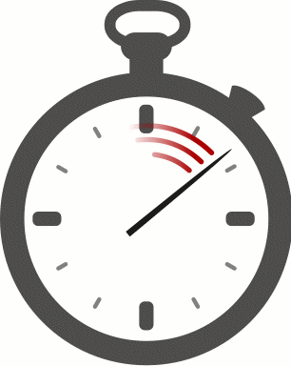  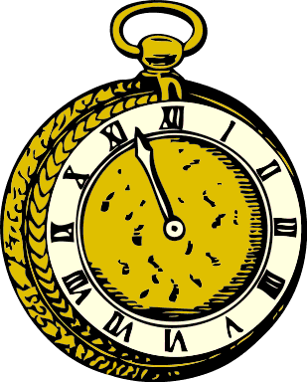
It’s one o’clock.
It’s twelve o’clock.
It’s midnight.
It’s five (minutes) past three.
It’s ten past four.
It’s quarter past five.
It’s half past six.
It’s quarter to seven.
It’s ten to seven.
It’s five to twelve.

Telling the time:
It’s one o’clock.
It’s twelve o’clock.
It’s midnight.
It’s five (minutes) past three.
It’s ten past four.
It’s quarter past five.
It’s half past six.
It’s quarter to seven.
It’s ten to seven.
It’s five to twelve.

Telling the time:
It’s one o’clock.
It’s twelve o’clock.
It’s midnight.
It’s five (minutes) past three.
It’s ten past four.
It’s quarter past five.
It’s half past six.
It’s quarter to seven.
It’s ten to seven.
It’s five to twelve.

Time Bingo
Draw in nine different times. Only draw five minute steps.
Then listen to your teacher and tick off the times that your teacher has announced.
Bingo: If you have ticked off three clocks in a row, shout out “BINGO”. You are the winner!

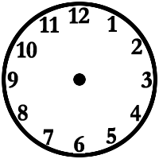

Partner Dictation: Time
Student A: Dictate these times to your partner. He/she has to draw them into the clock-faces.
1 | 2 | 1. It’s half past six.  2. It’s a quarter to eight.  3. It’s ten past five.  4. It’s twenty to ten.  5. It’s five to seven.  Now add your own:  6.  7.  8.
3 | 4
5 | 6
7 | 8

Partner Dictation: Time
Student B: Dictate these times to your partner. He/she has to draw them into the clock-faces.
1 | 2 | 1. It’s five to eleven.  2. It’s a quarter past one.  3. It’s twenty past four.  4. It’s quarter to nine.  5. It’s half past eight.  Now add your own:  6.  7.  8.
3 | 4
5 | 6
7 | 8

