Die Uhr:
Bilder von www.TheTeachersCorner.net

PAIRS
Work in a group of 3-4 students. Deal out all the cards.
Check if you can form any pairs already and put the complete pairs down.
The player with most pairs reads out one of their cards.
Listen carefully. If you have the matching picture or answer, the pair is yours.
Read out one of your cards.
Winner: The person who has collected most pairs is the winner.

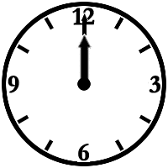 | 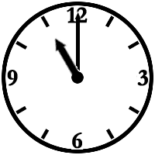 | 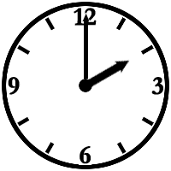 | 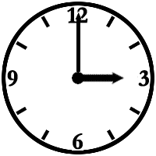
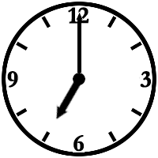 | 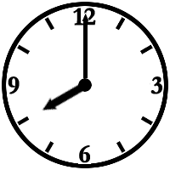 | 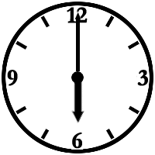 | 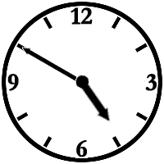
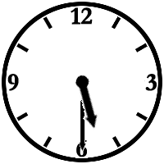 | 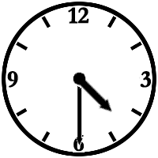 | 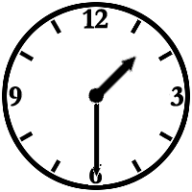 | 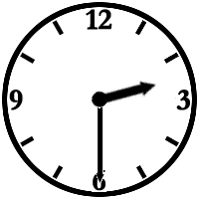
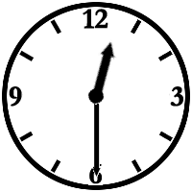 | 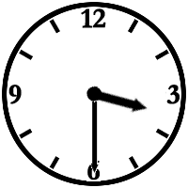 | 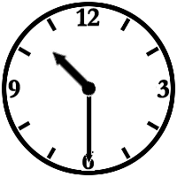 | 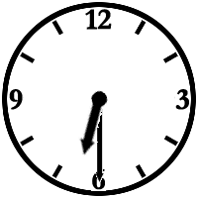
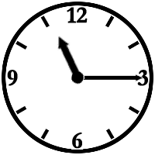 | 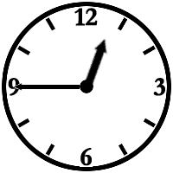 | 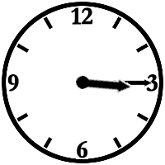 | 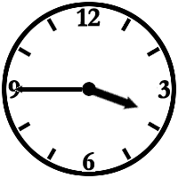
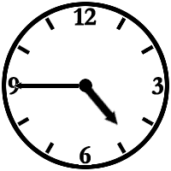 | 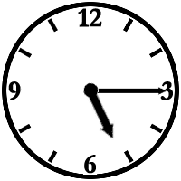 | 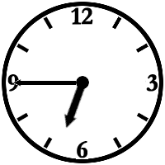 | 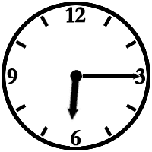
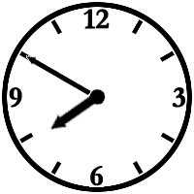 | 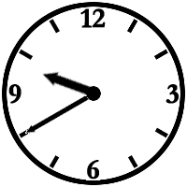 | 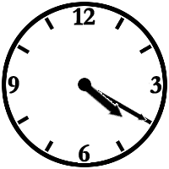 | 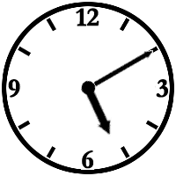
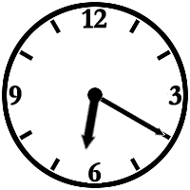 | 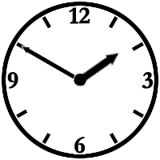 | 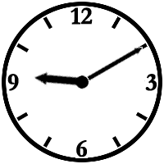
It’s twelve o’clock  or  It’s midnight | It’s eleven o’clock. | It’s two o’clock. | It’s three o’clock.
It’s seven o’clock. | It’s eight o’clock. | It’s six o’clock. | It’s ten to five.
It’s five thirty. | It’s half past four. | It’s half past one. | It’s two thirty.
It’s twelve thirty. | It’s half past three. | It’s ten thirty. | It’s half past six.
It’s quarter past eleven. | It’s quarter to one. | It’s three fifteen. | It’s quarter to four.
It’s quarter to five. | It’s five fifteen. | It’s quarter to seven. | It’s six fifteen.
It’s ten to eight. | It’s twenty to ten. | It’s twenty past four. | It’s ten past five.
It’s twenty past six. | It’s ten to two. | It’s ten past nine. | It’s ten to five.

