Roses are red…

On Valentines day people write love poems to their friends and family. One of the most famous poems is:
Roses are red
Violets are blue
Sugar is sweet
And so are you.
Every year Americans write new versions of this poem for their friends. Read these examples and then write your own “Roses are red…” poem.

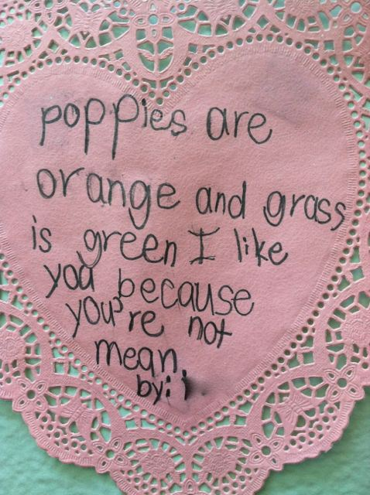

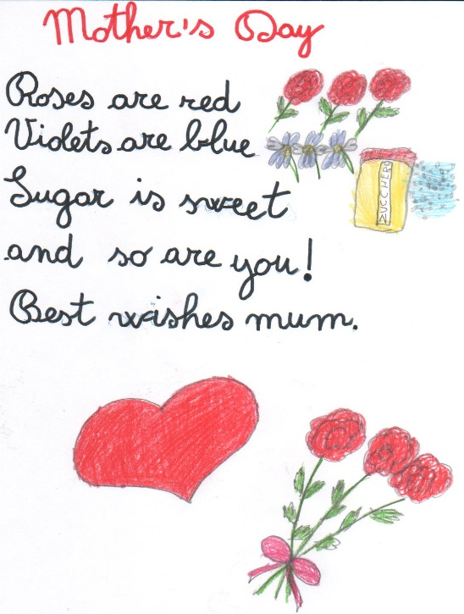





.. Now write your own version of the poem.

