Explain What You're Doing in Thirty Seconds

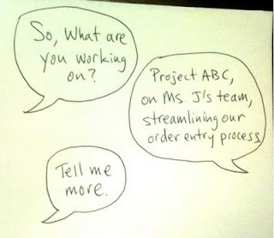
Symptom: When your boss asks you what you're up to, she soon starts fidgeting, looking around, checking the time, looking around some more, and so on. Eventually she cuts you off and says something like "sounds great, thanks" and moves along. And you hadn't even gotten to the important stuff yet!

Cure: You should be able to concisely explain what you are doing, and how your work aligns with the bigger picture, to anybody who asks, in about thirty seconds.

Why it Works: You need to be able to explain what you are doing to people familiar with your work, but more importantly, to people unfamiliar with your work. The goal is not to impress the other party with your vast knowledge, but to make a connection and a contact, and to perhaps learn something new that may be of value to you.
There are a lot of excellent reasons for you to have your 30-second explanation ready at all times.
• You need to completely understand how your actions are aligned with the objectives of your company, your department, your boss, and so on. Indeed, if you can't do this, how can you possibly know if you are doing the right things on a daily basis?
• Nobody really wants to listen to you prattle on about the details of what you are actually are doing. What they want to know is if what you’re doing might affect them in some way.
• Often, opportunities for advancement lie outside your department, not within. Being able to converse easily with people from a broad range of backgrounds and disciplines can help your standing when such opportunities arise. A concise explanation of what you are doing can serve as a good ice-breaker to get the conversation rolling.
• By explaining what you are doing and why in a concise manner, the questioner will understand you much more readily. Most people will not ask for clarification if they don't quite understand you, for fear of looking foolish. If they understand what you are doing, they are much more likely to be able to help you in some way. Which would be good for all parties, and your company, and hence your career.
Did this thirty-second tip help you out? Then tell your friends! Like, Share, Tweet, or Email below!
http://www.simplechief.com/2011/03/explain-what-youre-doing-in-thirty.html

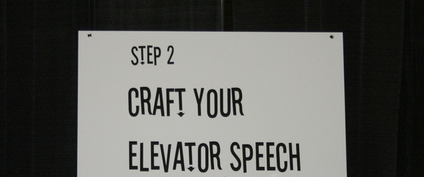
http://bitesizebio.com/articles/can-you-describe-your-research-in-30-seconds-60/

Craft your elevator speech for your research project. In our case you have 1 minute to explain the most important aspects of your project:
- What is your topic? Why is this topic interesting?
- What are the most interesting/ exciting/ odd/ shocking… facts that you have found in your research?
- What else should your audience know about your topic?

Practice your elevator speech a few times. Then record it on your mobile or on vocaroo.com and upload your file to the moodle database.

