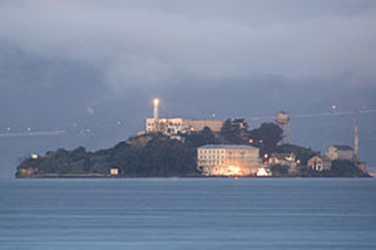
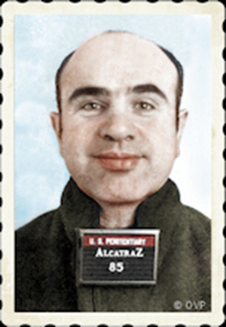
Crime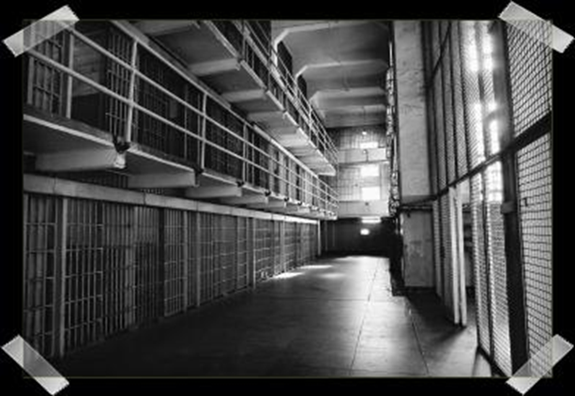

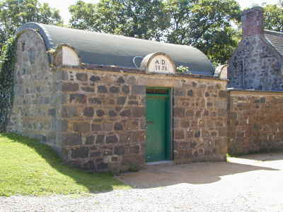

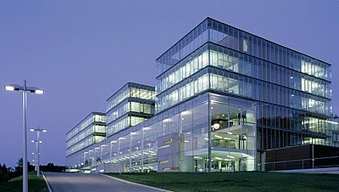
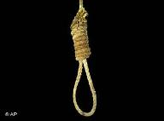

Table of contents

- Prisons p. 1-3

- Alcatraz p. 4-6

- Al Capone p. 7-8

- Guantánamo Bay Detention Camp p. 9

- Torture p. 10-11

- Jack Unterweger p. 12

- Graz- Karlau p. 13

- The Outbreaks p. 14

PRISONS
Prison in Leoben
Most luxurious
This prison was built in 2005. It is made for 205 men, women and Teenager who can stay for only 18 months. You are almost on holiday if you are an inmate because there are
- 2 sporthalls
- 2 fitnessrooms
- tablesoccer
- a library and wonderful huge gardens.

San saint-quentin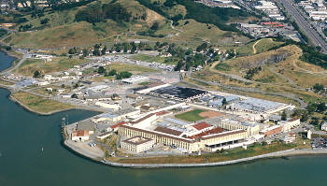
Most brutal
It was built in 1852 in California and is one of the most brutal prisons on earth. It´s 1.7 km2 big and made for 3317 men and women. Till 1937, 215 people were hanged and 196 were killed in gas chambers but 1995 killing with gas was abolished.

Kresty Prison 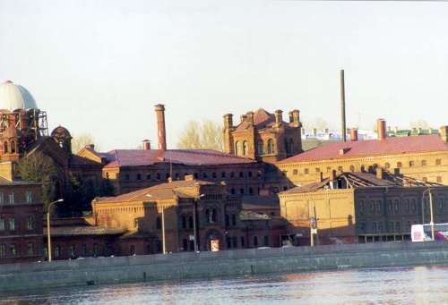
Most overcrowded prison

In the 1730s the wine warehouse of the Saint Petersburg city was converted into a 700 bed prison separated into male and female areas ,because the Emancipation reform of 1861 was over and many criminals were arrested. It was opened in the 1730s in Russia and was designed for 1150 criminals who lived in 96 cells.
San Pedro prison
Strangest prison

It is the biggest prison in Bolivia and is so to say a real city because the 1. 500 inmates have jobs and have to rent or buy a house or room where they can live in. Also their families can live with them although they are no criminals. There are even tourists who want to watch how life is in jails. But in fact there are gang- leader like mafia chefs who tell you what to do if you don´t agree you will be killed! And the police is recognizing this all but it doesn´t matters for them as long as they get paid. smallest prison “Sark Gefängnis, sark, guernsey”
savest prison 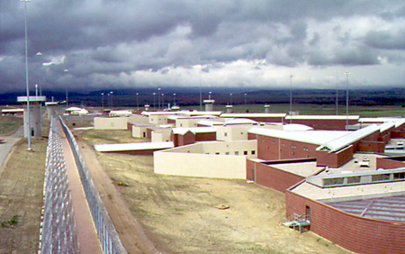 “Adx supermax, Florence, Colorado”

- Source: http://angelsmagazine.blog.de/2007/11/11/die_krassesten_gefangnisse_der_welt~3282470/z,
Wikipedia

Alcatraz

Alcatraz Island is an island located in the San Francisco Bay, 1.5 miles (2.4 km) away from San Francisco, (California, United States.). On the island is a prison called Alcatraz. It was opened on January 1 in 1934, and was closed in March 21 in 1963, after 29 years of operation. At this time, Alcatraz was America's premier maximum-security prison, the final stop for the nation's most incorrigible inmates. It is often referred to as "The Rock". Today, Alcatraz is a place, with a grim past and an enduring (dauerhaften) future as one of San Francisco's most prominent landmarks (Wahrzeichen) and tourist attractions
Visitors can reach the island by ferry ride from Pier 33, near Fisherman's Wharf in San Francisco. Alcatraz has been featured in many movies (“The rock”; ”Birdman of Alcatraz”; “Escape of Alcatraz”;…), TV shows, cartoons, books, comics, and games.
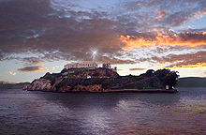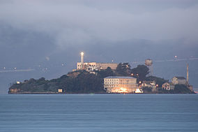
How big was the average cell?
Each cell in B & C block was 5 feet by 9 feet. Cells at Alcatraz had a small sink with cold running water, small sleeping cot, and a toilet. Most men could extend their arms and touch each wall within their cell. The cells in D Block (segregation, Einzelhaft) were bigger, but still the least popular.
How many cells were there?
There were 336 cells in B & C Block. NPS (National Park Service) says that there were originally 348, but 12 were removed when stairways were built at the end of each cellblock. There were 36 segregation(Einzelhaft) cells, and 6 Isolation cells in D-Block. The cells in A-Block were only used a few times for short lock-up periods when an inmate needed to be split off from other inmates! Otherwise, A-Block was used for materials storage.
Were Alcatraz inmates allowed visitors?
Yes. Inmates were allowed one visit per month and each visitation had to be approved directly by the Warden (Aufseher). No physical contact was allowed and rules said that inmates were not allowed to discuss current events, or any matters concerning prison life. Inmates talked with visitors via intercom (Gegensprechanlage) and a guard controlled the conversation. Prohibited behavior during visits could lead in a loss of visiting and/or other privileges.
Do the inmates who were imprisoned at Alcatraz have anything good to say about the prison?
Actually, yes. One prisoner, said that having your own cell was a great advantage over other prisons. By having your own cell, it reduced the chances of being violated and the privacy a positive thing. He also said that the staff treated the inmates respectfully, though they rarely spoke to one another. Furthermore, the food was the best within the entire prison system and considered his time at Alcatraz to be better than at any other penitentiary (Strafanstalt).
What did inmates dislike most about Alcatraz?
The most horrible thing was the rule of silence. In the earlier years of Alcatraz, inmates were not allowed to talk to one another except during meals and relaxing periods. Inmates also said that the island was always cold. What the inmates also hated:
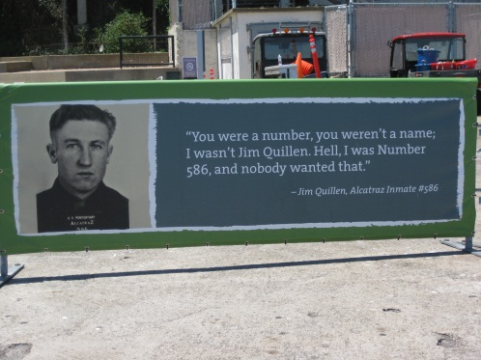
Alcatraz Inmate Jim Quillen: “You were a number, you weren’t a name. I wasn’t Jim Quillen, hell I was number 586 and nobody wanted that!”
Were executions performed at Alcatraz?
No. Inmates who had been served a death sentence (Urteil) were transferred to San Quentin State Penitentiary for execution in the Gas Chamber.
How many people died while at Alcatraz?
There were eight people murdered by inmates on Alcatraz! Five men committed suicide, and fifteen died from natural illnesses. The Island also had its own morgue (Leichenhalle) but no autopsies were performed there. All deceased inmates were brought back to the mainland and released to the San Francisco County Coroner (Leichenbeschauer).
How many prisoners did Alcatraz have at any given time?
The highest number ever recorded was 302, and the lowest number 222. The average number of inmates during the 29 years was around 260. There were approximately 1545 total men imprisoned there.
What was the average stay?
The average stay was about eight years.
How many people escaped?
The NPS records say that 36 prisoners were involved in various attempts. Two inmates actually successfully made it off the island but were quickly captured. Seven inmates were shot and killed while trying to escape. Two were drowned and 5 inmates have been missing, possibly drowned. The most famous escape was that of Frank Morris and the Anglin Brothers. All three managed to swimm off Alcatraz, but all three are believed to have drowned.
Why did Alcatraz close?
First of all, because of the rising costs and other “better” facilities. Alcatraz was the most expensive prison of any state or federal institution (Bundeseinrichtung)! It was said that other institutions could serve the same purpose for less cost.
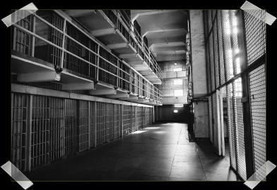

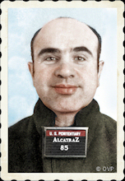
Al Capone

Alphonse Gabriel "Al" Capone, better known as Al Capone is one of the most notable inmates of Alcatraz. He was one of the most infamous criminal in America in the 1920s to 1930s. He controlled the whole Chicagoan underworld (called the “Chicago Outfit) and made his transactions (Geschäfte) with gambling (Glücksspiel), prostitution and illegal alcohol trade. Until today, his name is also connected with the term “money laundering” (Geldwäsche), since he first invested his illegal incomes in launderettes (Waschsalons). With his actions he became a model for tax evaders (Steuerhinterzieher) and cheaters. Although his career lasted only 5 years, Al Capone became an international symbol for organized crime! Capone gave his appearance as a serious business man, and on his business card he was an antiquarian. Al Capone started his life of crime at a young age. Rumours said he started pimping prostitutes before reaching puberty. He was raised on the tough streets of Brooklyn and earned extra money as a bouncer (Türsteher) in various brothels (Bordells). By the age of twenty, Capone had moved to Chicago and was managing a popular nightclub named The Four Deuces. By 1924, Capone had his hand in tough stuff, including prostitution rings, illegal trades, and gambling houses and was believed to be earning over 100,000 $ per week!!
Capone became a wealthy, powerful gangster figure. Despite his criminal activities, he had become a highly visible public figure. He made daily trips to City Hall, opened soup kitchens to feed the poor, and went to orphanages to support the children. City officials often were embarrassed by the politic strength of Capone, and began setting intentional fires to his places of business. In the beginning, the public liked Capone's activities and identified with him as a modern Robin Hood. It wasn't long until the public started weighing against him when it was believed that he had ordered the death of a famous local prosecutor (Ankläger) named Billy McSwiggin. The young prosecutor had before tried to get Capone in relation with the violent murder of a rival gang member. Although many speculated against Capone involvement in McSwiggin's death, there was a great number of people who went against Al Capone. He tried to hide in the underground, but after some weeks he decided to face the police. The police got enough evidences to send him to trial., and although of the unhappy public opinion he was set free. Later, he was convicted of income tax evasion, and had to go to Atlanta U.S. Penitentiary in May of 1932. There he bribed (bestach) the guards for special priviledges and manipulated the system . At the time, he was such a big influence that he was later on sent to Lincoln Heights Jail temporarily before being sent to Alcatraz (the only possiblility, because there he was not able to manipulate the system).
Capone spent 4 ½ years on Alcatraz. Capone's time there was not an easy time. He got into a fight with another inmate in the recreation yard and was placed in isolation for eight days. In the prison basement, an inmate who was standing in line waiting for a haircut, exchanged words with Capone and stabbed him with a pair of shears! Capone was sent to the prison hospital and was released a few days later with a small wound. He eventually became symptomatic from syphilis, a disease he had evidently been carrying for years. In 1938, he was transferred to Terminal Island Prison in Southern California to serve out the rest of his punishment, and was released in November of 1939. Capone died on January 25, 1947, in his Palm Island Mansion from complications of syphilis. All together Al Capone was arrested 12 times, and spent seven years in prison (including time in Alcatraz)!

Guantanamo Bay detention camp
The Guantanamo Bay detention camp is a maximum-security prison (Hochsicherheitsgefängnis) in Cuba. It belongs to the United States, and was opened up by George Bush, to hold the prisoners from the war in Afghanistan. Now it’s used for criminals that could be dangerous for the U.S., so called terrorists. There are two camps in this prison: Camp Delta and Camp Iguana. Once there was a third one too, Camp X-ray, but this has already been closed. The facility is often also called just Guantánamo, G-Bay or GTMO. After it was fixed, that the Guantanamo Bay detention camp could be considered outside U.S. legal jurisdiction, the first twenty criminals arrived there, on January 11, 2002. Susan J. Crawford, a woman from the Secretary of Defense (Verteidigungsministerium) who was supposed to control, how the inmates in the prison are treated, said in an interview, that torture was used there. This is actually not allowed. The criminals in the prison are people that never were at trial (ohne Gerichtsverhandlung) who are dangerous terrorists like from the Taliban or the Al-Khaida.

Camp X-ray
Camp X-ray was the first camp in the prison. It consisted of cages (Käfige) where the inmates were hold. They were standing in the blazing sun, so that they were exposed to the heat. Because you could look into the cages, they had no privacy too. But in Camp X-ray there was only room for 320 inmates. But now, it’s closed.

Camp Delta
Because Camp X-ray was too small, it was replaced by the bigger Camp Delta. It has enough room for 1000 crimials, which were hold and tortured there against the international law. This Camp still exists, but it’s divided into 7 smaller camps:
-Camp 5: in this camp are little isolation cells where the criminals are totally isolated from the rest of the prison
-Camp 6: in this high-security prison many of the criminals live in a bit bigger community-cells.
-Camp Echo: Camp Echo is another extension of the prison. It’s outside of Camp Delta and gets guarded (bewacht) by the military police. Different to Camp X-ray, there are toilets in the cells and the inmates can speak with their lawyers. It’s mostly used for Questionings and lawyer-contacts of the inmates.

Camp Iguana
Also Camp Iguana is a little further away from Camp Delta. Initially (ursprünglich) children were kept there. But in the meantime prisoners are kept there, who are actually innocent, but their home state doesn’t allow them to go free.

Many of the inmates there get abused and brutally tortured. On may the 18th 2006, after many inmates tried to commit suicide, they broke out, but were depressed (niedergeschlagen) immediately from the guards. The inmates in this prison have almost no rights at all, so the prison actually is illegal. Obama tried to close it because of the brutal treatment there, but he didn’t manage it. So we can easily say, that the Guantanamo Bay detention camp is one of the most brutal prisons of the world.

TORTURE
Torture was almost only used in the middle ages for obtaining a confession. If it was the truth or not could not be proofed but this was not important because everyone just said that it was him so the torture would end.
Different torturing methods:
- ‘Schädelquetsche‘ (Torture or execution)
In this torture method the head is put into a clamp and this was screwed down longer and longer until the head breaks.

- Drowning
The persons hands were bound together or he/she was in a cage. Then he/she was put down into the water so she had no chance to breathe. After a longer or shorter time the person was taken out and had a chance to confess that he/she was guilty. If he/she did not do so they did the same again and again.

- Weights
The person had to lie down onto a desk. Then they put very heavy weights onto his breast. If he did not confess, the put more and more weights on until the thorax breaks.

- Geißelungs belt
This was a belt with 20 long spikes in it. The person had to put it on and the spikes were drilled into his body. If he did not confess by now they took the belt of and put some carnivorous maggots into the wholes (the wounds from the belt) and waited until he was eaten up by the maggots.

- Spanischer Kitzler
The person was hung up upside down. Then another person scratched again and again at the same spot until the skin was totally scratched away at a bigger spot. This went so on until the tortured person confessed.

Jack Unterweger

Jack Unterweger is the illigitimate (unehelich) son of a US- soldier and a woman from Vienna, who lived in Austria. First, he was accused of the murder of a 18 year old german woman and was sentenced to lifelong detention (lebenslange Haft). On December the 12th 1974 he strangled the woman brutally with the wire of a bra. He was also accused of raping her. He was already under suspicion to have murdered a 23 years old woman from Salzburg, but this was never proved.

Unterweger started to write a diary in the prison, so he got famous as “the prison-writer”. After 16 years of stay, he was released from prison in 1990, according to paragraph 6 of the Criminal Code.

Six months after he was released from prison, a series of murders on prostitutes began (8 in Prague, Graz, Bregenz and Vienna and 3 in Los Angeles) who were all killed the same way: their underwear was bound to hangman knots (Henkersknoten) and strangled, murdered with it. Unterweger got suspicious and tried to flee with his underaged girlfriend, but he was catched on the 27th of February 1992 in Miami.

Jack denied to have done the murders, but there were many evidences against him. For example the hair of one of the murdered prostitutes in his car, a hair from his scarf on the body of one woman and he was always near the places where the murders happened. He had no Alibi.

On the 29th of June 1994 he was sentenced to life-long detention again, because of having killed 9 women. At the others there were no fix evidences, so he wasn’t accused of having killed them. In the night after the verdict (Urteil) he hanged him self in his cell with the rope of his sweatpants (jogginghose). The rope was bound to a hangman knot: like at all the victims.

His verdict was never in force of law because of his death. So he Jack Unterweger can only be called a “suspected serial killer” (mutmaßlicher Serienmörder).

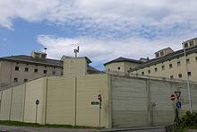

Graz- Karlau

The Prison Graz- Karlau is the third biggest prison in Austria (522 detention places). It is 67.500 m² big and only for male prisoners, most of them stay up to lifelong in the prison, but there are also many that just have to stay three years.
The Graz- Karlau is a very safe prison. So there was almost no prisoner that could escape and flee. The Prison is surrounded by a 1000 meter long wall. It is equipped with barbed wire fence and video cameras. In the prison itself are another 128 cameras for supervising the prisoners and ‘Bewegungsmelder’. In all the hallways in which the prisoners are allowed to walk around in their free time there are grids after a regular distance. Most of the prison cells are equipped with cameras and voice monitors.
The prison was built by archduke Karl II as a castle. He called it Karl- Au (later on it changed to Karlau).
1794 it was used by Kaiser Joseph II for French prisoners of war.
1805 Graz was taken by the French. Prisoners from the Zitadelle and the Kasematten where now placed into Karlau.
1820 it they built a new part next to it. So there was more space for prisoners.

The Outbreaks

1)The Belgium Nordine Ben Allal could break out four times from a Belgium prison, within 7 years. In October 2000 he managed to escape with a prison transporter. In the same year he dressed up like a visitor and walked out of the prison with nobody noticing! He also climbed down the outsidewall with nothing but a rope, in 2004. In October 2007 Nordine was freed from his complicity with a helicopter.
2) The German man Eckehard Wilhelm August Lehmann could break out 11 times from a prison. Therefore he was in the guiness book of world records! One time, he climed up the wall of the prison and over the roof. Without shoes! One time he fled with a sailing boat, and another time in a laundry bag.
3) The criminal Vasilis Paleokostas could escape twice with a helicopter from the biggest and safest prison in greek! In the first escape two accomplices bought a trip on a sight-seeing helicopter. They hijacked the helicopter using a gun and a hand grenade, and forced the pilot to fly to the prison. When the helicopter arrived, the guards believed the helicopter was a visit from prison inspectors. The helicopter flew the prisoners to a cemetery, where they took motorcycles and fled from there. In the second escape, Palaiokostas and his accomplice climbed up a rope ladder thrown to them by a female passenger in the helicopter as it flew over the prison courtyard. They also managed to fly away.
4) Michel Vaujour broke out five times from different French prisons. His methods were very funny because he hid grenades as oranges, or he made a copy of his cell key. After a “crash” with one of the guards he pressed the key into an old cheese, and managed to make a copy of it.Once he made a fake gun from normal handsoap! 1986 his wife freed him with a helicopter!

