Oliver Twist 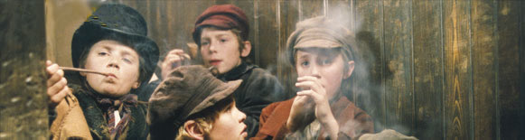

Diary Project
You need:
- a thin A5 notebook with an old-fashioned cover for Oliver’s Diary. (Tip: teabags do a wonderful job. ☺)
- two different colored pens (one for Oliver Twist, one for Fagin)
1. After each viewing sequence slip into the role of Oliver Twist and write down your/his thoughts and feelings as Oliver would have written them had he been able to write a diary. (Check the task “The day I met Fagin”)

2. At some points you will be asked to slip into another character’s mind (e.g. Fagin’s) and write an entry from his point of view. Use a different color for these entries.

3. Produce a WANTED POSTER for Fagin or The Artful Dodger. For details read the instructions on your handout. Stick your finished poster into your project diary.

4. Write a NEWSPAPER ARTICLE for the LONDON GAZETTE on Thursday 4th March 1864. Report the murder of Nancy by Bill Sikes. Follow your teacher’s instructions (run-dic, dictogloss and free ending). Then type the whole article and choose a fitting layout (columns, big title, lead) Print it out and stick it into your project diary after peer-conferencing and revising.

Oliver Twist Internet Search and Quiz:

5. Design an Oliver Twist quiz for another group.

Work with a partner and go to www.filmeducation.org/olivertwist.
Then go to learning recources and read the information you will find under the following headings:
- Oliver’s London
- Rich and Poor
- On Dickens
- Timeline
- People
Also click on some of the sub-topics under these headings.
Read each section slowly and carefully and collect interesting information. Then discuss what you think are the most important facts. Choose 3 facts in each section and make up questions for them. (Don’t forget to write down the answers on a separate sheet.)
Your quiz should have 5x3 = 15 questions altogether.
When you are finished print your quiz (or handwrite it very neatly) and pass it on to another group.

