

The 39 Clues

Getting started: Grace’s Funeral
Read the info to set the scene and discuss it in class:
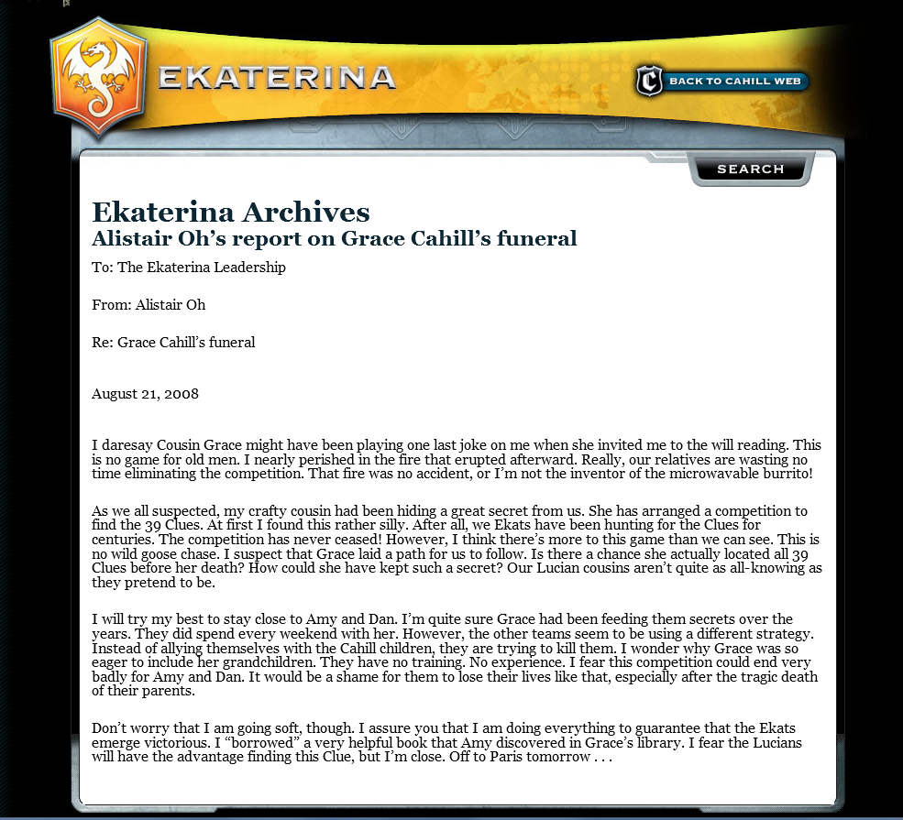

2. Starting to read:
Find the students who have received the same book and start to read. (30min)

3. Who is who?
Computerroom or homework: Go to the Cahill’s Web (link on Moodle) and click on BOOKS. Choose your book and find out about the main characters in your book.
Start your “Who is Who?: Character Profiles”. Keep adding to your profiles as you find out more about the characters in the course of the project.

Who is Who? Character Profiles:


For your character profiles you will need one page per character. Organize your pages clearly so you can easily find and add information and facts to the characters. Use one full page per person.
Name  Picture (print or draw) | Branch
Facts: (age, profession, achievements…) | Personality: (describe the person in detail, collect lots of fitting adjectives and other little details from the book)  …

4. The Clue Hunters’ Travel Diary

Slip into the minds of either Dan or Amy and write a diary entry at each place that they have visited. In your diary describe the places you have visited and what happened there. Make sure you include your/their thoughts and feelings, worries, hopes… Diaries are usually full of such reflections.

5. Optional:
Read as many books as possible and collect the clues. Play the online game and win… or write short entries for each book into your reading diary to get credit for your reading.


Who is Who?

My Top Secret Diary

