Barack Obama DNC Speech Highlights

Democratic National Convention 2012
http://www.youtube.com/watch?v=Zw-ec4grvvc
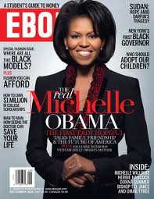
Michelle, I love you. The other night, I think the entire country saw just how lucky I am. Malia and Sasha, you make me so proud…but don’t get any ideas, you’re still going to class tomorrow. And Joe Biden, thank you for being the best Vice President I could ever hope for.

- What role do Michelle, Malia and Sasha play in the presidential election?
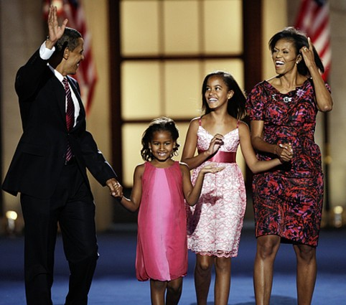
Madam Chairwoman, delegates, I accept your nomination for President of the United States.
The first time I addressed this convention in 2004, I was a younger man; a Senate candidate from Illinois who spoke about hope – not blind optimism or wishful thinking, but hope in the face of difficulty; hope in the face of uncertainty; that dogged faith in the future which has pushed this nation forward, even when the odds are great; even when the road is long.
- What was Obama’s job in Illinois? Which economic sector is dominant in Illionois? Explain the metaphor: when the odds are great …

Eight years later, that hope has been tested – by the cost of war; by one of the worst economic crises in history; and by political gridlock [politischer Stillstand] that’s left us wondering whether it’s still possible to tackle the challenges of our time.
- Which war/crisis does he refer to?
I know that campaigns can seem small, and even silly. Trivial things become big distractions. Serious issues become sound bites. And the truth gets buried under an avalanche of money and advertising. If you’re sick of hearing me approve this message, believe me – so am I.
On every issue, the choice you face won’t be just between two candidates or two parties.
It will be a choice between two different paths for America. A choice between two fundamentally different visions for the future.
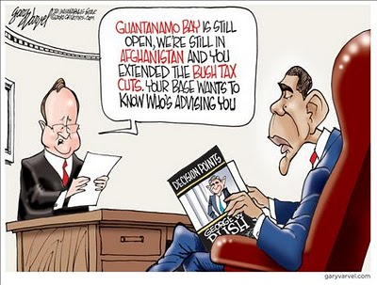
Ours is a fight to restore the values that built the largest middle class and the strongest economy the world has ever known; the values my grandfather defended as a soldier in Patton’s Army; [general in World War II, North Africa Campaign, Sicily Campaign, Normandy Campaign, Lorraine Campaign, Ardennes Campaign] the values that drove my grandmother to work on a bomber assembly line while he was gone.
They knew they were part of something larger – a nation that triumphed over fascism and depression; a nation where the most innovative businesses turned out the world’s best products, and everyone shared in the pride and success – from the corner office to the factory floor. My grandparents were given the chance to go to c___________________, buy their first home, and fulfill the basic bargain at the heart of America’s story: the promise that h_____________ work will pay off; that r________________________ will be rewarded; that everyone gets a fair shot [coll. Versuch], and everyone does their fair share, and everyone plays by the same rules – from Main Street to Wall Street to Washington, DC.
- What does Obama imply by using the term from Main Street to Wall Street?
I ran for President because I saw that basic bargain slipping away. I began my career helping people in the shadow of a shuttered steel mill, at a time when too many good jobs were starting to move overseas. And by 2008, we had seen nearly a decade in which families struggled with costs that kept rising but paychecks that didn’t; racking up more and more debt just to make the mortgage or pay tuition; to put gas in the car or food on the table. And when the house of cards collapsed in the Great Recession, millions of innocent Americans lost their jobs, their homes, and their life savings – a tragedy from which we are still fighting to recover.
- Explain the terms paychecks – mortgage - tuition
Now, our friends at the Republican convention were more than happy to talk about everything they think is ______________ with America, but they didn’t have much to say about how they’d make it ______________. They want your vote, but they don’t want you to know their plan. And that’s because all they have to offer is the same prescription they’ve had for the last thirty years:
“Have a surplus? Try a tax cut.” “Deficit too high? Try another.” “Feel a cold coming on? Take two tax cuts, roll back some regulations, and call us in the morning!” Now, I’ve cut taxes for those who need it – middle-class families and small businesses. But I don’t believe that another round of tax breaks for millionaires will bring good jobs to our shores, or pay down our deficit. I don’t believe that firing teachers or kicking students off financial aid will grow the economy, or help us compete with the scientists and engineers coming out of China. After all that we’ve been through, I don’t believe that rolling back regulations on Wall Street will help the small businesswoman expand, or the laid-off construction worker keep his home. We’ve been there, we’ve tried that, and we’re not going _______________. We’re moving ________________.
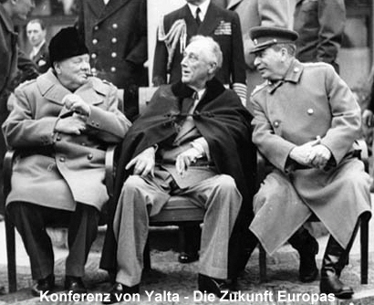
I won’t pretend the path I’m offering is quick or easy. I never have. You didn’t elect me to tell you what you wanted to hear. You elected me to tell you the truth. And the truth is, it will take more than a few years for us to solve challenges that have built up over decades. It will require common effort, shared responsibility, and the kind of bold, persistent experimentation that Franklin Roosevelt pursued during the only crisis worse than this one. And by the way – those of us who carry on his party’s legacy should remember that not every problem can be remedied with another government program or dictate from Washington.
- Explain the bold terms. What role did Franklin D. Roosevelt play in American history? Why does Obama refer to Roosevelt?
But know this, America: Our problems can be solved. Our challenges can be met. The path we offer may be harder, but it leads to a better place. And I’m asking you to choose that future. I’m asking you to rally around a set of goals for your country – goals in manufacturing, energy, education, national security, and the deficit; a real, achievable plan that will lead to new jobs, more opportunity, and rebuild this economy on a stronger foundation. That’s what we can do in the next four years, and that’s why I’m running for a second term as President of the United States.
- What does it mean “to rally”?
In a world of new threats and new challenges, you can choose leadership that has been tested and proven. Four years ago, I promised to end the war in _______________. We did. I promised to refocus on the terrorists who actually attacked us on 9/11. We have. We’ve blunted the Taliban’s momentum in Afghanistan, and in 2014, our longest war will be over. A new tower rises above the New York skyline, al Qaeda is on the path to defeat, and _________________________ is dead.
So now we face a choice. My opponent and his running mate are new to foreign policy, but from all that we’ve seen and heard, they want to take us back to an era of blustering and blundering that cost America so dearly.
After all, you don’t call _______________ our number one enemy – and not al Qaeda – unless you’re still stuck in a Cold War time warp. You might not be ready for diplomacy with Beijing if you can’t visit the Olympics without insulting our closest ally. My opponent said it was “tragic” to end the war in Iraq, and he won’t tell us how he’ll end the war in Afghanistan. I have, and I will. And while my opponent would spend more money on military hardware that our Joint Chiefs don’t even want, I’ll use the money we’re no longer spending on war to pay down our debt and put more people back to work – rebuilding roads and bridges; schools and runways.
- How does Obama describe Romney’s ideas of foreign policy?
I refuse to ask middle class families to give up their deductions for owning a home or raising their kids just to pay for another millionaire’s tax cut. I refuse to ask students to pay more for college; or kick children out of Head Start programs, or eliminate health insurance for millions of Americans who are poor, elderly, or disabled – all so those with the most can pay less.
You know what? That’s not who we are. That’s not what this country’s about. As Americans, we believe we are endowed by our Creator with certain inalienable rights – rights that no man or government can take away. We insist on personal responsibility and we celebrate individual initiative. We’re not entitled to success. We have to earn it. We honor the strivers, the dreamers, the risk-takers who have always been the driving force behind our free enterprise system – the greatest engine of growth and prosperity the world has ever known.
We know that churches and charities can often make more of a difference than a poverty program alone. We don’t want handouts for people who refuse to help themselves, and we don’t want bailouts for banks that break the rules. We don’t think government can solve all our problems. But we don’t think that government is the source of all our problems – any more than are welfare recipients, or corporations, or unions, or immigrants, or gays, or any other group we’re told to blame for our troubles. Because we understand that this democracy is ours. We, the People, recognize that we have responsibilities as well as rights; that our destinies are bound together; that a freedom which only asks what’s in it for me, a freedom without a commitment to others, a freedom without love or charity or duty or patriotism, is unworthy of our founding ideals, and those who died in their defense.
As citizens, we understand that America is not about what can be done for us. It’s about what can be done by us, together, through the hard and frustrating but necessary work of self-government. So you see, the election four years ago wasn’t about me. It was about you. My fellow citizens – you were the change.
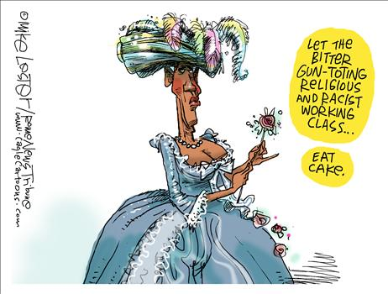
I recognize that ___________ ______________ ___________________ since I first spoke to this convention. The times have changed – and so have I.
I’m no longer just a candidate. I’m the President. I know what it means to send young Americans into battle, for I have held in my arms the mothers and fathers of those who didn’t return. I’ve shared the pain of families who’ve lost their homes, and the frustration of workers who’ve lost their jobs. But as I stand here tonight, I have never been more hopeful about America. Not because I think I have all the answers. Not because I’m naïve about the magnitude of our challenges.
I’m hopeful because of you. America, I never said this journey would be easy, and I won’t promise that now. Yes, our path is harder – but it leads to a better place. Yes our road is longer – but we travel it together. We don’t turn back. We leave no one behind. We pull each other up. We draw strength from our victories, and we learn from our mistakes, but we keep our eyes fixed on that distant horizon, knowing that Providence is with us, and that we are surely blessed to be citizens of the greatest nation on Earth.
Thank you, God bless you, and may God bless these United States.
- Which famous speeches, documents … do the bold terms remind you of? Would a speech like this work in a European country?

