Civil Rights Reading Project

Read your novel by …………………………………
While reading take notes and collect information that will help you do the following tasks.

Character Profiles
Choose two interesting characters and fill in a detailed character profile for each one. Use extra sheets.
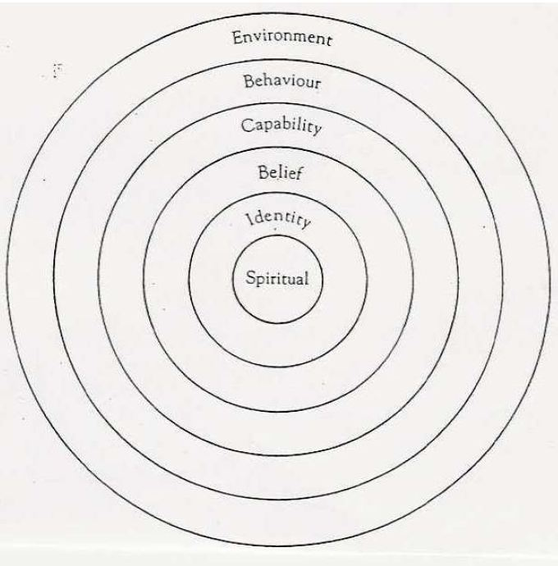  Understanding your characters better:  In what way does the information in the profiles explain the characters’ actions? | Environment:  Where does your character live/work? What is this place like? How does it affect him/her? Who else is there? How do these other people influence him/her? How does your character get along with them?  Behavior:  What does your character do? List a few important or typical actions or activities of your character  Capability:  What is your character good at? What strategies does he/she use in the story? Does he/she use them openly and consciously? What skills does he/she have?  Beliefs:  What are your character’s basic beliefs? Think of the various ideas that he/she thinks are true, and that your character uses as a basis of daily action. Beliefs can be both permissions and limitations. (e.g.: "I am strong! The positive forces will always win!" or "I am afraid of my stronger enemy, he will certainly kill me." or "I don't do this or that because I think it's wrong.)  Identity:  What are your character’s core values and his/her mission in life? What does your character want to achieve?  Spiritual: (if relevant)  This is the deepest level of any character or person. Here we consider such metaphysical questions as "Why are we here? What is our purpose?" These questions are hardly ever asked or answered openly. Try to slip into your character's mind and answer these questions for him/her. What would he/she say?

Vocabulary
Collect 20 useful words/phrases from the book. Look each of the new words up in Vocabulary.com and add them to your list of words to study (on Vocab.com). Practice your vocabulary.com list regularly until you can use the words actively. Tip: if you have not downloaded the app, use vocabulary.com in your phone’s browser or on your computer.
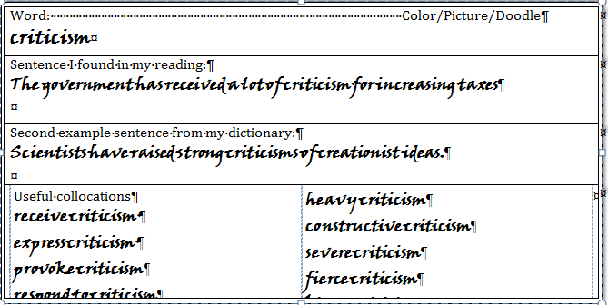
Enter the 20 words into your language reference book using the following format:
Word: Color/Picture/Doodle

Sentence I found in my reading:
Second example sentence from Vocabulary.com

Useful collocations:

Pot diagram
Draw a diagram of the ups and downs in your main character’s life. Label important points in your diagram.

Racist Behavior
Collect all instances of racist behavior in your novel. Choose three of them and write a short note to the perpetrators telling them your opinion on their behavior. Write about 100 words for each one. Type your three paragraphs and upload the whole task on Moodle.
For example: Dear xxx, I have noticed how meanly you treaded yyy when … I am really appalled by your behavior and…

Examples of racist behavior in my novel: (just a few keywords to remind you of the situation) | page nr.

References to historical events or to Jim Crow Laws (if applicable to your novel)
Events in the novel | Historical reference | Page ref.

Discussion topics:
Discuss the following issues in your group. Take a few notes, keywords are fine.
Put yourself in someone else’s shoes  The characters in your book have had to make many decisions. Do you agree with all of them?  Find a few examples of  A: Decisions you agree with.  B: Things you would have done differently. | Highs and Lows  For the characters in your book life is a bit like an emotional roller-coaster. At some points they are really happy, at other points they are really sad, depressed and humiliated.  Find a few highs and lows in the story and read out the relevant passages to each other. Don’t forget to take a few notes (just keywords and page numbers) in your project booklet.
Places  The author of your book has described several important places with so much detail that you can see, hear, smell and feel what the place is like.  Choose one or two places in your novel that are described in such detail and read out the passages to each other.  Make a sketch of a place and label your drawing using some of the new expressions that you have found in your book. | Cliff- hangers  Cliff-hangers or page-turners are an author’s way to keep you hooked to the book and make you think, I’ve just got to read on.  Find two or three cliff-hangers in your book and explain why you felt you had to read on.

Writing
Choose one of the following tasks and write a well-planned text of about 350 words. In your reading group each of you should do a different task.
Put your text on Moodle in order to get some feedback. Then revise your text carefully and upload a final version.

Friend

When you are faced with a problem, it often helps to get some good advice and tips from a friend. Go through your novel and choose a moment where your main character is in trouble or sad and needs some help from a friend. Write him/her a letter giving encouragement and advice in this difficult situation.


Diary
Choose an interesting point in your novel (a high point or a low point) and slip into your character’s mind. Write a diary entry for that day.
In your diary reflect upon the events that have happened, your feelings about them and possible solutions or consequences in the future.


Newspaper article
Choose an event in your novel that would make it into a local newspaper. Write a well-structured article informing your reader about the event.
Tip: Don’t forget to find a catchy title, a lead (intro sentence that will capture the readers’ interest and tell them what to expect). Answer the 5 Ws: Who? What? When? Where? Why?. Remember: use formal language in your article.

Presentations: Pecha Kucha 20x20

A pecha kucha is a(powerpoint) presentation where you show 20 pictures and talk about each one for about 20 seconds. Your presentation must NOT contain any words. We will make an exception and allow a few names and a few dates (years) – IF you find them REALLY important.
Check out this link to find out more about pecha kucha events and competitions: http://www.pechakucha.org
In your presentation tell the story and its (historical) background … Bring the characters to life. SHOW us their experiences and feelings in different situations.
Use telling pictures, maps, drawings, photos …
Use copy-right free pictures wherever possible and quote ALL your sources (links are fine) on the last slide (nr. 21)
Practice your presentation several times using a timer (on your phone). Decide how you want to divide the presentation and who will be responsible for the different parts.
Let’s see who will win this pecha kucha contest.

What do these books have in common?
During the presentations find out what all the books have in common. Take notes on a separate sheet. Then decide on a number of categories that you want to use in your comparison. (e.g. A main character feels offended or humiliated.)
Complete the following table and show how the novels in this project are alike and different. Mark an X in the spaces under each title if the idea or category is treated in this book.
Books: | Roll of Thunder,  Hear my Cry | The Secret Life of Bees | Durango Street | Monster | Noughts  and  Crosses | Spite  Fences | The Color  Purple
a main character feels offended or humiliated due to his/her racial or social background

