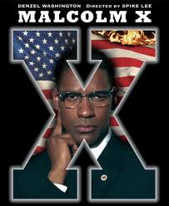
Malcolm X – The Movie (1992)
V E

Extract 1: First encounter with racism
- Who were the intruders and what did they want?

- What does Malcolm X’s father want black Americans to do?

- Why is Malcolm’s mother so fair skinned and how did it affect her?

Extract 2: His time in prison
- What do you notice about his appearance?

- Bembry tells him to “quit taking the white man’s poison into his body”. What examples does he give?

- Name as many definitions/examples of black as possible.

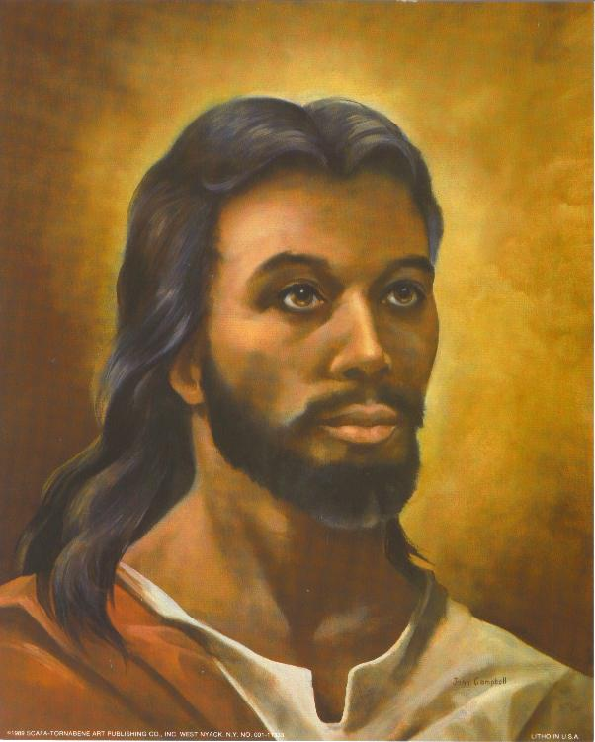
- Name as many definitions/examples of white as possible.

Extract 3: God is black
- What does the chaplain call Malcolm?

- Why does Malcolm think that Jesus was black? Outline the main points.

Extract 4: The charismatic speaker
- Malcolm X says he speaks not as a … (circle the words he uses)
Republican, Christian, Baptist, Mason, Muslim, racist, American, Negro, Democrat, Catholic, Methodist, civil rights activist, Jew, drug dealer
but as a ….

- What aspects of the treatment of black Americans and the civil rights movement does the authentic film footage show? Note down key words.

- Malcolm implicitly criticizes the teaching of Martin Luther King. He says it’s not intelligent for black people to …

Extract 5: Media attention
- In mathematics X represents ….
- Why did Malcolm choose to call himself X?

- How does Malcolm describe the mentality of the ‘house negro’?

V E
- Elijah Muhammed and one of his ministers discuss Malcolm. Mark the statements true or false.
Statements | True | False
Some members of the Nation of Islam think Malcolm is giving the media the wrong impression.
Some members of the Nation of Islam think Malcolm is becoming too self-important.
Elijah approves of what Malcolm has done for the Nation of Islam.

Extract 6: His visit to Africa and the truth as a blinding light
- What does Malcolm realize as a result of his visit to Africa?

- Choose a), b) or c) to complete what Malcolm says.

In the past I made sweeping indictments of …
- all white Americans b) all white people c) all white racists.

In future I will be careful not to sentences anyone who has
- not committed a crime b) been proven innocent c) not been proven guilty.

Extract 7: The press and his change of heart
- Mark the statements true or false.
Statements | True | False
Malcolm is still striving for black supremacy in America.
He’s not yet prepared to work with other groups, organizations or leaders.
He thinks black Americans should migrate back to Africa in their minds.
He believes it is intelligent to defend yourself with a rifle if necessary.
He thinks the UN doesn’t do enough for black Americans.

Extract 8: The end of the “black shining prince”
- What did Martin Luther King say about the assassination? Mark the statements true or false.
Statements | True | False
He said it was tragic.
He said that some people could only express disagreement through killing
He said that people were violent and disagreeable.

- What did Malcolm X consider himself to be by the end of his life?

- How does the film end? What point do you think Spike Lee is trying to make by ending the film in this way?

- Malcolm X said he was prepared to achieve his goal by …
How do you react to this attitude?

Images: http://www.crownarts.com/art/ProdImages/production/AG-9550-1620.jpg, http://t2.gstatic.com/images?q=tbn:ANd9GcTMk7NCoJvheu2U695SmfZHpdcImYdFN37fsiuVw8ImzesJJjgT4w

