Watch these two movies at home. If possible, organize small groups and invite each other for a cozy movie night with popcorn and drinks. While watching, take a few notes so we can discuss the films in school.
Date | 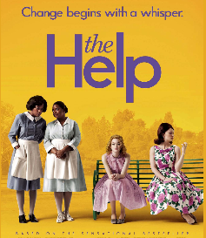  In this table collect keywords that will help you to describe the main characters of the movie.
I watched the film with:…
Elizabeth Leefolt | Constantine Bates
Hilly Holbrook | Aibileen Clark
Celia Foote | Yule Mae Crookle
Miss Walters | Minny Jackson
Eugenie “Skeeter” Phelan | Minny Jackson
Collect instances and examples of discrimination

Date | 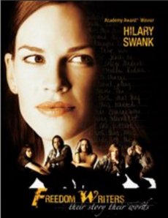  In this table collect keywords that will help you to describe the main characters and their stories.  Choose 5 characters that you find interesting.
I watched the film with:…
Erin Gruwell
Collect instances and examples of discrimination or unequal opportunities

