Book-choosing for the

Civil Rights Reading Project
- Find each of the books on Amazon and get a first impression of the content and themes by reading some readers’ comments.
- Then read the first few pages using the “look inside” function.
- Take notes in the table below in order to remember the bits and pieces of your research. Then mark your first and second choice in the column on the right.
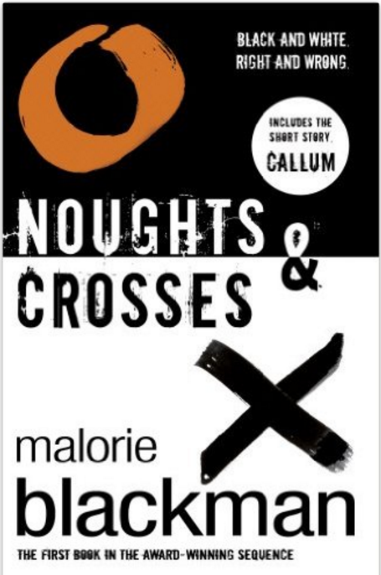 | Who is the main character? What do you know about him/her?  What is his/her problem?  When and where is the story set?  Other comments:
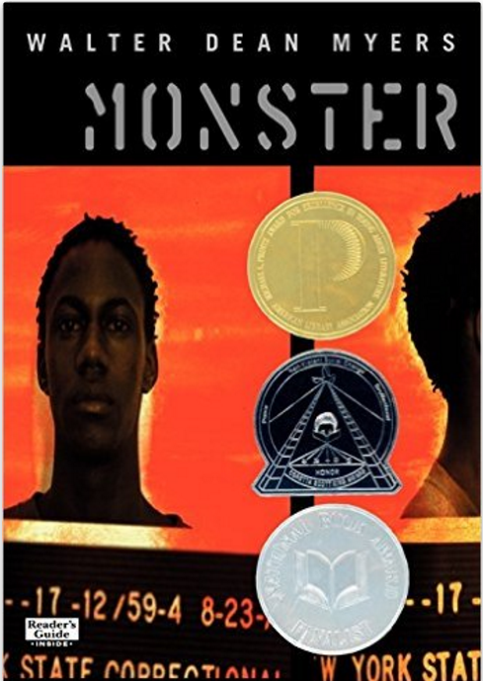 | Who is the main character? What do you know about him/her?  What is his/her problem?  When and where is the story set?  Other comments:
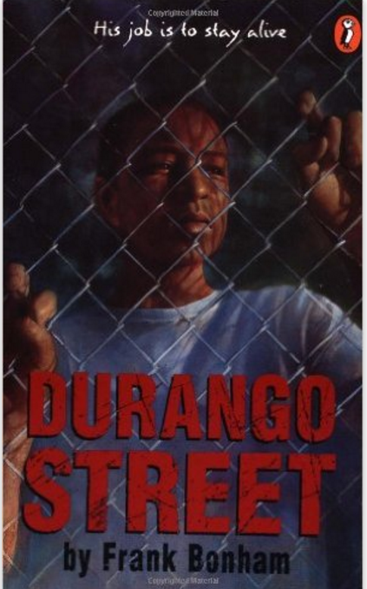 | Who is the main character? What do you know about him/her?  What is his/her problem?  When and where is the story set?  Other comments:
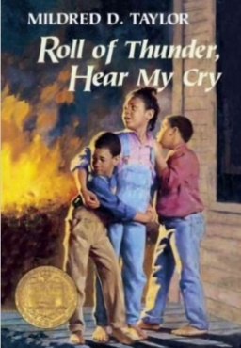 | Who is the main character? What do you know about him/her?  What is his/her problem?  When and where is the story set?  Other comments:
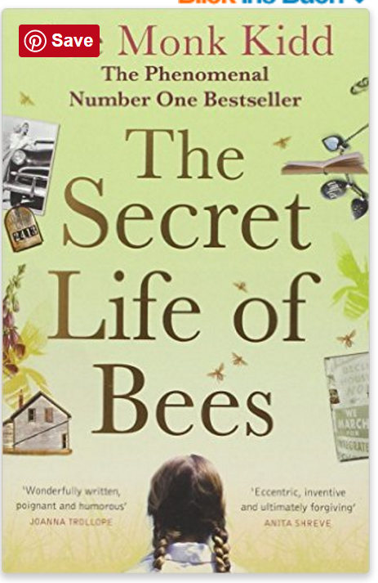 | Who is the main character? What do you know about him/her?  What is his/her problem?  When and where is the story set?  Other comments:
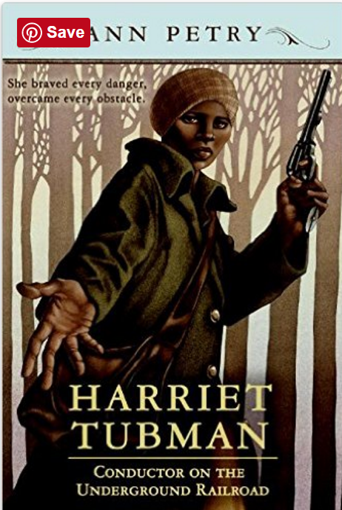 | Who is the main character? What do you know about him/her?  What is his/her problem?  When and where is the story set?  Other comments:
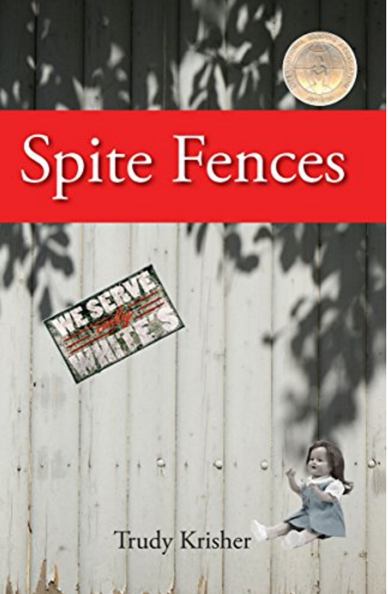 | Who is the main character? What do you know about him/her?  What is his/her problem?  When and where is the story set?  Other comments:
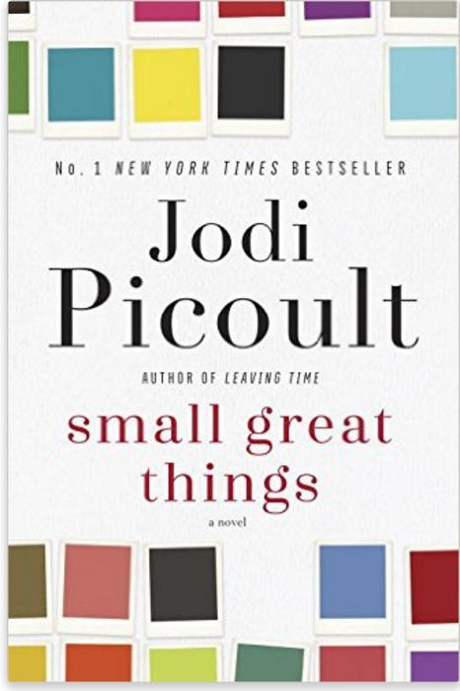 | Who is the main character? What do you know about him/her?  What is his/her problem?  When and where is the story set?  Other comments:
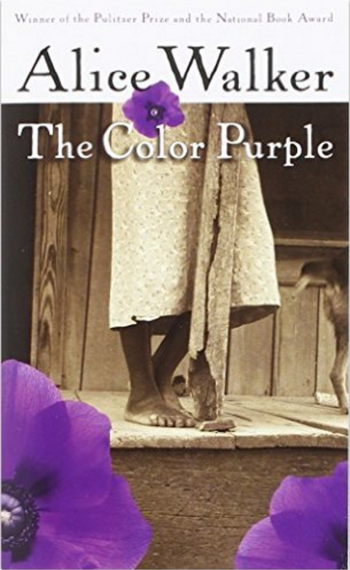 | Who is the main character? What do you know about him/her?  What is his/her problem?  When and where is the story set?  Other comments:

