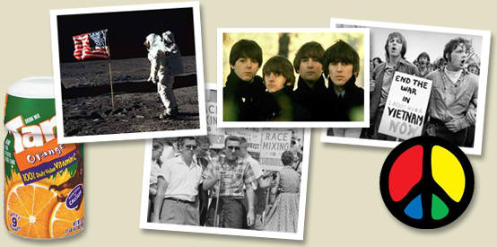

- Create your personal 1960s timeline – Include the two events for each year you consider most memorable
1961 | 1962 | 1963 | 1964 | 1965 | 1966 | 1967 | 1968 | 1969 | 1970

1961
Adolf Eichmann on Trial for Role in Holocaust
Bay of Pigs Invasion (Cuba)
Berlin Wall Built
Freedom Riders Challenge Segregation on Interstate Buses
JFK Gives "Man on the Moon" Speech
Peace Corps Founded
Soviets Launch First Man in Space
1962
Andy Warhol Exhibits His Campbell's Soup Can
Cuban Missile Crisis
1963
John F. Kennedy - Assassinated
March on Washington
Martin Luther King Jr. Makes His "I Have a Dream" Speech
May. Anti-Vietnam war protests in England and Australia.
1964
Fall. Free Speech Movement at the University of California at Berkeley defends the right of students to carry out political organizing on campus. Founder: Mario Savio.
Nelson Mandela Sentenced to Life in Prison
1965
US increases troops in Vietnam (1964 – 16.000 US Forces committed to South Vietnam, 1965 – 60.000, 1969 – 539.000)
October 15–16. First 'International Days of Protest. Anti-U.S. demonstrations in London, Rome, Brussels, Copenhagen and Stockholm.
Malcolm X Assassinated
Miniskirt First Appears
Nicolai Ceausescu Comes to Power in Romania
1966
Muhammad Ali (Cassius Clay) refused to go to war, famously stating that he had "got nothing against no Viet Cong" and that "no Viet Cong ever called me nigger." n 1967 he was sentenced to 5 years in prison, but was released on appeal.
Nazi Albert Speer Released From Spandau Prison
Black Panther Party Established
Mao Zedong Launches the Cultural Revolution
National Organization for Women (NOW) Founded
Star Trek T.V. Series Airs
1967
Sweden, December 20. Seventh Year of the Viet Cong (the Front National de Libération du Vietnam du Sud, or FNL) celebrated with violent clashes in Stockholm. Demonstrations in forty Swedish towns.
Six-Day War in the Middle East
1968
April 3. National draft-card turn-in. About 1,000 draft cards were turned in. In Boston, 15,000 protesters watched 235 men turn in their draft cards
April 4. Reverend Martin Luther King, Jr. assassinated
April 11. Berlin, Germany, Rudi Dutschke shot and wounded. Massive riots against Axel Springer publishers. RAF-Rote Armee Franktion terror
My Lai Massacre
Prague Spring
Robert F. Kennedy Assassinated
1969
April 5–6. Antiwar demonstrations and parades in several cities, New York, San Francisco, Los Angeles, Washington, D.C. …
Neil Armstrong Becomes the First Man on the Moon
Rock-and-Roll Concert at Woodstock

- 1960s Slogans & Cartoons – USA, France, Germany

Lifestyle Slogans
- Back to Nature
- Burn Your Bra
- Let it all Hang Out
- Flower Power
- Never Trust Anyone Over Thirty- Beatles/Bob Dylan
- Tune In, Turn On, Drop Out
- Don’t Bogart That Joint
- Turn Them on to Beauty, Love, Honesty, Fun

Political Slogans Left Wing
- Black is Beautiful
- Make Love not War
- Ban the Bomb
- Eat the Rich
- In Your Guts, You Know He’s Nuts (Barry Goldwater, “Mr. Conservative”)
- Up Against the Wall
- Off the Pigs
- Hell no, we won't go!
- Hey, hey, LBJ, how many kids did you kill today? (Lyndon B. Johnson – US president)
- Give Peace a Chance
Political Slogans Right Wing
- In Your Heart, You Know He’s Right (Barry Goldwater, Republican candidate for presidency)
- Support Your Local Police
- America – Love It or Leave It
- Nicon’s the one
- Next Time You’re in Trouble – Call a Hippie
- Better Dead Than Red

Cartoons
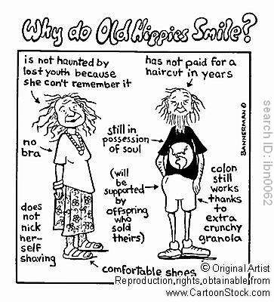
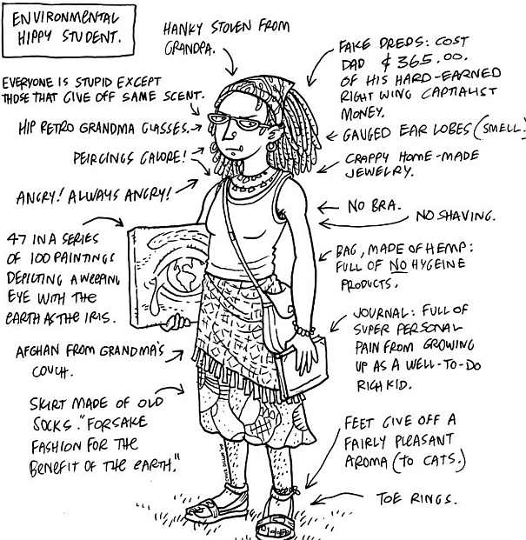

1960s Slogans – France
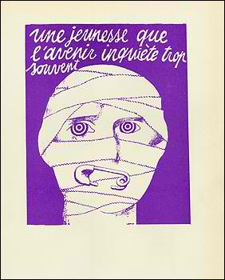
- Dessous les pavés c’est la plage - „Unter dem Pflaster liegt der Strand.“
- Die Fantasie an die Macht“
- Le rêve est réalité- „Traum ist Wirklichkeit“
- „Vive la Commune!“
- Il est interdit d’interdire. „Es ist verboten zu verbieten“
- Imagine
- Les murs ont la parole.
- Nous sommes tous des Juifs allemands (à l'occasion du retour à la Sorbonne de Daniel Cohn-Bendit).

1960s Slogans – Germany
- Wer zweimal mit derselben pennt, gehört schon zum Establishment
- Unter den Talaren – Muff von 1000 Jahren
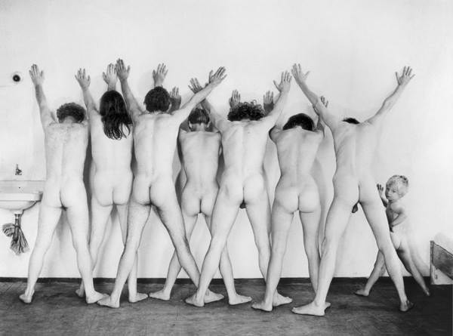
- Schlagt die Germanistik tot, färbt die blaue Blume rot!
- Macht kaputt, was euch kaputt macht. (Ton Steine Scherben)
- Petting statt Pershing
- Euch die Macht – uns die Nacht.
- Ich geh kaputt – gehst du mit?
- Ratschläge sind auch Schläge.
- Du hast keine Chance, darum nutze sie!
- Die Scheibe klirrt, der Sponti kichert, hoffentlich Allianz-versichert.
- Wenn der Krieg ausbricht, war der Frieden offenbar ein Gefängnis.
- Der Klügere gibt solange nach, bis er der Dumme ist.
- Liberté, Égalité, Pfefferminztee
- Wer nicht genießt, wird ungenießbar.
- Nieder mit der Schwerkraft, es lebe der Leichtsinn.
- Wer zu viel fernsieht, verliert den Weitblick.
4. “Zeitgeist” – What’s a “hippy”
Reminiscing about late 1940s Harlem in his 1964 autobiography, Malcolm X referred to the word hippy as a term African Americans used to describe a specific type of white man who "acted more Negro than Negroes." (Malcolm X)
A person, especially of the late 1960s, who rejected established institutions and values and sought spontaneity, direct personal relations expressing love, and expanded consciousness, often expressed externally in the wearing of casual, folksy clothing and of beads, headbands, used garments, etc. (Collins Cobuild Dictionary)

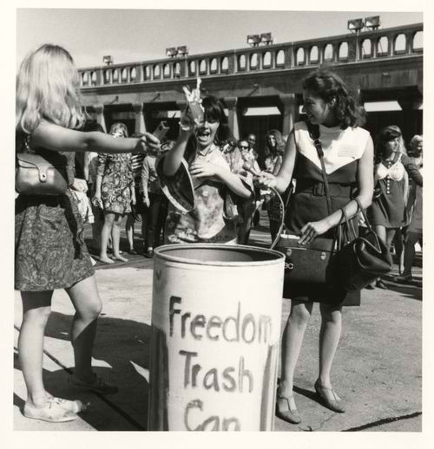
The whole “bra burning” thing was a myth—what truly happened was that women at a Miss America pageant in 1968 burned Playboy magazines, girdles, and high heels to protest symbols of women’s oppression via stringent beauty standards. (Activist)

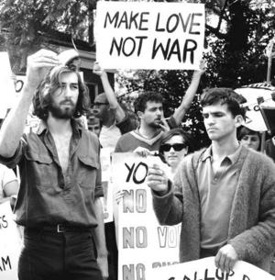

In August 1965, 61% of the population thought the American involvement in Vietnam was right. By May 1971 it was exactly reversed; 61% thought the involvement was wrong. (H.Zinn, A People’s History of the United States, 1980)

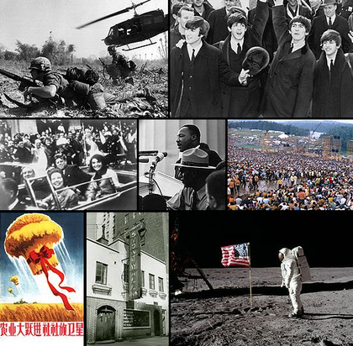

Leary later explained in his 1983 autobiography Flashbacks: "Turn on" meant go within to activate your neural and genetic equipment. Become sensitive to the many and various levels of consciousness and the specific triggers that engage them. Drugs were one way to accomplish this end. "Tune in" meant interact harmoniously with the world around you - externalize, materialize, express your new internal perspectives. "Drop out" suggested an active, selective, graceful process of detachment from involuntary or unconscious commitments. "Drop Out" meant self-reliance, a discovery of one's singularity, a commitment to mobility, choice, and change. Unhappily my explanations of this sequence of personal development were often misinterpreted to mean "Get stoned and abandon all constructive activity"
Dieser Spruch spielt darauf an, dass Straßenpflaster häufig auf einem Sanduntergrund verlegt wird, und Pflastersteine eine beliebte Waffe im Straßenkampf waren und bis heute sind; er verbindet so Hedonismus mit Militanz. Die französische Version Sous les pavés, la plage, die auch der Situationistischen Internationalen zugeschrieben wird, war bei den Pariser Unruhen Mai 68 populär. Der Name der Zeitschrift Pflasterstrand, des Sprachrohrs der linken Sponti-Szene in Frankfurt am Main, geht darauf zurück.
Sponti-Sprüche entstanden im Zuge der Studenten- und Schüler-Revolte bzw. mit dem Aufkommen der sogenannten Spontis in den 1970er Jahren. Die Sponti-Sprüche sind herkömmliche Sprichwörter oder Redewendungen, die provokativ verändert wurden, jedoch nicht nur durch die Medien verbreitet, sondern auch als Graffiti an Hauswänden oder Wänden öffentlicher Toiletten zu lesen sind. Manche der Sprüche entstanden einfach aus Jux, andere hatten einen ernsten Hintergrund oder eine deutlich politische Aussage. Oft entstanden solche Sprüche während einer Demonstration. Um sich beispielsweise über die Texte auf den Spruchbändern der K-Gruppen lustig zu machen, skandierte man rhythmisch: „Nieder mit, Kampf dem, weg mit, vorwärts, es lebe!“

